For TCGA-blca patients belonging to high or low tmb levels and having til maps, we compute the global moran’s index by considering both tmb heat map and til map. Using the computed moran’s index, we select the median cut-off value to divide patients into two groups. The KM curve is plotted as follows:

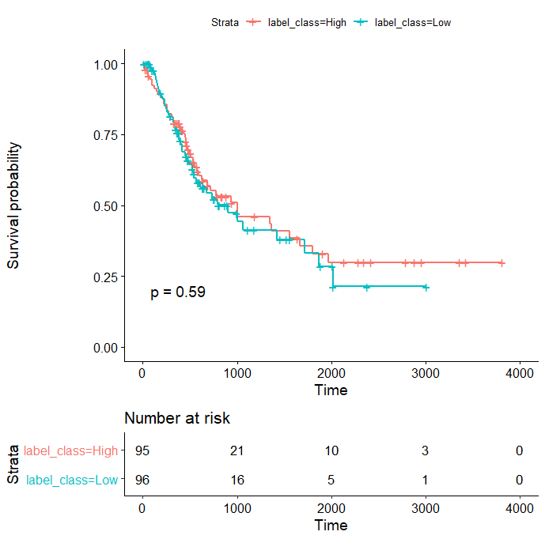

From the above curve, unfortunately we cannot stratify patients into two groups with significant different survival.

For the (ground truth) high TMB patients, we compute the Global Moran’s index from til map. Then we divide the high TMB patients into two groups by using the median cut-off value. The KM curve is as follows:

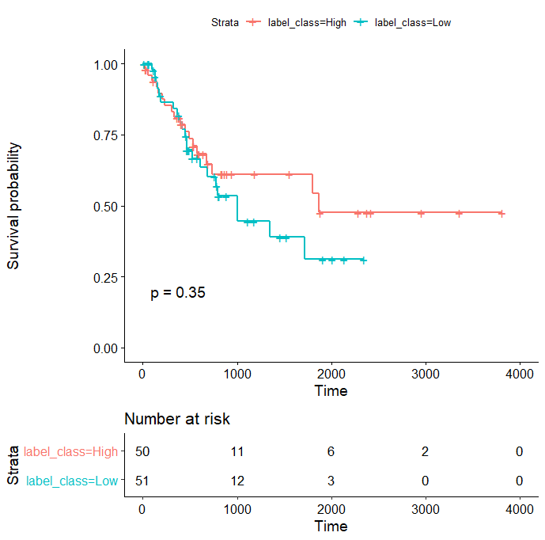

From the KM curve, we can see: using moran’s global index on til maps, we cannot stratify high tmb patients into two groups with significant different survival.

TCGA_blca patients (124 patients) are predicted into the following two groups (based on automatic prediction):

Class 1(High TMB-Low Entropy) vs Class 2 (Low TMB-Low Entropy)

The mean/median survival time (in days) for the class 1 is: 1015/706 Days

The mean/median survival time (in days) for the class 2 is: 696/428 Days

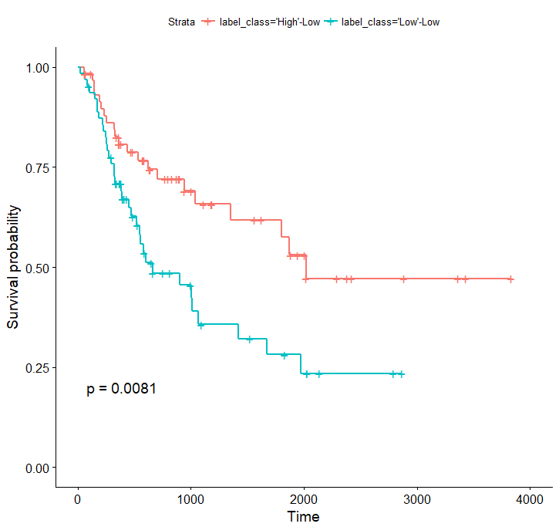

TCGA_blca patients (248 patients) are predicted into the following two groups (based on automatic prediction):

Class 1(High TMB) vs Class 2 (Low TMB)

The mean/median survival time (in days) for the class 1 is: 880/590 Days

The mean/median survival time (in days) for the class 2 is: 746/460 Days

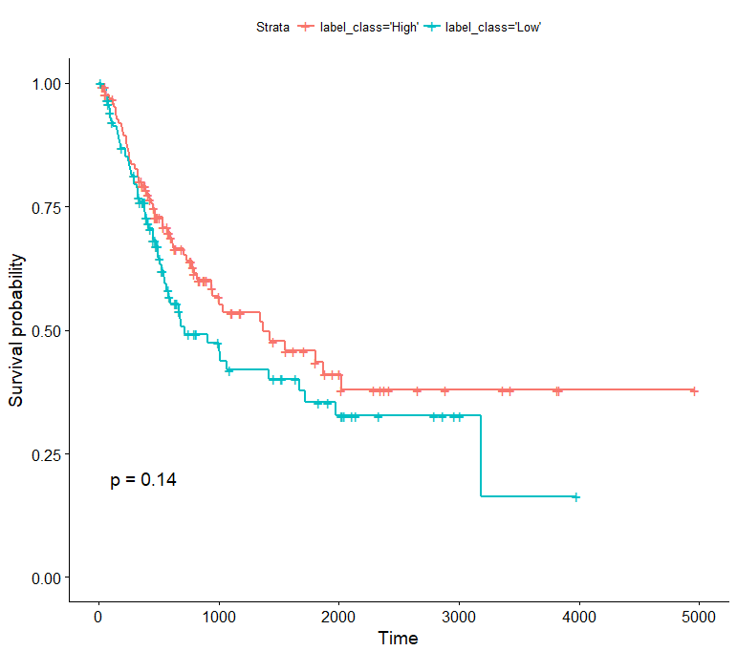

TCGA_blca patients (248 patients) are divided into the following two groups based on the ground truth TMB level:

Class 1(High TMB) vs Class 2 (Low TMB)

The mean/median survival time (in days) for the class 1 is: 948/622 Days

The mean/median survival time (in days) for the class 2 is: 678/416☻ Days

