The following is the figure by dividing patients into two groups:

‘High’-‘High’-Low, vs ‘Low’-‘Low’-Low

Where the first ‘High’ -> ground truth high TMB

The second ‘High’-> automatically predicted high TMB

The third Low -> Low entropy of tmb prediction heatmap

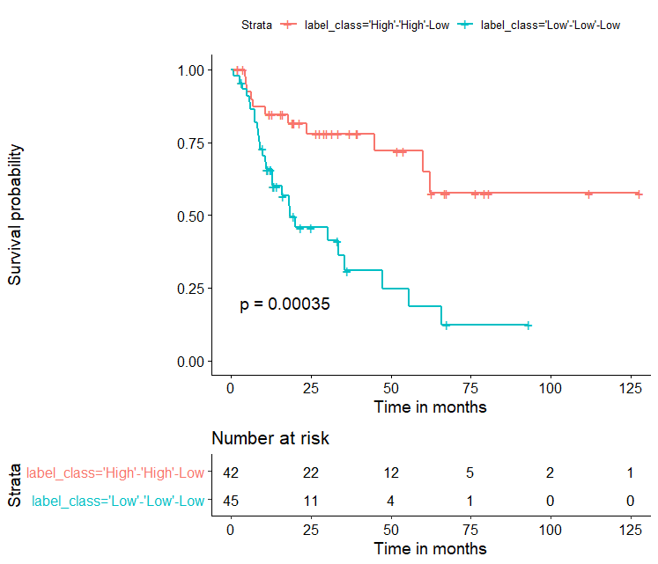

The following is the figure:

High-High-Low vs others

Where others include: High-High-High, High-Low-High, High-Low-Low

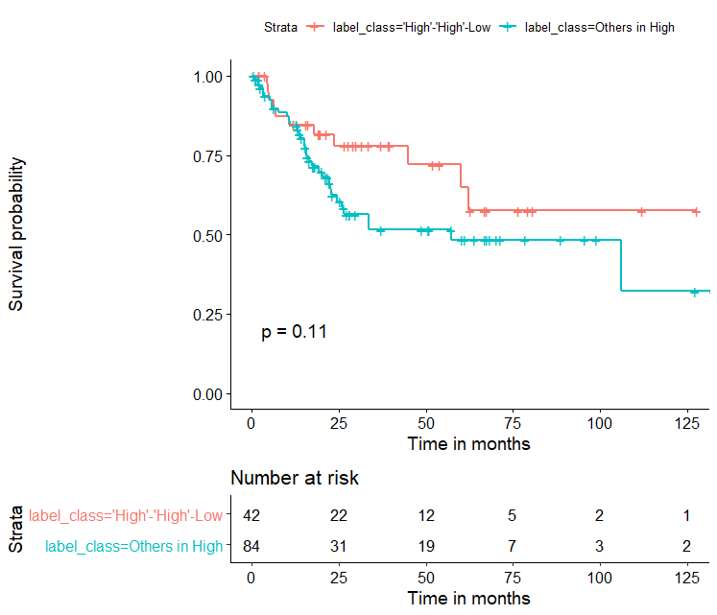

The following is the figure:

High-High-Low vs others in High vs Low TMB (WES ground truth)

Where others in High include: High-High-High, High-Low-High, High-Low-Low

**Note that: High-High-High -> first High: WES ground truth, second High: automatic prediction, third High: high entropy of TMB prediction map**

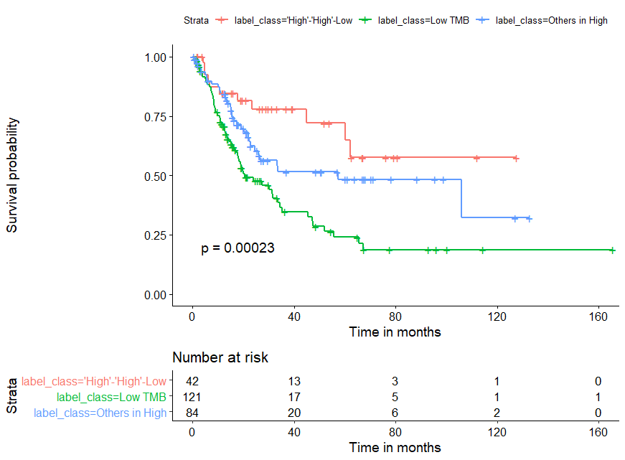

The following is the figure:

High-High-Low vs others in High vs Low-High-Low vs others in Low

Where others in High include: High-High-High, High-Low-High, High-Low-Low

Others in Low include: Low-High-High, Low-Low-High, Low-Low-Low

