In the following figures,

‘High’ indicates High TMB, - High indicates High Entropy (by 30%, 40%, 50%, 60% and 70%)

‘Low’ indicates Low TMB, - Low indicates Low Entropy

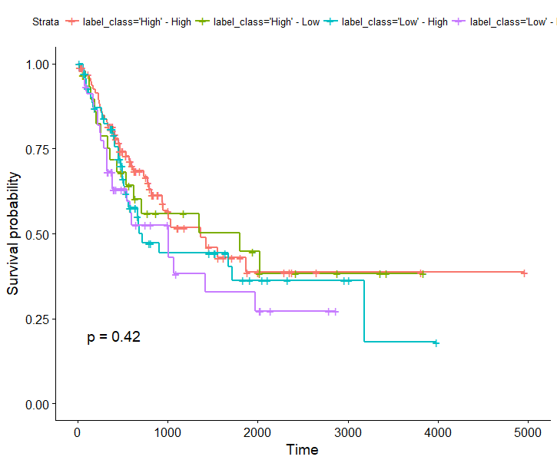

(Entropy threshold: 30%)

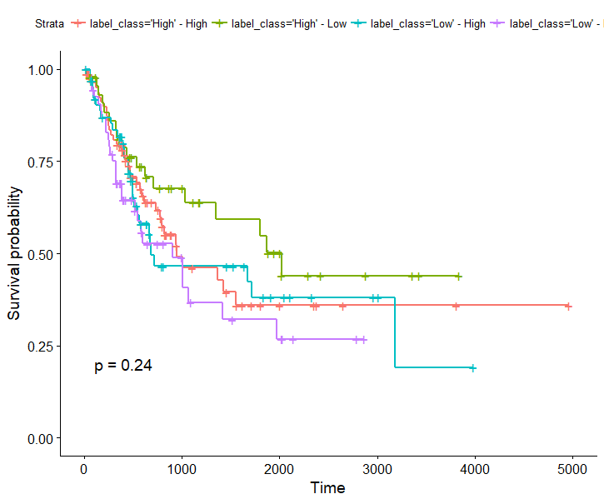

(Entropy threshold: 40%)

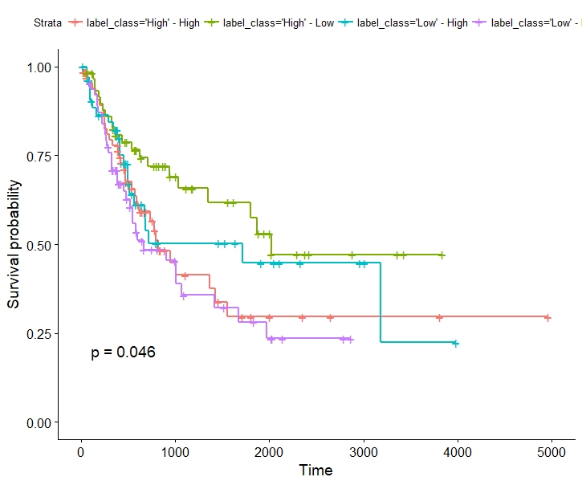(Entropy threshold: 50%)

**As expected: For High TMB, low entropy is good prognosis; For Low TMB, high entropy is good proganosis**

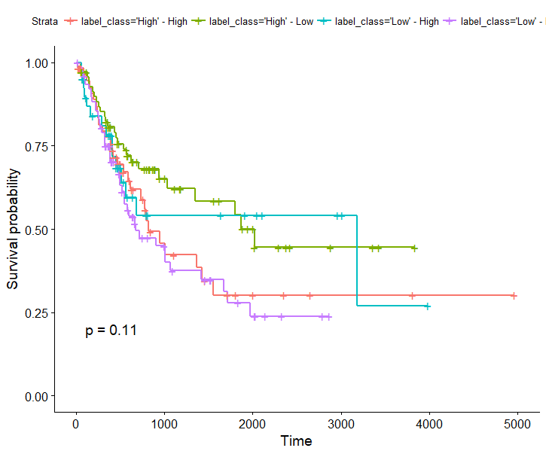

(Entropy threshold: 60%)

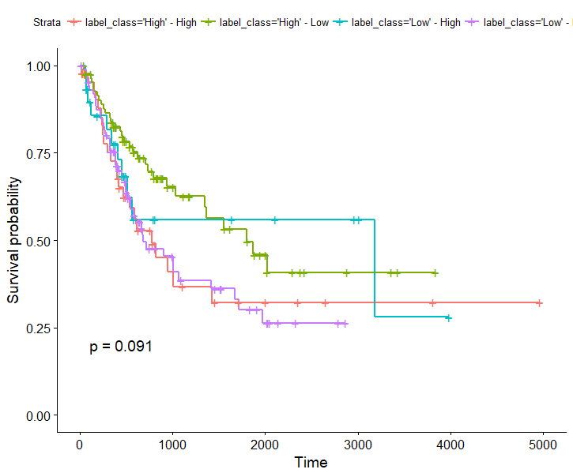

(Entropy threshold: 70%)

In the following figure, ‘High’ or ‘Low’ TMB are based on ground truth labels

High or Low Entropy is based on 50%

