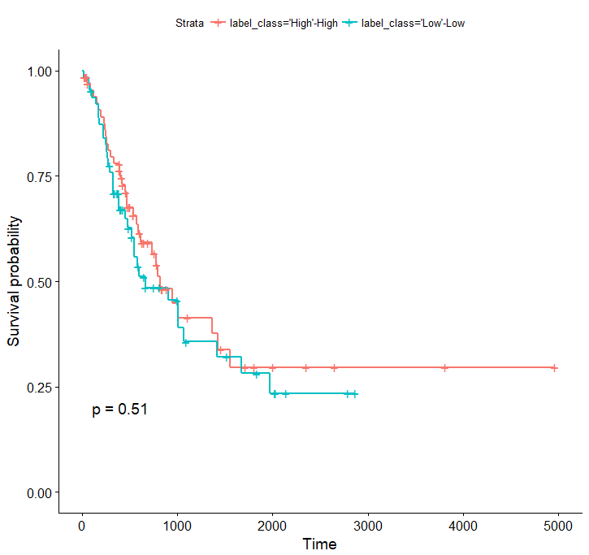

In this figure, High or low tmb is predicted using our method. High or low entropy is threshold by 50%.

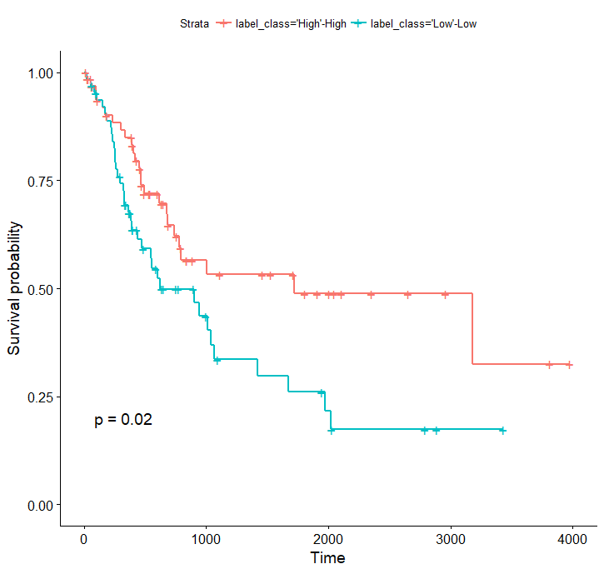

In this figure, high or low tmb is from ground truths. High or low entropy is threshold by 50%.