**Radio Astronomy Lab: Measuring the Rotation Curve of the Milky Way Galaxy**

Chris Lam, Francisco Mendez & Sarik Jeram

**1 Introduction**

Radio astronomy has become very useful for astronomers in the past century. It has allowed us to detect the cosmic microwave background, map different asteroids in our solar system, detect invisible jets coming out of galaxies, and even detect extrasolar planets around pulsars. In this report, we describe how we used a small radio antenna to measure neutral hydrogen in the Milky Way galaxy in order to characterize its rotation velocity.

**2 Procedure**

**2.1 Hardware Used**

The equipment we used to observe the Galactic Plane and collect the calibration data included a radio telescope dish, mount, tripod, and feed; a dipole antenna; a RealTek Software-Defined Radio (RTL-SDR) USB; a low-noise amplifier (LNA); a big-to-little coaxial adapter; a little-to-little male coaxial adapter; a coaxial cable; a 50-ohm terminator; and a laptop with the RTL-SDR-HI-OBSERVATIONS software already installed.

**2.2 Collecting Calibration Data**

In order to collect our calibration data, we used the RTL-SDR connected to the computer. Then, three 1 second darks and one 60 seconds dark frames were collected using the following setups: First, we connected a resistor to the RTL-SDR and collected the frames with and without the resistor. Finally, we connected the LNA filter into the setup, along with the resistor and collected the same amount of calibration frames with and without the resistor. The calibration data for each setup can be seen in Figure 1 for the 1 second dark frames. The spectra are slightly noisier with the resistor on and exhibit one absorption line, as opposed to three emission lines, with the LNA on.

A cleaner signal was obtained by performing a frequency switch. As explained in the lab instructions, the frequency switch was achieved by collecting data at two different frequencies separated by more than the line-width, but less than the received band-with. Then, the integration was taken for two consecutive observations, and finally the difference was taken between them. The frequency switch calibrated data can be seen in Figure 2. We use this FSW power for our observations in what follows.

**2.3 Data Collection**

The data collection was performed at the Campus Teaching Observatory (CTO). The antenna was set up by following the lab instructions; nothing different from those instructions was done. We used an Android Phone App called SkyPortal by Celestron in order to point the antenna to three different positions of the galactic plane. The Altitude and Azimuth were provided by the App and are listed on Table 1, along with the observing time, galactic coordinates, and exposure time.

|  |  |  |  |  |  |  |  |
| --- | --- | --- | --- | --- | --- | --- | --- |
| Name | Observation time | Altitude | Azimuth | Galactic longitude | Galactic latitude | T_int (s) | Notes |
| Science_loc1 | 1:37 | 27 deg 14’ | 163 deg 15’ | –1°22' | –1°50' | 60 |  |
| Science_loc2 | 1:46 | 44 deg 17’ | 142 deg 54’ | +21°52' | +2°02' | 60 |  |
| Science_loc3 | 1:52 | 49 deg 26’ | 138 deg 43’ | +26°53' | +5°21' | 60 |  |

Table 1. Provides the observation positions of the galactic plane at three different locations, and their corresponding parameters. T_int is the integration time in seconds.

In order to calibrate the science data, we subtracted the dark frames of 60 seconds that had the LNA filter on and the resistor off. We decided to use this frame because that particular dark fame showed the least amount of noise. This dark-subtracted data was plotted in Figures 3, 5, and 7 and show two main features: an emission and an absorption line. The emission line corresponds with the HI line from the Galactic center, but the absorption line may be a case of radio frequency interference (RFI), such as water vapor in the atmosphere.

**2.4 Measuring The Rotation Velocity of the Galaxy**

From the reduced scientific data, we isolated the HI emission line from the rest of the spectrum and fitted a Gaussian to it to calculate its centroid frequency (Figure 4). We plugged this frequency into the Doppler formula (Equations 1 and 2) in order to calculate the rotation velocity of the galaxy. Since the observed frequency is less than the vacuum frequency of the HI line, we know the emission line has been redshifted, which informed our choice of signs for the Doppler formula. We repeated this process for the other two observations of the HI emission line (Figures 6 and 8). We considered two possible scenarios in calculating the rotation velocity. In the first case, we considered the velocity based on the frame of an observer at rest:

Equation 1

$v_{rr }=\frac{c}{f}×(f_{0 }-f)$

Where $c$ is the speed of light, $f$ is the detected centroid frequency measured from the Gaussian fit, and $f_{0 }$ is the frequency of the HI line in vacuum. In the second scenario, we assume a moving observer frame. In that case, the Doppler equation for rotation velocity becomes:

Equation 2

$$v_{rm }=\frac{f_{0}c +f_{0}v_{0}-fc}{f}$$

Where $v_{0}$ is the rotation of the observer (in our case, the Earth) around the Sun.

The uncertainties from the Gaussian fit were calculated as the standard deviation of the fit, divided by the square root of the number of data points used in the fit, $σ/\sqrt{N}$. The uncertainties of the rotation velocities were computed by propagating the uncertainty from the Gaussian fit through Equation 1 (Equation 3) at the rest frame:

Equation 3

$$σ_{v_{rr}}=\sqrt{\frac{c^{2}{f_{0}}^{2}{σ_{f}}^{2}}{f^{4}}}$$

Where $σ_{f}$ is the uncertainty on the calculated frequency of the HI line. Then, the uncertainty for the rotation velocity of the galaxy at the moving observer’s frame is (Equation 4; the formatting changed when downloading from Google Docs – it is the second power of $σ_{f}$; that is, 2 should be in the box):

Equation 4

$$σ_{v_{rm}}=\sqrt{\frac{{f_{0}}^{2}{{σ_{f}}^{}}^{2}(c+v_{0})^{2}}{f^{4}}}$$

These measured velocities and uncertainties can be seen in Table 3. Finally, we calculated the amplitude and the full width half maximum (FWHM) of the Gaussian fit. The FWHM was calculated using the following formula (Equation 5):

Equation 5

$$FWHM=2\sqrt{2 ln 2} σ$$

Where $σ$ is the standard deviation from the Gaussian fit. These results are reported in Table 2.

**3 Results Data Analysis**

As we can see in Figure 1, LNA-on spectra yield what appear to be absorption lines, while LNA-off spectra yield emission lines. Also, resistor-off spectra seem to be less noisy than their resistor-on counterparts. Then, we can see in Figure 2 that the frequency switched spectra look like residuals of the non-frequency switched spectra.

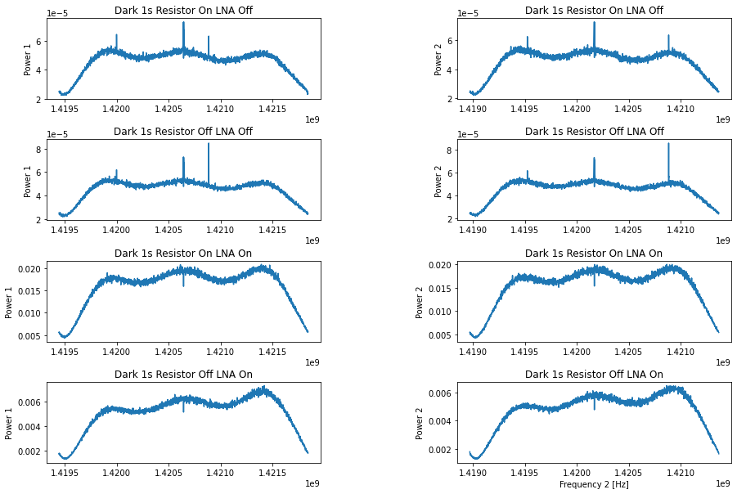

Figure 1: Data calibration darks, showing different combinations of Power 1 and 2, Resistor On and Off, and LNA On and Off. The spectra are a little noisier with the resistor on and exhibit one absorption line, as opposed to three emission lines, with the LNA on.

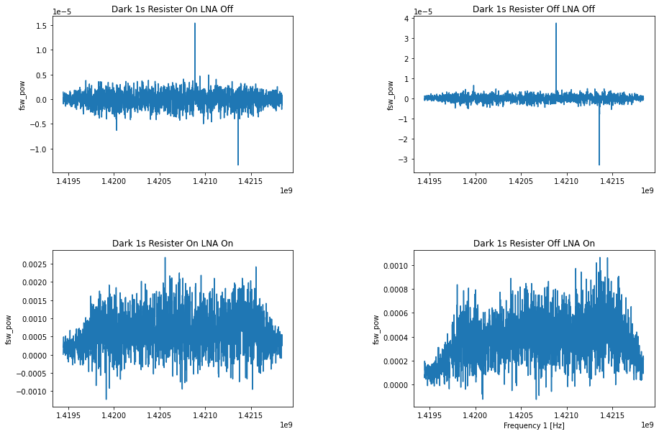

Figure 2: Frequency switching wavelength power vs Frequency 1

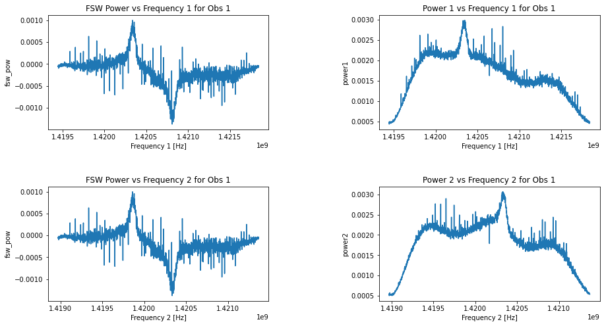

Figure 3: Frequency-power plots for Observation 1. Upper left: Frequency switched power versus Frequency 1. Upper right: Power 1 versus Frequency 1.Lower left: FSW power versus Frequency 2. Lower right: Power 2 versus Frequency 2

In Figure 3, by using the frequency switched data for the y-axis, we were able to detect a little emission line between 1.4200 and 1.4205 GHz. We believe this is the HI line we are interested in analyzing. As explained in Section 2.4, we isolated this emission line and fitted a Gausian curve to it to measure its centroid frequency value.

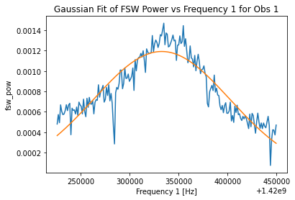

Figure 4: Gaussian fit of the HI emission line for first observation.

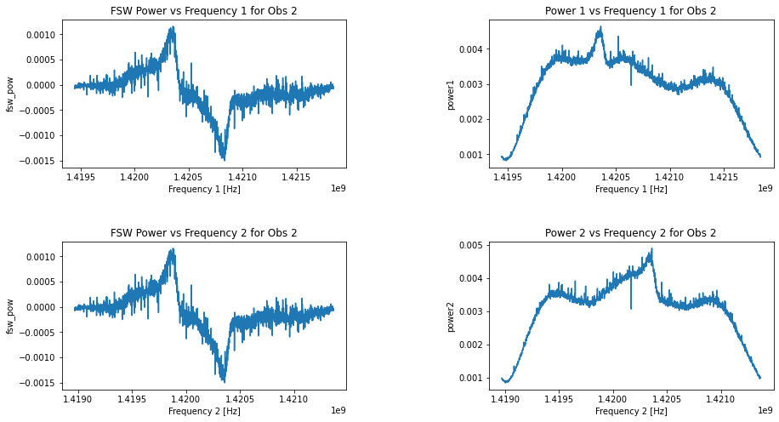

Figure 5: Frequency-power plots for Observation 2. Upper left: Frequency switched power versus Frequency 1. Upper right: Power 1 versus Frequency 1.Lower left: FSW power versus Frequency 2. Lower right: Power 2 versus Frequency 2

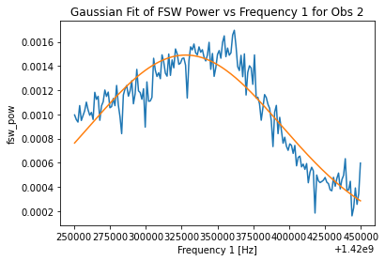

Figure 6: Gaussian fit of the HI emission line for second observation.

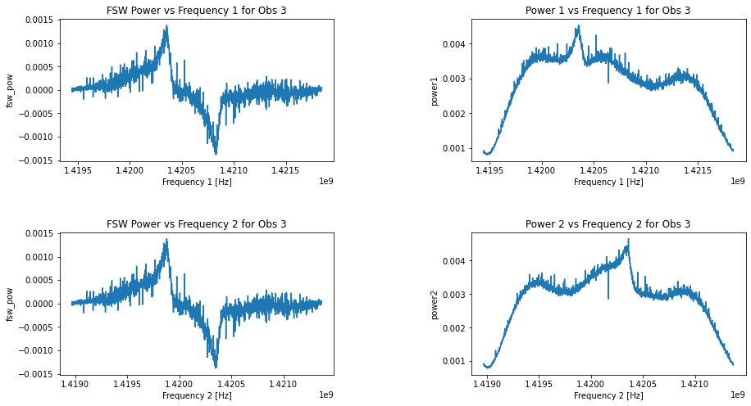

Figure 7: Frequency-power plots for Observation 3. Upper left: Frequency switched power versus Frequency 1. Upper right: Power 1 versus Frequency 1.Lower left: FSW power versus Frequency 2. Lower right: Power 2 versus Frequency 2

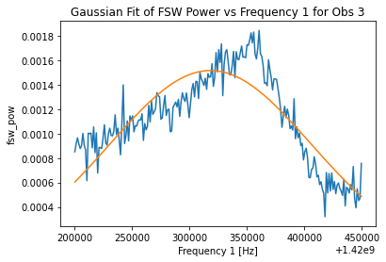

Figure 8: Gaussian fit of the HI emission line for third observation.

|  |  |  |  |
| --- | --- | --- | --- |
| **Observation ID** | **Fitted mean (GHz)** | **Amplitude** | **FWHM (GHz)** |
| 1 | 1.420333 +/- 0.000005 | 0.0012 | 0.000164 |
| 2 | 1.420328 +/- 0.000005 | 0.0015 | 0.000158 |
| 3 | 1.420318 +/- 0.000006 | 0.0015 | 0.000205 |

Table 2: Fitted mean with uncertainty, amplitude, and FWHM for the Gaussian fit of each observed line.

|  |  |  |  |  |
| --- | --- | --- | --- | --- |
| **Observation ID** | **Gal. Longitude** | **Gal. Latitude** | **HI Velocity with rest observer (km/s)** | **HI Velocity with moving observer (km/s)** |
| 1 | –1°22' | –1°50' | 15 +/- 1 | 16 +/- 1 |
| 2 | +21°52' | +2°02' | 16 +/- 1 | 17 +/- 1 |
| 3 | +26°53' | +5°21' | 18 +/- 1 | 19 +/- 1 |

Table 3: Galactic longitude and latitude of the three observations, along with their measured HI velocities.

**4 Error Analysis**

While fitting a Gaussian curve to measure the centroid frequency, we noticed that the fits were not as good for observations 2 and 3. The non-Gaussianity of these observations shifted the fitted curve from the true peak of the emission HI line. As a result, we might have a misinterpretation of the results of what the exact rotation of the galaxy is. Another error contribution that we might have encountered has to do with our measurements of uncertainties. While we used other variables other than the measured frequency (for which we had uncertainties), including the speed of light, the frequency of the line in vacuum, and the rotation of the Earth around the Sun, we did not account for the uncertainties of these quantities because the literature reports different values and we did not feel confident about picking a random value from there. Also, their contributions are very small because these are well-constrained values. Therefore, we may be underestimating the uncertainties as well.

**5 Conclusion**

We have reported on our use of a small radio antenna telescope to detect HI emission lines and use their velocities to measure the rotation velocity of the Milky Way. From our dark calibration, we decided to use the 1s LNA on, resistor off dark frame to dark-subtract our three science frames. The observed spectra show one absorption line (which we presume to be RFI from water in the atmosphere) and one emission line (which we presume to be the HI line). We fit a Gaussian to the line in each of our three observations, finding its amplitude, FWHM, and mean, which we take to be the line’s frequency. Comparing it to the vacuum frequency of HI, we use the Doppler formula to calculate the velocity of the line, which we find to be on the order of +10 km/s, indicating that the parts of the Galactic center we observed were moving away from us. This is one order of magnitude smaller than values found online, and we attribute this discrepancy to less-than-ideal observing conditions, such as high humidity. In the future, additional observations can be made during better weather conditions, and more flexible models could be used to fit the emission line.

**Appendix (Data Packaging and Delivery)**

Please see the notebook in <https://github.com/cl3425/ast6725-radio-lab> for the code and figures associated with this report.