

VOCABUILDER – A tool for learning foreign languages

Cleber Luis Mendes Goncalves

Bachelor’s Thesis
DP in Business Information
2008

Authors  Cleber Luis Mendes Goncalves | Group
The title of your thesis  Vocabuilder – A tool for learning foreign languages | Number of pages and appendices  20 + 1
Supervisors
Jukka Juslin
Vocabuilder is a mobile phone application, written in java, which aims to help on language studies by facilitating vocabulary learning.

The application follows the concept of electronic ‘Flash Cards’ in which vocabulary learning is attained through spaced study and repetition.

There are a few well know and established implementations of electronic flashcards but they are web based and therefore not available for commodity offline study. Printing the flashcards is possible but it is not ecologically friendly and involves a fair amount of artesian work, therefore justifying the creation of a mobile based version.

The objective of this project is to improve on the existing prototype application, increasing performance, usability and convenience for use as a mobile study companion. Performance improvements are needed as the sheer amount of flash cards that accompany the application lengthens loading and saving times. The amount of cards also calls for usability improvements as a very large number of cards to study makes learning difficult if not properly managed. Improving the convenience of use of the application by allowing the saving of partially studied sets, re-study a finished set, loading alternate sets, viewing sets randomly or sequentially and creating usage statistics all contribute to make the application a highly competitive substitute to paper based flash cards.

Since the application is open-source, an incremental short-cycled release approach was used in the development process, much like the popular ‘agile’ methodologies. New versions where released to the public as soon as new features became available; new features where prioritized according to the perceived benefit to the end user and feedback received from via email or bug reports. A comprehensive set of unit tests was created in order to support an extensive re-factoring of the model and controller layers which was required by the performance and usability improvements.

The original scope of the project included the creation of a companion website to serve as front-end for custom flash card creation. Due to the limited maximum duration of 400 hours for this project work, the scope was later reduced to only include the improvements to the existing mobile phone application. Creation of the website and connection of it to the application remains the subject of future development.

Key words
Language vocabulary learning mobile flashcard java

Table of contents

1 Introduction 3
2 Development process 5
2.1 Key concepts 5
2.2 Project plan 5
2.2.1 Scope 5
2.3 Setting up the development environment 6
2.3.1 Eclipse 6
2.3.2 J2ME and WTK 6
2.3.3 Subversion 6
2.3.4 EclipseME 7
2.3.5 J2MEUnit 7
3 Implementation 7
3.1 Changes in the RMS file storage format 7
3.2 Performance improvements in the RMS layer 12
3.3 Show both question and answer in the same ‘card side’ after turning 17
3.4 “OutOfMemory” exceptions when loading or saving long sets of cards 18
3.5 Exit by pressing the ‘hang up’ button causes lost of study state 18
3.6 Allow management of multiple sets of cards in the application 19
3.7 Show cards randomly 19
3.8 Show the least viewed cards first 20
3.9 Changes in the TXT file format 20
3.10 Properties 21
4 Installing the application to a mobile phone 21
5 User Guide 22
5.1 Summary and conclusion 23
5.2 Bibliography 23
5.2.1 Source criticism 23
5.2.2 References 23
6 Attachments 25
Bibliography 23
Appendices
Appendix 1. The structure of the thesis report 26

Introduction
Vocabuilder is a free open-source mobile phone application, written in java, which aims to help on language studies by facilitating vocabulary learning.

In an increasingly multi-cultural world, the ability to communicate in foreign languages is not viewed anymore as an advantage, but as a requirement of modern life.

The application is inspired by the concept of electronic ‘Flash Cards’ in which vocabulary learning is attained through spaced study and repetition. The user is show a ‘flash card’ containing a word in one language and challenged to recall it in another language. If the user successfully recalls the word the word is removed from the list of words to learn. If the doesn’t recall it, the word is saved for later studying and displayed repeatedly until the user learns it. (http://en.wikipedia.org; http://en.wikibooks.org.)

There are a few well know and established implementations of electronic flashcards but they are web based and therefore not available for commodity offline study. Printing the flashcards is possible but it is not ecologically friendly and involves a fair amount of artesian work, therefore justifying the creation of a mobile based version. (http://www.flashcardexchange.com; http://www.studystack.com)

The objective of this project is to improve on the existing prototype application, release 1.3 of which is the first publicly available version, increasing performance, usability and convenience for use as mobile study companion. (http://code.google.com/p/vocabuilder)

A secondary objective is to facilitate the creation of custom lists of flash cards by the end user.

Performance improvements are needed as the sheer amount of flash cards that accompany the application lengthens loading and saving times. The amount of cards also calls for usability improvements as a very large number of cards to study makes learning difficult if not properly managed. Improving the convenience of use of the application by allowing the saving of partially studied sets, re-study a finished set, loading alternate sets, viewing sets randomly or sequentially and creating usage statistics all contribute to make the application a highly competitive substitute to paper based flash cards.

Since the application is open-source, an incremental short-cycled release approach was used in the development process, much like the popular ‘agile’ methodologies. New versions where released to the public as soon as new features became available; new features where prioritized according to the perceived benefit to the end user and feedback received from via email or bug reports. A comprehensive set of unit tests was created in order to support an extensive re-factoring of the model and controller layers which was required by the performance and usability improvements. (Subramanian, V., Hunt, A. 2008; http://www.infoq.com.)

The work was structured so to first create a set of unit test to validate the changes done in the code against the required functionality, according to the concepts of Test Driven Development (TDD).
Following, the performance requirements where addressed, since those involved the greatest changes on the existing architecture. Those required mostly changes to the model and controller layers of the application.

The next step was to improve the usability by adding several new features and changing the user interface. The changes at this point involved mainly the controller and view layers. Unit tests where created for the controller layer but not for the view layer since the transfer of business code from the view layer to the controller layer simplified the former layer making the creating of a set of test cases for it dispensable. (http://blog.briandicroce.com)

Development process

Key concepts

J2ME – Java mobile edition
Electronic Flashcard – electronic representation of a business card containing in one side a question and in the other the answer for it.
Set Of Cards – a collection of correlated electronic flashcards.
Metadata – Data about the data itself
Study state – which cards are marked ‘done’ or wrong
Study session – A single use of the application in which cards are marked ‘done’ or ‘wrong’
TDD – Test Driven Development, also know as Test First.
Agile – Software development methodology that aims to improve the success rate of software development projects through the use of shorter development cycles, constant user iteration, TDD, re-factoring and other techniques.
MVC – Model View Controller
Open Source – Software whose source code is freely available and can be modified and redistributed freely.
Eclipse – Open source integrated development environment (IDE)
Unit test – Automated test of a unit of code like a class or method
Wireless toolkit – Basic set of tools and device profiles needed for J2ME development
RMS - Record Management System, the internal persistent storage in J2ME enabled devices.
XML – Extensible Markup Language
JSON – JavaScript Object Notation
Groovy – Java compatible scripting language, applications written in Groovy can use directly the Java API and be compiled into bytecode that may be run in the Java virtual machine.

Project plan

Scope
The main objective of the project is to improve the existing application; the following points will be improved:
- Improve the speed of the RMS access mechanism for loading and saving
- Separate metadata about the set of cards from card data in RMS storage
- Forcing the application exit by pressing the ‘hang up’ button causes lost of study state
- “OutOfMemory” exceptions occur when loading or saving very long lists of words in certain handsets
- Allow management of multiple sets of cards in the application
- Improve the application exit algorithm and user interface
- In the ‘answer page’ show both the question and answer together
- Show cards randomly
- Show the least viewed cards first

The original scope presented in the thesis topic proposal included also the creation of a companion website to serve as front-end for custom flash card creation. Due to the limited maximum duration of 400 hours for this project work, the scope was later reduced to only include the above described improvements to the existing mobile phone application. Creation of a web front end and connection of it to the application remains the subject of future development.

Setting up the development environment
Vocabuilder being an open-source effort, the tools used to develop it were also selected among the open source offers.
The application’s sources and documentation are hosted at Google Code:
http://code.google.com/p/vocabuilder/

Eclipse
Eclipse is a free and open-source IDE. It facilitates the job of programming by assisting the developer.
Vocabuilder was developed using it; an Eclipse project is included with the Vocabuilder sources downloadable from the version control. Eclipse can be obtained at:
http://www.eclipse.org

J2ME and WTK
Development for mobile devices requires Sun's Wireless tool Kit (WTK) or similar; the wireless toolkit includes phone profiles and the J2ME version of java:
http://java.sun.com/javame/downloads/index.jsp

Subversion
The application sources are freely available and live in Google code’s subversion repository at:
http://code.google.com/p/vocabuilder/source/checkout
In order to download it a subversion client is needed. For windows, the recommended client is Tortoise:
http://tortoisesvn.net/downloads

EclipseME
Eclipse and Sun’s WTK are separated and independent applications. In order to make the integration of both smooth we use EclipseME. It is not strictly needed but it simplifies the job of compiling, pre-verifying and packaging the application immensely.
http://sourceforge.net/project/showfiles.php?group_id=86829

J2MEUnit
Unit testing gives developers confidence and freedom to do deep changes in the application by allowing the validation of the application’s new and existing functionality against automated tests.
Due to limitations in J2ME it is not possible to use the original Junit framework and unit testing is done using J2MEunit:
http://j2meunit.sourceforge.net/
The libraries needed by J2MEunit are included in the project and the developer doesn’t need to install anything in order to use it. The link above is provided solely as a reference.

Implementation

Changes in the RMS file storage format

In the original version of the application, metadata about the set of cards was saved to all records in RMS, together with card data.
That approach had various shortcomings
- The same metadata was repeated across the whole record store
- Used more space
- Updating a single record was not possible as the set metadata would need a update in all records

Additionally, that was highly inefficient for parsing the data back. Data from the set was read all the time, even when it was not needed, since it is not possible to skip a part of the record when reading from RMS.

Table X (###TODO table number). Original file format; note that the set metadata is mixed with card data
title | setIsDone | totalTime | side1title | side1text | side2title | side2text | cardIsDone | tip | totalOfDisplayedCards | setLastTimeViewed | setLastTimeMarkedDone | setMarkedDoneCounter | cardViewedCounter | cardMarkedDoneCounter | cardLastTimeViewed | cardLastTimeMarkedDone
String | boolean | int | String | String | String | String | boolean | String | int | long | long | int | int | int | long | long

The table shows the original file format, the first row shows the data that was being saved and the order it had in the record store, the second row is not part of the file, it only shows the java type of each of the fields stored in RMS.
The set metadata (in bold) was scattered within the record and duplicated in every record.

In order to solve this, a new format for storing the metadata should be created.
Since I want to keep using the ‘DataInputStream’ and ‘DataOutputStream’ facilities to read and write data to RMS, I could either create a proprietary fixed file format for the metadata in one of the records or store a XML or JSON version of the metadata in a String, also in one of the records that would be dedicated only for that.

Generating a XML or JSON seems too complex for the current needs; since the file doesn’t need to be transferred anywhere, creating a parser would be too much overhead. Additionally the file would become considerably bigger due to the XML or JSON notation than it would be in a proprietary fixed format file.

Table (###TODO table #). New proprietary fixed file format for the metadata
setOfCardsTitle | setOfCardsIsDone | setOfCardsStudyTime | totalCardsDisplayed | lastTimeSetViewed | lastTimeSetMarkedDone | markedDoneSetCounter
String | boolean | long | int | long | long | int

The metadata is stored in the second record in order to allow for the storage of a 'file format version' metadata in the first record to maintain backwards compatibility in case we need to change the file format again.

Table (##TODO table #). The format for the metadata to be stored in the first record.

fileFormatVersion
int

If the file format changes once again, future versions of the parsing code can read the file format before doing anything else and call the new or older versions of the parsing algorithm accordingly.

Table (TODO TABLE#). Format of the flashcard data to be stored in the 3rd
cardSideOneTitle | cardSideOneText | cardSideTwoTitle | cardSideTwoText | cardIsDone | cardTip | cardViewedCounter | cardMarkedDoneCounter | cardLastTimeViewed | cardLastTimeMarkedDone
String | String | String | String | boolean | String | int | int | long | long

All the flashcard data is stored in the 3rd record. The flashcards are stored and recovered sequentially.

Table X (TODO #). The new RMS file storage format
1st record | File format version (currently version 4)
2nd record | Set meta data (see table X TODO)
3rd record | card data (see table above TODO)

The new RMS storage format included the file format version in the first record, the set metadata in the second record and in the third record all card data.

To upgrade the file format, the following has to be done:

- Add one new field called 'cardId' to the value object FlashCardVO
- Check if the recordStore being read has the file format version number in the first record and if so, check that the number is the same as the current file format.
- If there is no version number or the version is minor than the current version, we need to upgrade the file format. To do that, we first read using the old method and then write the store back at the end of the session in the new format.
- Although the current file format is version 4, versions 1 and 3 of the file format where not publicly available, so we only need to support the upgrade of version 2.
- As a consequence, the application will have 2 active file reading algorithms and 1 file writing.

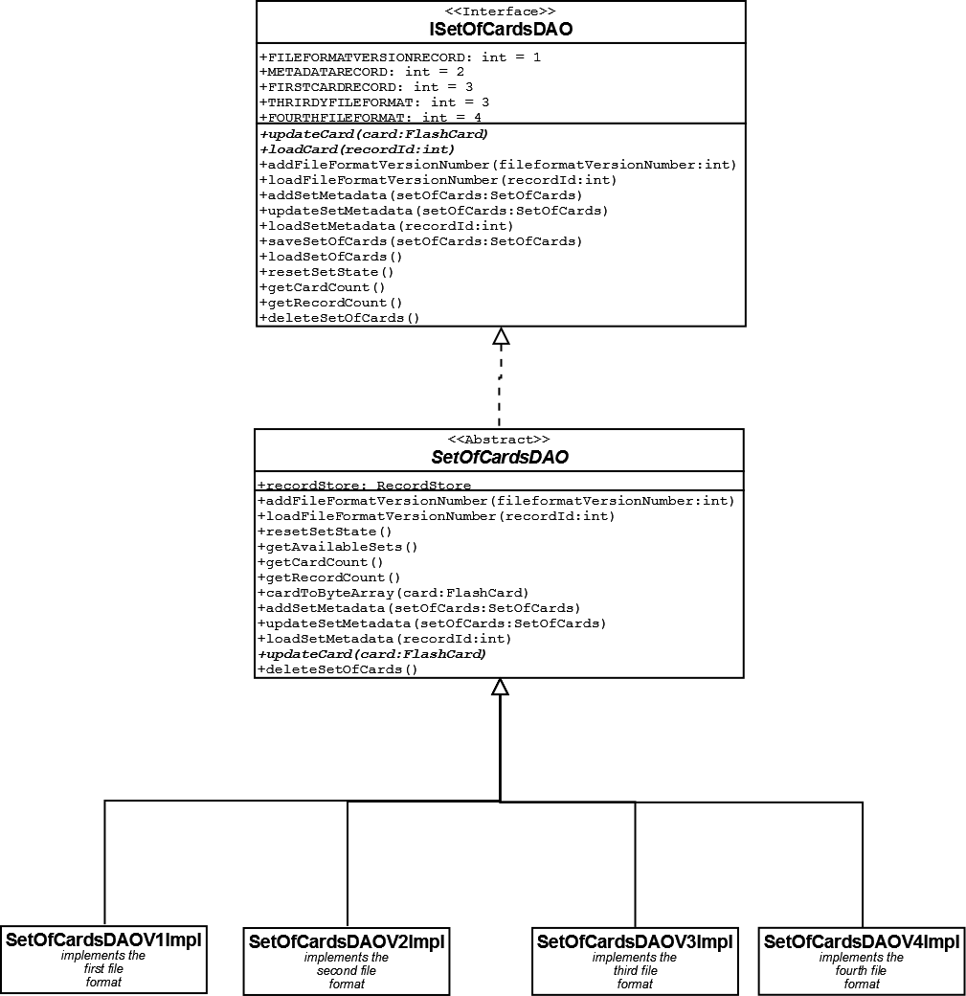
Figure X. Data Access Object class hierarchy

In order to shield the View and Controller layer from changes in the Model layers that are still likely to occur as the application evolves an interface was created. Access to DAO classes that implement the low level RMS operations is done via the interface so if the implementation changes, the classes that use then doesn’t have to be chaged. (TODO add reference).
Also, to further improve the design and avoid code duplication, an abstract class was created between the interface and the different RMS file format implementations to hold the functionality common to them. Each one of the concrete classes extends the abstract ‘SetOfCardsDAO’ class and as a consequence, implements the interface ‘ISetOfCardsDAO’.
If there are operations declared in the interface that doesn’t apply to a certain version of the concrete classes, the implementation for it simply thrown an ‘OperationNotSupported’ exception.

(TODO)- Mention the design patterns that apply (Interface, factory, single town, at least)

Performance improvements in the RMS layer

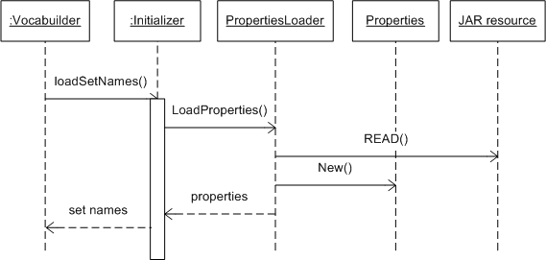
Figure 1. Retrieving the list of sets available for studying

The above diagram shows the process of retrieving the names of all the set of cards that can be loaded for studying.

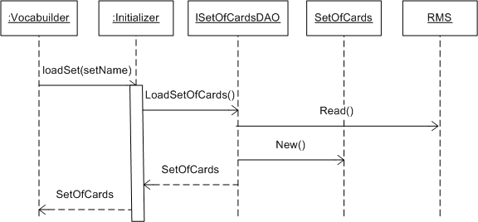
Figure 2. Loading a set of cards from RMS

These sequence diagrams shows the classes and operations involved in the process of loading a set of cards from RMS storage.

The ‘Load Set’ operation, among with the ‘Save Set’ and ‘Load Card’ operations, when run in a real handset took longer than the maximum accepted time. This had a serious effect in the application’s usability, especially in the case of the ‘Save Set’ operation, which was executed as part of the application’s exit procedure.
This lengthy saving operation gave users the impression that the application had crashed during the exit, originating several bug reports.
While the saving operation never crashed and would ultimately finish executing after some time finally letting the application exit, the performance was far from ideal.

Table 1. Original performance of key RMS operations
Operation | Simulator | Nokia E50 | Target performance
Load Set | 17s | 8s | < 5s
Save Set | 6s | 51s | < 5s
Load Card | 15ms | 142ms | < 100ms
Get record count | 0ms | 1ms | < 100ms
Reset state | 0ms | 457ms | < 1s
Load set metadata | 31ms | 140ms | < 500 ms

This performance was verified by creating automated unit tests that exercised and recorded the execution time of the problematic methods.
The tests used a set of cards that contained 1827 flashcards.
The simulator results are better than the results obtained from the real handset, but the performance issue is still noticeable there.

Since the performance issue was in the RMS layer and it was clear that access to the comparatively slower storage media was the problem, the first tentative to improve it focused on spreading the use of RMS access during the whole study session.

Instead of reading the whole set of cards during application startup and saving it at exit time, only one card would be read and updated at a time, thus making the saving operation lighter and distributed during the whole time the user is interacting with the application. That way the loading and exiting processes could be made instantaneous.
Table 2. Load and update a card instead of the whole set of cards
Operation | Simulator | Nokia E50
Load card | 15ms | 144ms
Update card | 0ms | 31ms
Add card | 0ms | 131ms
Get record count | 0ms | 1ms
Add file Format Version | 0ms | 131ms
Load file format version | 15ms | 135ms
Load set metadata | 15ms | 153ms
Add set metadata | 0ms | 131ms
Update set metadata | 0ms | 31ms
Load set (expanded metadata) | 17s | 3s

While changing the load and save operations to work on cards instead of working on sets of cards apparently would solve the performance issue, as demonstrated by a proof of concept implementation, it would require extensive changes on the view and controller layers of the application that relied on having the whole set loaded in memory.
This problem could be partially mitigated by expanding the metadata about the set of cards saved in RMS.
This metadata expansion was implemented and kept in use (see section ###TODO) since it offered several advantages in relation to the previous approach, although the ‘atomic approach for loading and updating’ the flash cards was disfavored to an alternative approach that didn’t require changes in the view and controller layer, described bellow.

Table 3. Loading and saving the set of cards to a single record
Operation | Simulator | Nokia E50
Load set (only one record) | 641ms | 523ms
Save Set (only one record) | 156ms | 1s
Load set metadata | 32ms | 162ms
Add metadata | 0ms | 131ms
Update metadata | 0ms | 31ms
Load file format version | 16ms | 141ms
Add file Format Version | 16ms | 131ms
Reset state | 0ms | 457ms
Get record count | 0ms | 1ms
Load card (only one record) | 0ms | 134ms
Add card (only one record) | 0ms | 140ms

The best solution found was to save the whole data into a single record, improving the performance for the original saving operation in average 75 times. As it turns out, creating new records in RMS for each card in the set was a very time consuming operation.
The loading operation times also improved, although not as dramatically as the saving operation times.
The expanded metadata thought originally for the ‘load/update a single card’ approach, proved to be also useful for this approach, since some data about the set of cards that could be indirectly obtained from the record store, like the number of records (cards) was no longer available.

To test the different possible approaches, proof of concept implementations where created, they consisted in a new RMS access class and Junit tests that would simulate the real application uses of this class. This led to several improvements on the implementation in order to diminish the code repetition and improve maintainability.
One of the improvements consisted in removing the code responsible of creating a card from the load routine and placing it inside a subroutine that was called by that.

This practice, very common and recommended in regular Java applications proved to be extremely slow in the J2ME implementation as show in the table bellow.

Table 3. Card creation inside the load routine becomes a method
Operation | Simulator | Nokia E50  card creation in own method | Nokia E50  card creation inside load method
Load Set (original) | 22s | 300s | 8s
Load set (expanded metadata) | 28s | 884s | 3s
Load set (only one record) | 4s | 297s | 523ms

As we can see by the results, apparently switching the processing from a method to another in J2ME takes a lot of time.

Before giving up on having the ‘create a card’ code as a routing, an attempt to improve its performance was made by changing some of the key methods used in the loading process to be static. The idea was to save time by having they already loaded to memory when the application started.

Table 4. Load Set, load card and load set metadata made static
Operation | Simulator | Nokia E50
Load (original) | 23s | 239s
Load Card (original) | 15ms | 117ms
Load set metadata (original) | 31ms | 140ms
Load set (new file format) | 33s | 760s
Load card (new file format) | 15ms | 123ms
Load set metadata | 32ms | 162ms
Load set (from single record) | 4s | 237s
Load card (from single record) | 0ms | 134ms

Making the methods static didn't improve the performance significantly.

Because of that, this improvement had to be undone and the card creating code reintegrated as part of the load set method.

_________________________________________

Show both question and answer in the same ‘card side’ after turning
Two of the users of the application suggested that it would help the memorization if both the ‘question’ and the ‘answer’ (text from side 1 and side 2) where show at the same time in the ‘answer’ side of the card.
Specifically, he was a user of the Finnish<->English version of the application and wanted that after 'turning', both the Finnish word and the English translation where show in the page.
While it represented a big improvement on the usability of the application, the change necessary to do that was trivial since both sides of the card where already available in the View layer inside a “FlashCard” value object; All that was needed was to create a new label in the user interface class and display it when the card was turned.

That change was implemented in release 1.4 of the application.

“OutOfMemory” exceptions when loading or saving long sets of cards

In certain handsets the very long sets of cars that currently accompany the application (like the Portuguese <-> English set, with 9634 cards) cannot be loaded without risking an “OutOfMemoryException”.
This is mainly due to the very limited amount of memory on the handsets and as such cannot be easily overcome.
To fix that, two approaches are possible:
- Instead of loading the whole set of cards to memory, load a subset of it or a single card
- Break the long sets in smaller ones that can fit into memory and allow the user to load and unload sets at will
To implement the first option would require deep changes in all the layers of the application and since the use of very long sets of cards is atypical since they are difficult to be learnt (one can never finish a set of cards with 9000+ cards).
The second option has the advantage of not requiring changes in the other application layers and adding a new feature that is going to be necessary for future planned improvements (loading sets from internet).
Since it offered the lowest impact and highest benefit, the approach chosen was the second one; the sets where broken in smaller sets with around 350 cards each. The division was made using a utility written in Groovy for the purpose, the utility took into consideration the initial of the words in the set, making sure that all the words starting with a particular letter were placed in the same set.
Some of the lists had large amounts of repeated words in the translations; this was probably due to a bug in the software that generated the lists originally. To further save memory the utility also removed the duplicated translations while breaking the lists in smaller ones.
The utility used to do that is also available in the project’s website.
Version 1.6 of the application solves the issue by breaking the long lists down into shorter ones.

Exit by pressing the ‘hang up’ button causes lost of study state
Some users reported that when they forced the application to exit by pressing the ‘hang up’ button, the study state (cards studied, amount of correct and wrong, etc) is lost.
Some investigation revealed that two issues where at play:
- The application’s study state was being saved when showing the ‘statistics’ page.
- Saving the state was a very slow operation

When the user tried to exit the application the ‘statistics’ page was show while the state was saved in the background; Since saving could take several minutes, the user had the impression that the application had hanged up and eventually forced the exit, causing data loss.
This was resolved by improving the application saving mechanism (see ‘Performance improvements in the RMS layer’) and by moving the ‘save’ operation to the ‘destroyApp’ method, the last method that is always called by the exit procedure.

Allow management of multiple sets of cards in the application
The original version of the application only supported one list of cards that came built in. In order to improve the usability, solve memory constraints issues and create the framework needed for other planned features, we need to be able to load and unload lists at the user's criteria.
That way, the application can be used to study several languages or other subjects, in opposite to the current version that requires a new compilation for each language. With this all the user needs to do is load a new set of cards to study another language.
The changes made in the application’s Model layer for improving RMS performance, separating metadata from card data and solving the ‘OutOfMemory’ issues created the basis needed for this.
What was left was minor changes in the controller classes to allow for loading/unloading of the lists and create the user interface for managing the lists (load, unload, delete).

This was implemented in Release 1.6

Show cards randomly
The initial versions of the application where showing the cards in a set in the same order they where loaded. This was a problem for sets composed of ‘dictionary like’ lists of words since a user would first have to visualize dozens of words starting with ‘a’, then ‘b’ and so on. Every time the user started the application he was presented with the same cards, until he marked them as ‘correct’. Studying long sets of cards was very boring.
Showing cards in random order would allow the user to learn a more homogeneous vocabulary with words starting with any letter.
To implement that a few methods were created in the Controller layer that will return either a set of cards in the original order or a randomized set, depending on a configuration flag.
No changes were needed on the View or Model layers.

Show the least viewed cards first
When visualizing the cards in a set in either the sequential or random modes, some cards tend to be show several times while others are not show at all.
In sequential mode that is expected for large sets since the user will normally stop studying before all the cards in the set are visualized.
In random mode this is due to the way the ‘pseudo-random’ index is generated. With a large amount of hits, statistically all the indexes tend to have the same change of being displayed, but for smaller amounts of hits some numbers will be displayed more than others.
To overcome that, an ordering algorithm was created to display first the least viewed cards in a set.
The cards are first grouped by the amount of views, then if the ‘random’ flag is set they are randomized inside the groups and finally the groups are merged and returned in a single set with the least viewed cards first. The user interface simply display the cards in the set in sequential order since the randomizing and ordering already happened in the Controller layer.
Since part of the logic for generating the order of the cards to be show and detecting the end of the set was in the View layer, both the Controller and View layers had to be changed to implement this. All controlling logic is not in the controller layer, the View layer simply displays the data it receives.
Feature available since release 1.6

Changes in the TXT file format
The application ships with at least one set of cards built in. This set is a regular text file that is bundled in the application’s JAR file and upon first application startup is read to memory and saved to RMS at the end of the session. After that the set is always read from RMS in subsequent sessions.
The original file format for this text file was simply ‘question = answer’. E.g.:
I loved him. = Minä rakastin häntä.

In order to support different languages and multiple sets of cards, some metadata which previously was hard coded in the application needed to become part of the file. The following information was introduced in the top of the files:
#setName = name_of_the_set
#sideOneTitle = the_title_of_the_first_side
#sideTwoTitle = the_title_of_the_second_side

E.g.:
#setName = frases_en_fi
#sideOneTitle = ENG
#sideTwoTitle = FIN

Properties
To support multiple sets of cards, we must be able to display a list of the sets available to the user so he can choose what to load.
The sets can be available in a TXT resource that ships with the application or in both RMS and TXT resources.
When the application is started for the first time, the sets are only available in the TXT resources, when the user chooses to load one set, the set is automatically saved to RMS at the end of the study session and loaded from there from this point on.
This is necessary since the TXT resources are ready only and there is not way to ship the application with a set of cards recorded in RMS.
In order to be able to present the user a list of the sets available for studying, a new ‘properties’ file was created. This file ships with the application and contains a list of the default set of cards bundled in the application’s JAR in the format:

defaultset=setname.txt

E.g.:

defaultset=semanticprimitives.txt

At startup, the application reads these properties, generate a list of the ‘default’ sets, compare it with the list of sets available in RMS and display a ‘merged’ view to the user containing the set names only once. If the set is available in RMS the RMS name is show, if it is available only in TXT resources, then the TXT resource name is show.

Installing the application to a mobile phone
The easiest way to install the application is by downloading it to the mobile using the its browser. When the application finishes downloading, the phone’s application installer will start and install the application will be installed to the phone’s memory.
For example, to install Vocabuilder 1.7 English <-> Finnish, enter the following URL in your mobile phone's browser:
http://vocabuilder.googlecode.com/files/Vocabuilder17_fi_en.jar
Currently there are 13 different versions of the application supporting various languages. To install another language or version of it, just look at the link location in the ‘Downloads’ section of the site and load it in the mobile's browser.
To see the link location just hover your mouse pointer over the link, the address is show at the status bar in the bottom of your browser screen.

A second option for installing it is to copy the application's JAR file to the mobile and execute it; this will start the installation process.
To install Vocabuilder 1.7 English <-> Finnish this way:
- Download the JAR file to from the site to your computer.
- Transfer it to your mobile via USB, Bluetooth, IR, memory card or any other way
- Execute it

Supported handsets
Vocabuilder should work in any Java enabled phone; with a few exceptions, all modern phones are Java enabled.
It was tested and found to work in the following Nokia models:
- E50
- E70
- 5700 Music Express
- 2626
- N76
- 6630
- 9300i
- N81 8GB

User Guide
The application has a list of words with its translation in another language.
A combination of a word and its translation makes up an ‘electronic flash card'. The cards are displayed randomly; you can see a side of the card (containing a word or question), turn the card to see the answer and mark it as 'done' if you already know it or if you don't know it yet, mark it as 'wrong'.
Cards marked as 'done' are not displayed anymore until the set is finished, so that the user may focus on new or yet to memorize questions.
There is a 'statistics' screen showing the amount of cards you know, time spent studying, etc. You can get to that screen by pressing the 'stats' button while viewing a card.
When you mark all cards in a particular list as 'done' the application will ask the user if it should start over, so the whole set may be studied again.
The application saves its own state between sessions, making it suitable for studying even in very short periods like a trip by bus from home to work.

The default sets of cards
Most of the default sets of cards that ship with the application came from the wakefield.org website. (http://welcometowakefield.org.uk/translations/)
The original lists present in the website were machine-generated using a multi-language ‘English -> Esperanto -> ‘target language’ translator and according to the site maintainer are in the public domain.
Attachment 2 contains a full transcript of the email communications with the site maintainer regarding this.

Summary and conclusion
This project was successfully delivered 4 new versions of the application during the duration of the thesis work.
These versions addressed all of the main objectives for the work building a solid ground for future improvements.
The use of well know software development patterns like MVC, Interfaces, Abstraction, Factories and others improved the overall quality and maintainability of the application.
The adoption of agile development methods and the fact that the application is an open source effort contributed to a close interaction with the end users that resulted in sizeable improvements in the final quality of the product.
The application is now a stable and viable substitute for paper based virtual cards.
While gathering users for it was not the focus, a few efforts on divulgating the application amongst peers resulted in several hundreds of downloads of the various versions of it for different idioms.
The limited duration of the thesis didn’t allow time to create a website where a user can create his sets and link it make it available to download via the mobile application. This remains the subject of further improvements that will probably be taken on after this work is delivered.

References

Bibliography
Wikipedia article on Flashcards. URL:
http://en.wikipedia.org/wiki/Flashcard. Quoted: 27.09.2008

Wikibook on how to learn a language. URL:
http://en.wikibooks.org/wiki/How_to_learn_a_language. Quoted: 27.09.2008

Flashcard Exchange, web based flashcard implementation. URL:
http://www.flashcardexchange.com. Quoted: 28.09.2008

Study Stack, web based flashcard implementation. URL:
http://www.studystack.com. Quoted: 28.09.2008

All the published versions of Vocabuilder. URL:
http://code.google.com/p/vocabuilder/downloads/list?can=1&q=&colspec=Filename+Summary+Uploaded+Size+DownloadCount. Quoted: 28.09.2008

Subramanian, V., Hunt, A. 2008. Practices of an Agile Developer. 4. ed. The Pragmatic Programmers. The Pragmatic Bookshelf. Dallas, Texas.

Agile practices. URL:
http://www.infoq.com/presentations/Natural-Laws-Jeffries-Hendrickson. Quoted: 28.09.2008

Essence of Test Driven Development. URL:
http://blog.briandicroce.com/2008/03/14/three-index-cards-to-easily-remember-the-essence-of-test-driven-development. Quoted: 28.09.2008

--------------------------------

Attachments
Attachment 1. Sample list of words ‘Semantic primitives’
#setName = semanticprimitives
#sideOneTitle = ENG
#sideTwoTitle = FIN
I = Minä
YOU = Sinä
SOMEONE = Joku
PEOPLE = Ihmiset
SOMETHING = Jotain
THING = Asia / Juttu / Esine (Asia is for abstract things, others concrete)
BODY = Vartalo
THINK = Ajatella
KNOW = Tietää
WANT = Haluta
FEEL = Tuntea
SEE = Nähdä
HEAR = Kuunnella
BE = Olla
speech = puhe
SAY = Sanoa
WORD = Sana
TRUE = Totta
DO = tehdä
HAPPEN = Tapahtua
MOVE = Liikkua
PUT = Panna / Laittaa
GO = Mennä
THERE IS = Siellä on
HAVE = Add 'lla' to the end of the noun, like 'I have a cat' 'minulla on kissa'
LIVE = Elää
DIE = Kuolla
time = aika
WHEN = Milloin
TIME = Aika
NOW = Nyt
BEFORE = Ennen
AFTER = Jälkeen
A LONG TIME = Pitkä aika
A SHORT TIME = Lyhyt aika
FOR SOME TIME = Jonkin aikaa
MOMENT = Hetki
space = tila
WHERE = Missä
PLACE = Paikka
HERE = Tässä
ABOVE = Ylhäällä
BELOW = Alhaalla
FAR = Kaukana
NEAR = Lähellä
SIDE = Sivulla
INSIDE = Sisällä
TOUCHING = Koskee
NOT = Ei
MAYBE = Ehkä
CAN = Voida
BECAUSE = Koska / Siksi
IF = Jos
VERY = Todella
MORE = Lisää / Enemmän (Enemmän is for comparission - Minulla on enemmän rahaa)
ONE = Yksi
TWO = Kaksi
SOME = Jotakin
ALL = Kaikki
MANY = Monta
MUCH = Paljon
GOOD = Hyvä
BAD = Paha
BIG = Iso
SMALL = Pieni
LONG = Pitkä
KIND OF = Niin kuin
PART OF = Osa
LIKE = Kuin
THIS = Tämä
THE SAME = Sama
OTHER = Toinen

Attachment 2. Quoting of the mail conversation about the lists of words

From_Email: cl3b34@gmail.com
From_Name: Cleber Goncalves
Subject: Wakefield Website
Problem: http://freepages.genealogy.rootsweb.com/~wakefield/international/fineng.html
Message: Hi,
I found the page mentioned above a few months ago in your site. It contained a list of Finnish words and it's translation to English. I noticed it is not there anymore.
I build a free open source application for use in mobile phones meant to help people learn vocabulary and would like to distribute your list with the application. The application is distributed on the principle that I hold no power over it's development. People can copy/modify/redistribute it at their will. The copyright for the original version of the wordlist would remain yours but it would have to be fully redistributable and modifiable by other people. Would you agree on that? Could I use your list?
The application is freely available at:
http://code.google.com/p/vocabuilder/
Regards,
Cleber Goncalves

Response:
Hi Cleber,
The translations are still there but following part of an updating of
my website they are now in a section of their own:-
http://welcometowakefield.org.uk/translations/
I'm currently still maintaining the freepages.genealogy site as well
as the new one.
The translations and creation was done using a translation program
which used Esperanto as a common link between the two languages. Sadly
the program is no longer available. The lists produced that are on my
website are, as far as I know, in the public domain now.
Joe Court
webmaster
http://welcometowakefield.org.uk/

RESEARCH-ORIENTED THESIS  An empirical study* | PROJECT-ORIENTED THESIS  A study, an application, an experiment, a planning or development project
Cover
Official assessment statement
Abstract
Abstract in Finnish
Table of contents
1 Introduction  - general introduction  - objectives, research questions, scope  - concepts | 1 Introduction  - general introduction  - goals, definition of assignment (detailed)  - concepts
2 Theoretical part
prior research
theories and models
professional literature and other sources
3a Empirical part  - presentation of target under study  - data  - methods (data acquisition and analysis)  - results  - assessment (reliability and validity) | 3b Empirical part  - presentation of target under study  - project plan  - project implementation  - presentation of results  - evaluation
4 Discussion (analysis)
summary
conclusions and/or recommendations
suggestions for further research or development
(the discussion can also include an evaluation of the thesis process)
Bibliography
Attachments (if any) | Attachments: Documentation (the project outcome can be a separate document)

*For a theoretical/philosophical analysis, part 3 is somewhat different.

