QWIM Dashboard — Demo & User Guide
This guide walks through the QWIM dashboard the way we present it to business partners: what each tab shows, the order to demo it in, and the talking points for the Goal Parity investment model. Screenshots are taken from the live dashboard.

Suggested demo flow
- Open on the Overview tab and state the value proposition in one line.
- Show Clients: the advisor-entered profile that personalizes everything downstream.
- Walk the Goal Parity tab left to right — it is a story in six steps.
- Close with the Historical Backtest: out-of-sample evidence, then the Results tab.

The main tabs

Overview
The executive summary — the one-slide version of the QWIM approach. Start the demo here and keep it short.
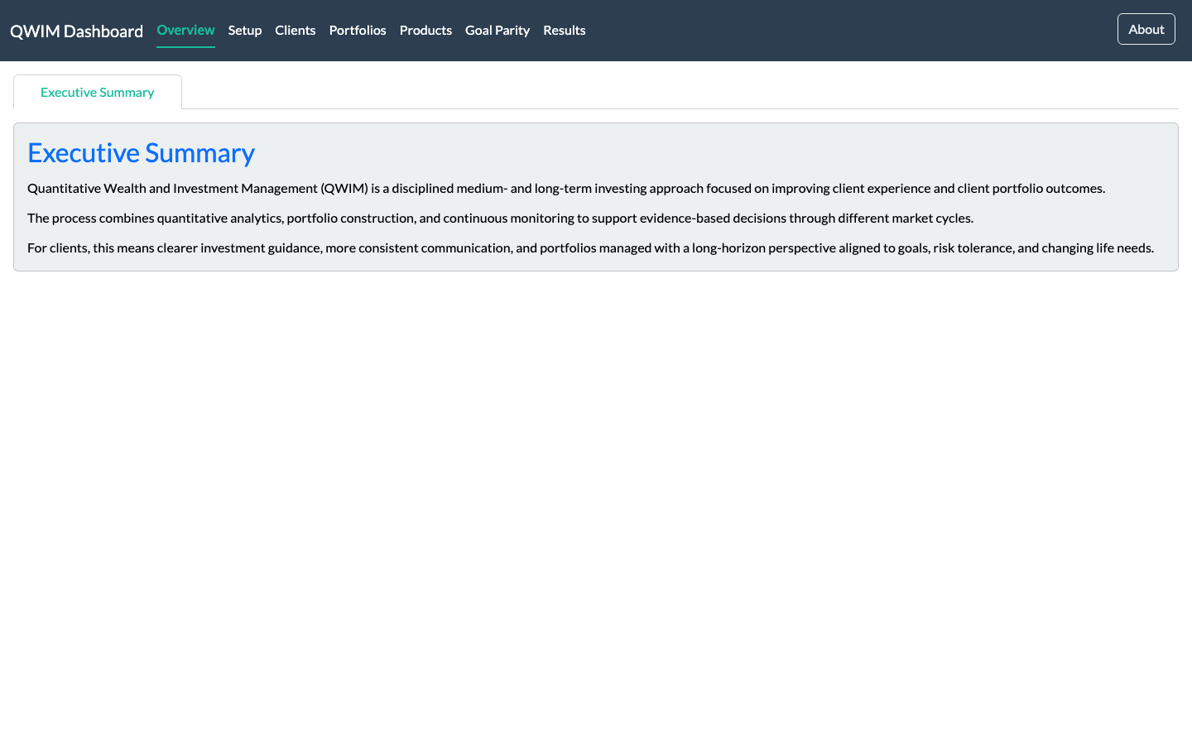
The Overview tab.

Setup
Data sources, computation settings, and per-subtab console verbosity. In a partner demo you normally skip this tab; mention it exists so partners know configuration is centralized.
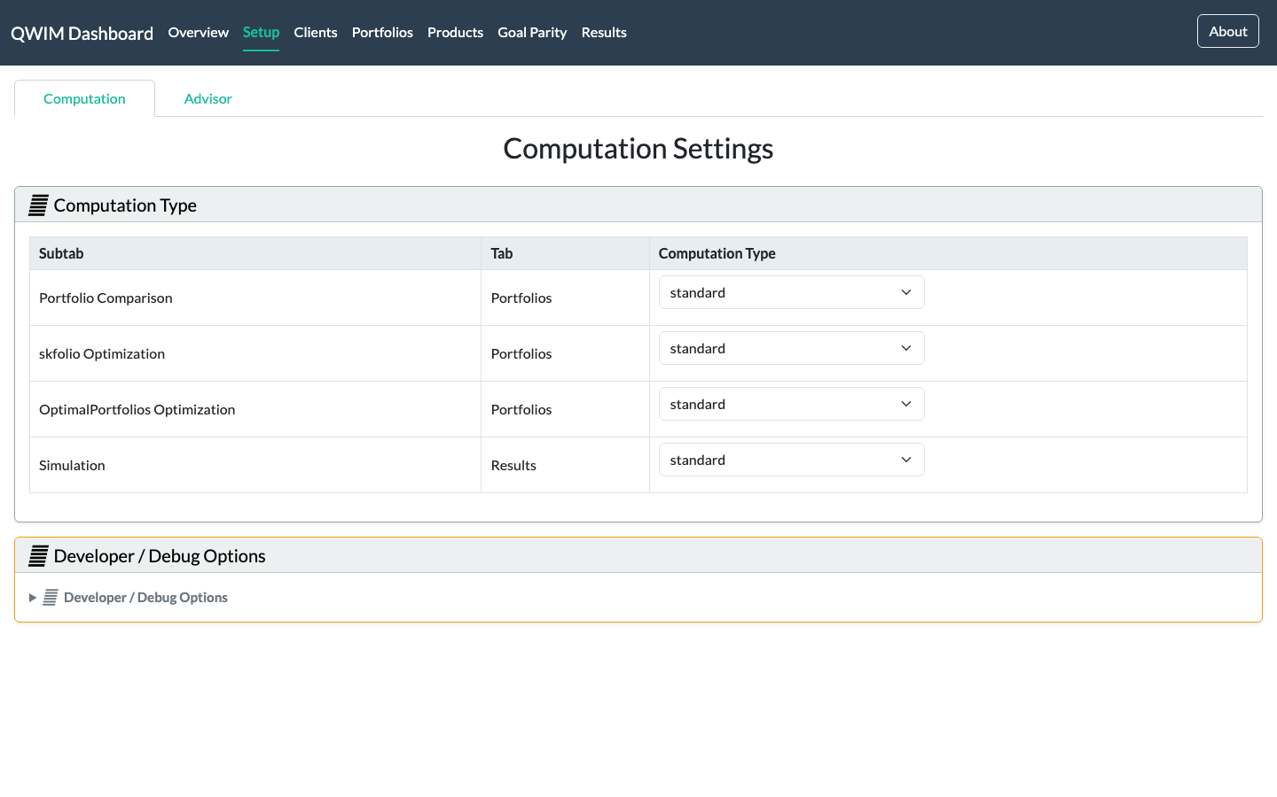
The Setup tab.

Clients
The advisor enters the client's personal information, assets, income, and goals here. Emphasize that models downstream — including Goal Parity — read this profile automatically: enter the client once, and every analysis is personalized.
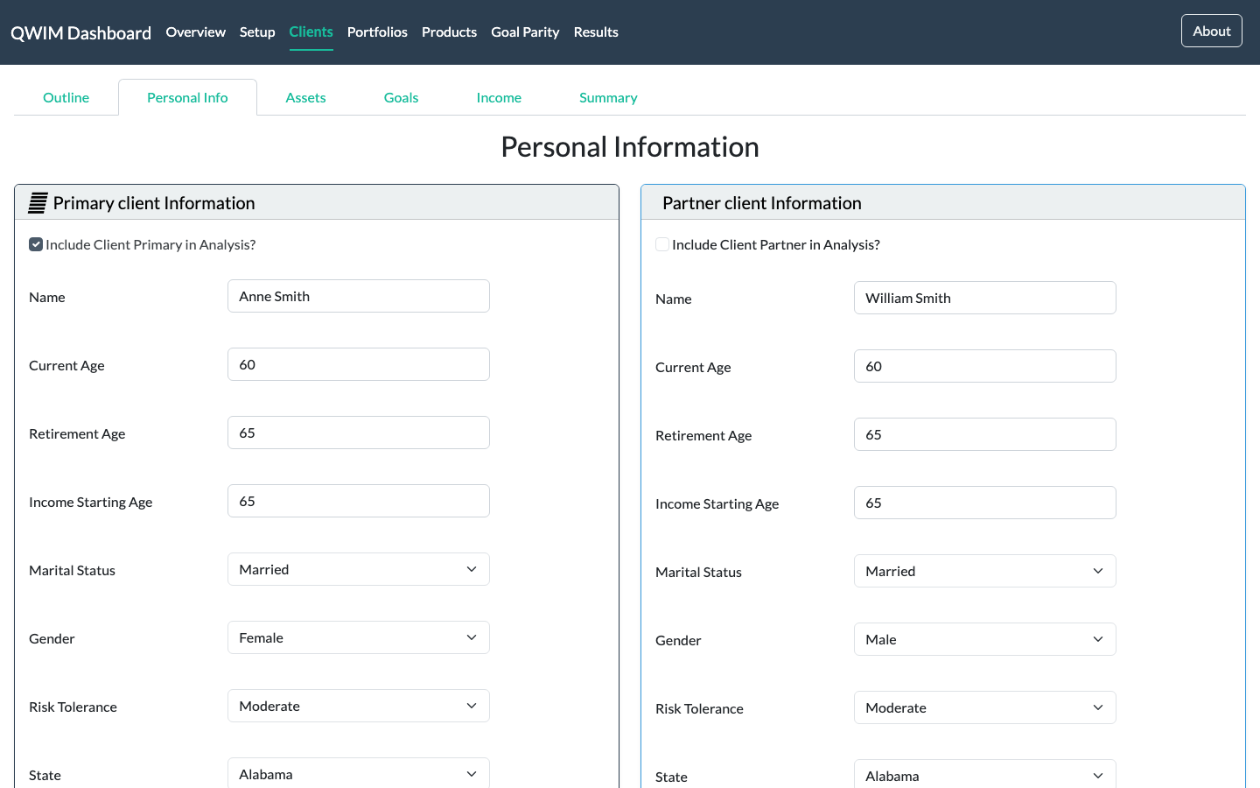
The Clients tab.

Portfolios
Classical portfolio construction and comparison tooling (analysis, optimizers, benchmarks). Useful to frame Goal Parity against: this is the conventional toolkit.
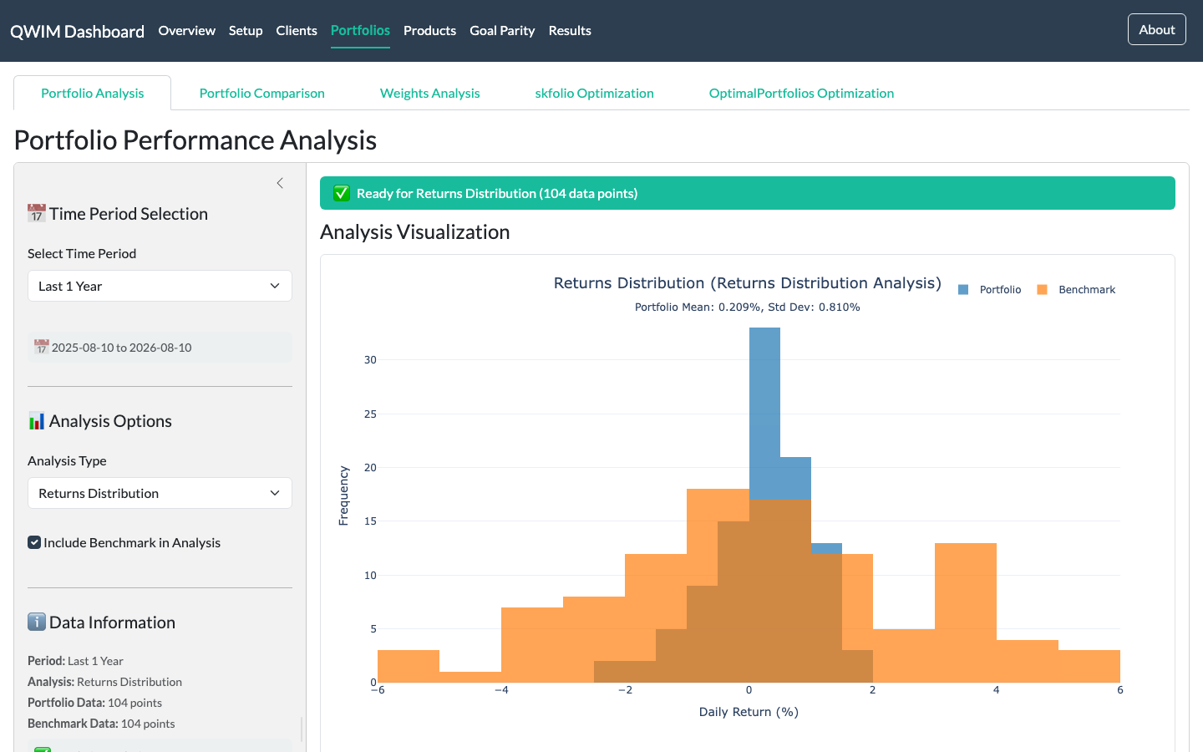
The Portfolios tab.

Products
The investable product shelf backing the portfolios.
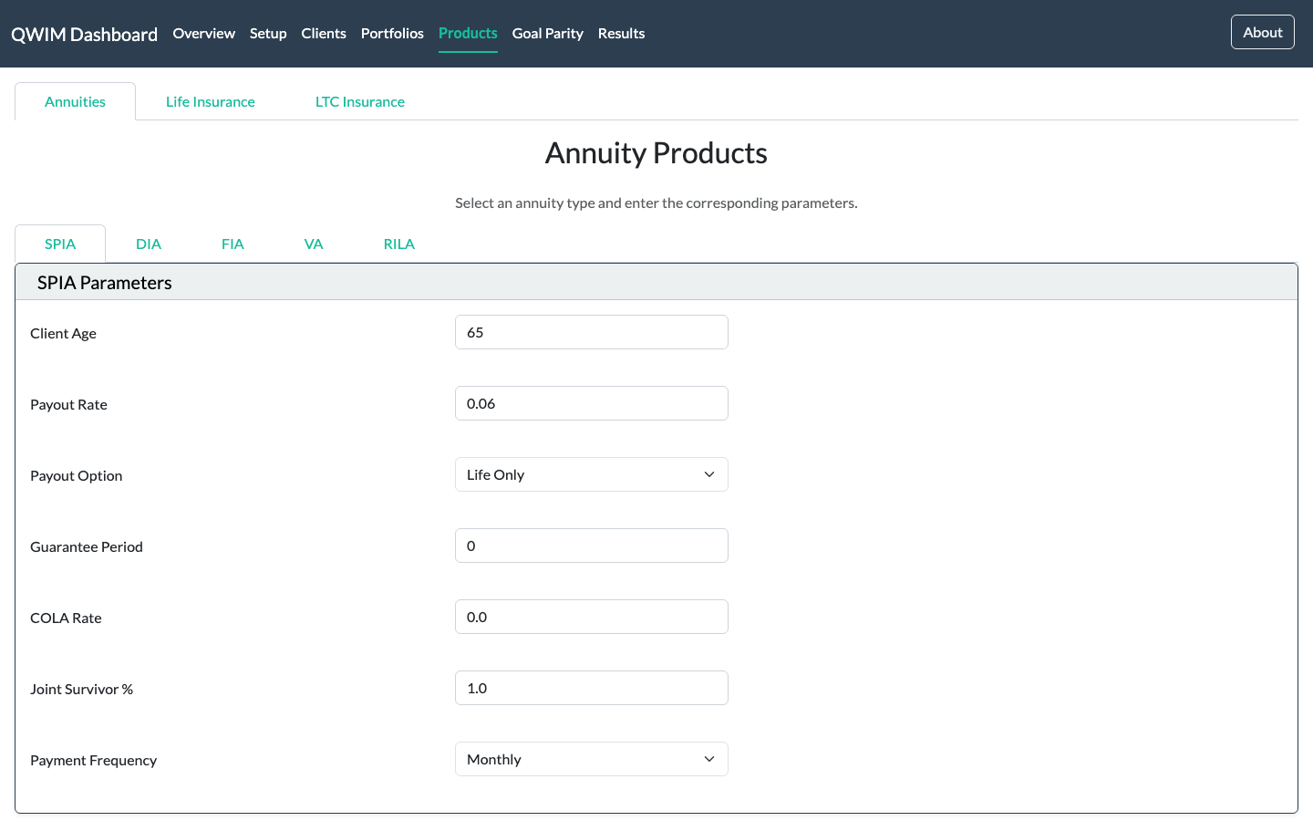
The Products tab.

Results
Simulations and consolidated outputs, and where the client PDF report is produced. End the demo here: everything shown on screen can be handed to the client as a document.
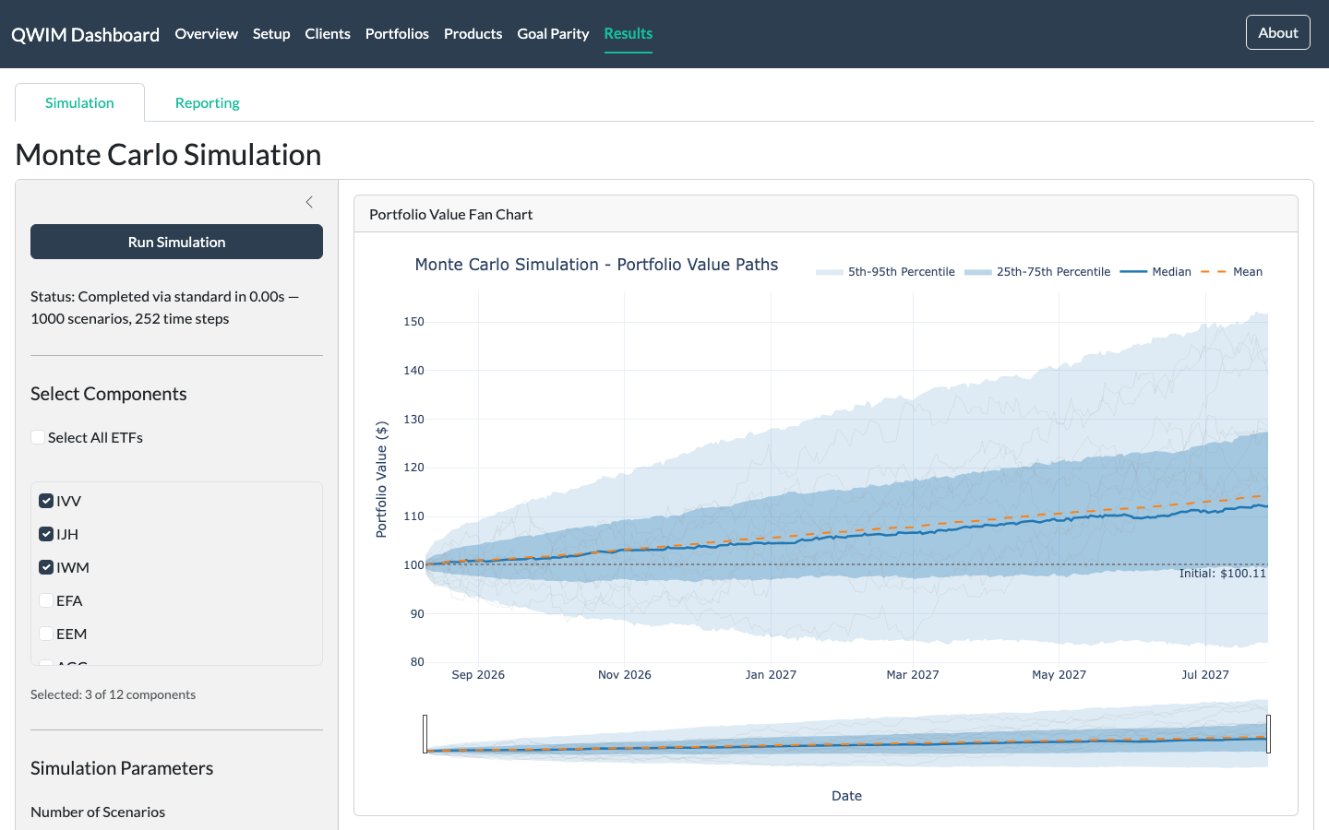
The Results tab.

The Goal Parity tab — step by step
Goal Parity builds the portfolio around four client goals — Liquidity, Income, Preservation, and Growth — instead of a single market benchmark. Demo the subtabs left to right; each step feeds the next.

Overview & Guide
The landing page: why goal-based investing holds up across market regimes, and the step-by-step usage guide. Partners can download this document from the button here.
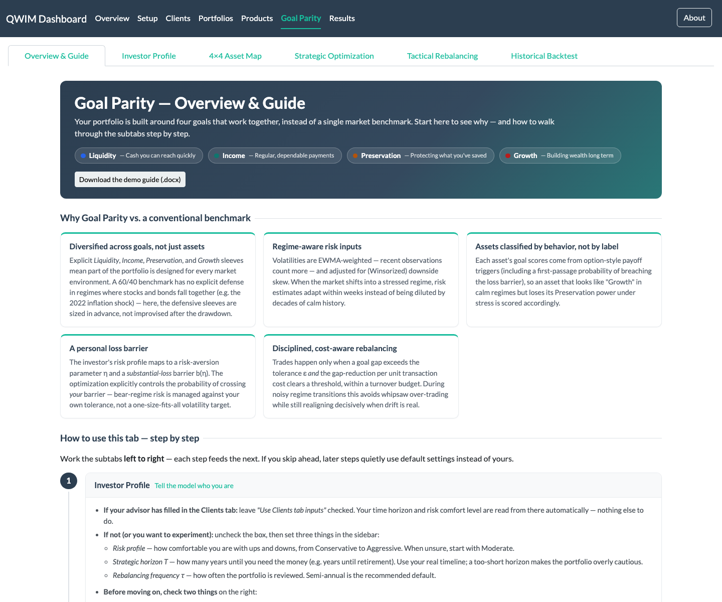
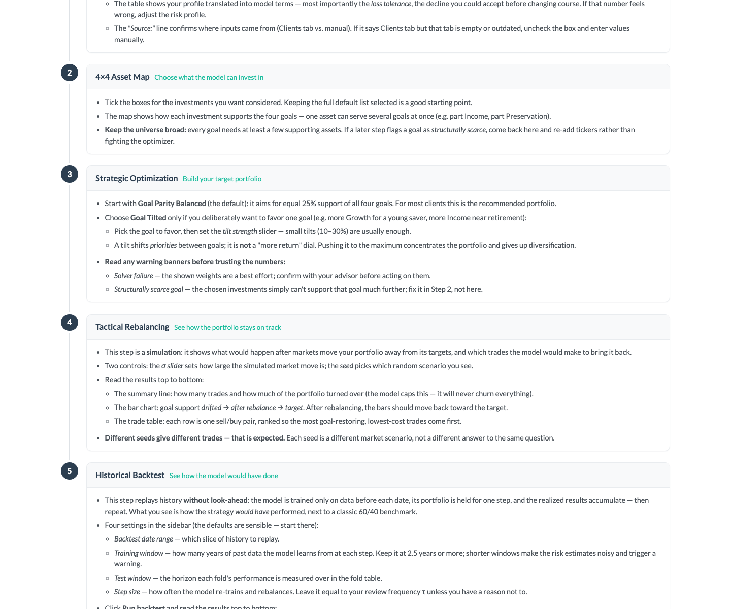
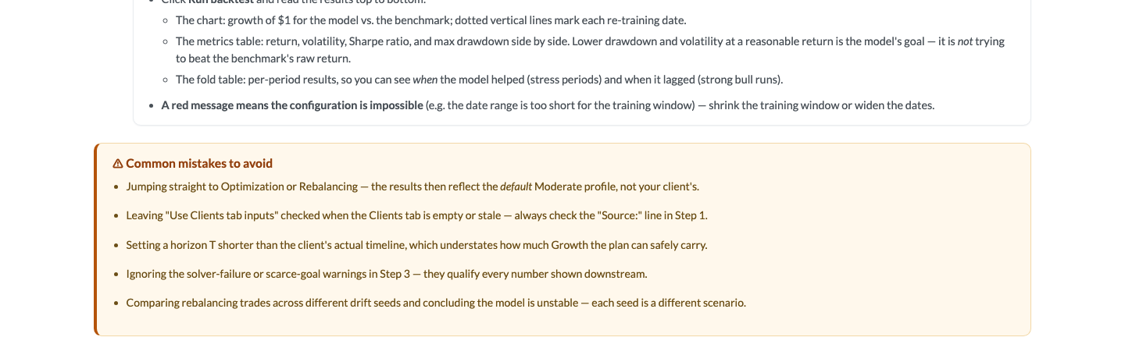
Goal Parity — Overview & Guide.

Investor Profile
Step 1 — the client's risk comfort and horizon become the model's risk-aversion and loss barrier. Point out the 'Source:' line showing inputs flow in from the Clients tab.
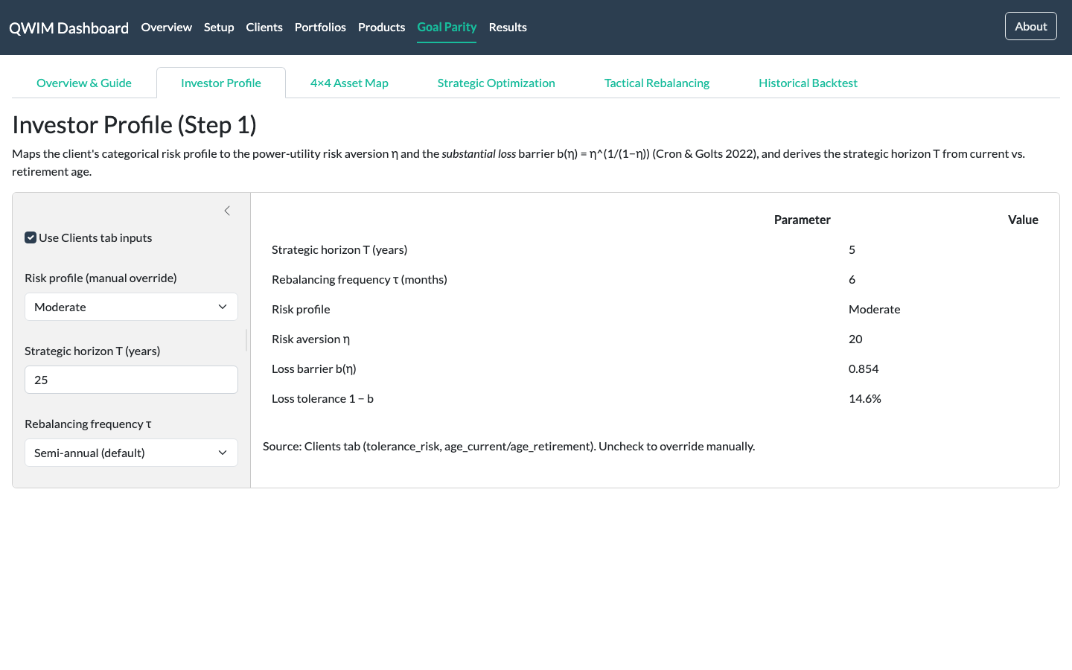
Goal Parity — Investor Profile.

4×4 Asset Map
Steps 2–4 — every asset is scored on how it actually behaves toward each goal (option-style triggers, not static labels). The scatter places each asset between the four goal corners.
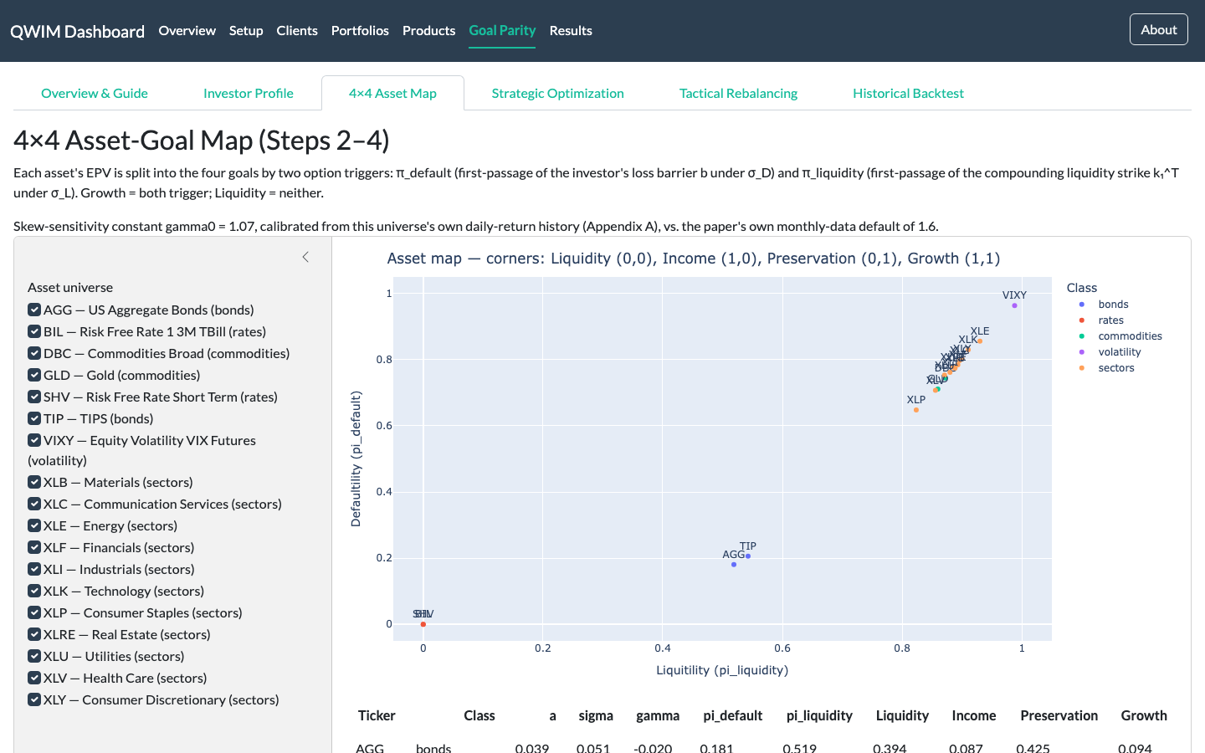
Goal Parity — 4×4 Asset Map.

Strategic Optimization
Step 5 — the optimizer balances the four goal powers (default: 25% each) or applies a deliberate tilt. Show the weights and goal-power bars; note the warnings the page surfaces when something needs advisor judgement.
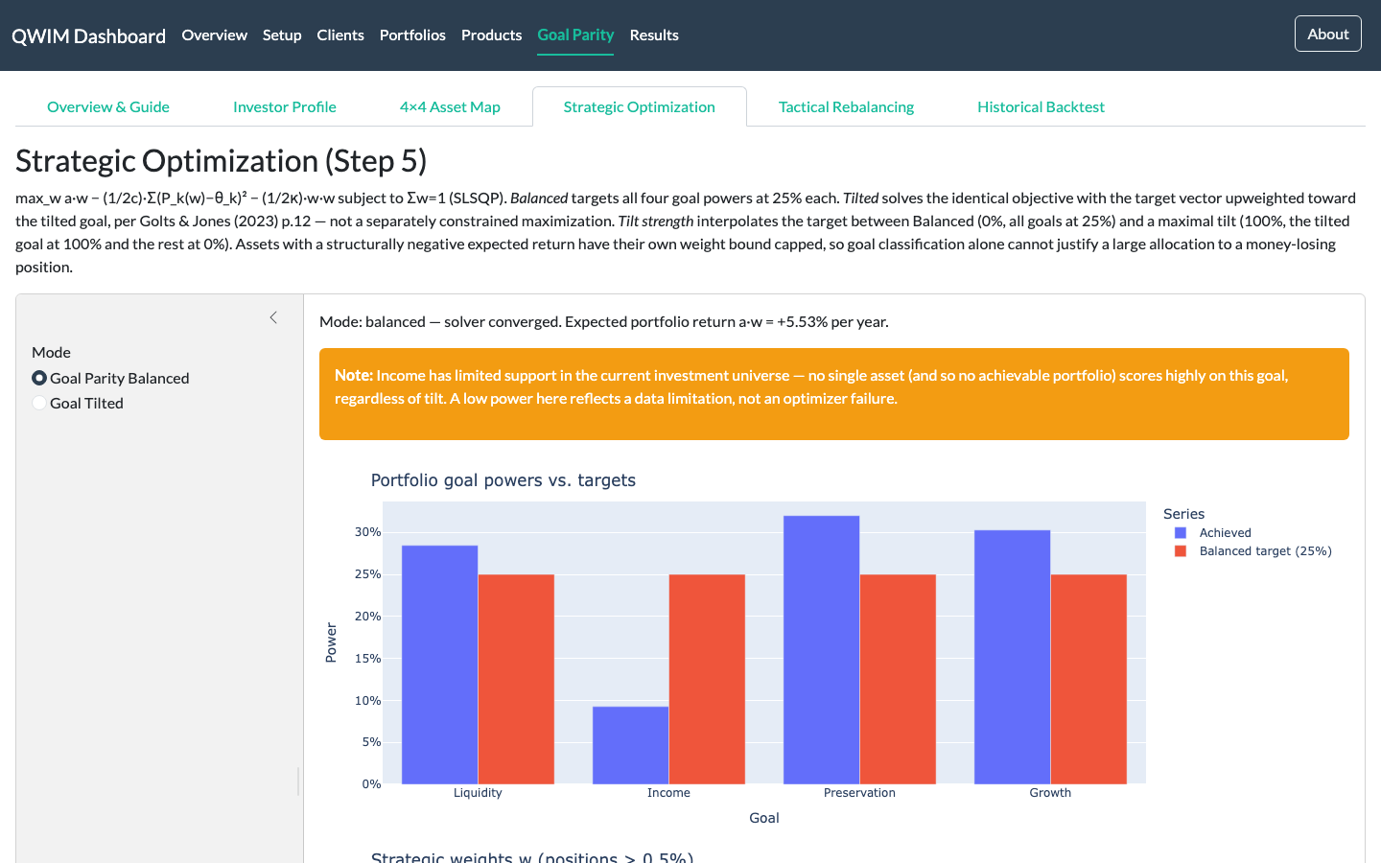
Goal Parity — Strategic Optimization.

Tactical Rebalancing
Step 6 — a simulated market drift and the cost-aware trades that restore the goal balance. Emphasize the turnover budget: the model will not churn the portfolio.
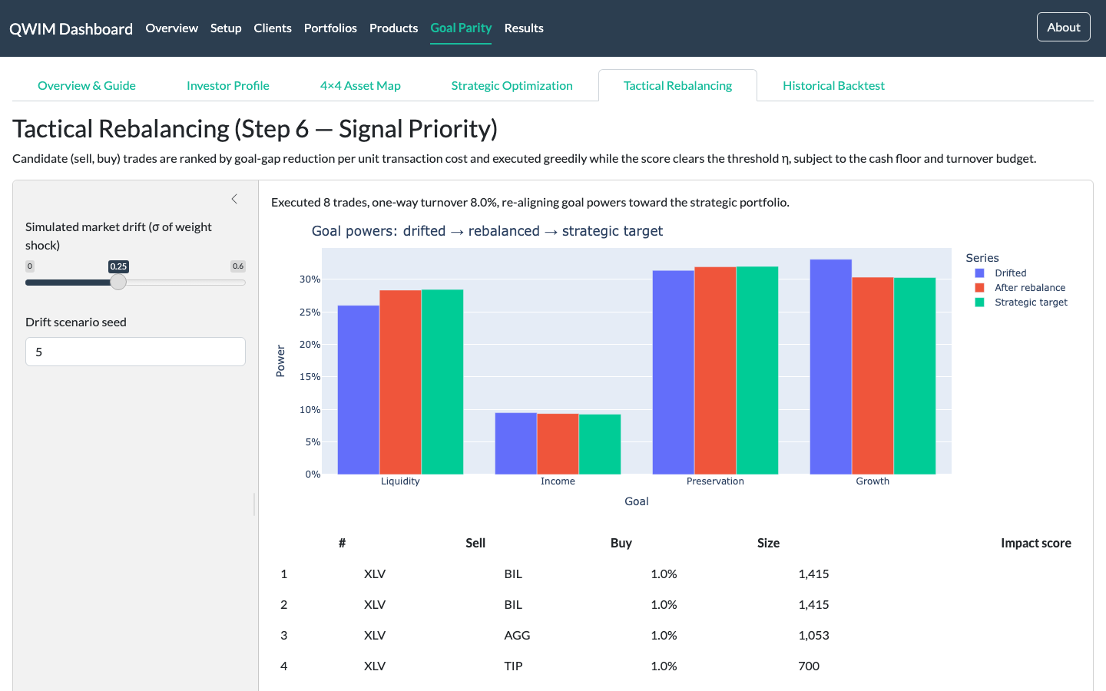
Goal Parity — Tactical Rebalancing.

Historical Backtest
The evidence: a walk-forward replay with no look-ahead — the model is re-trained on past data only at every step. The user chooses the date range, training window, test window, and step size, then runs it live.
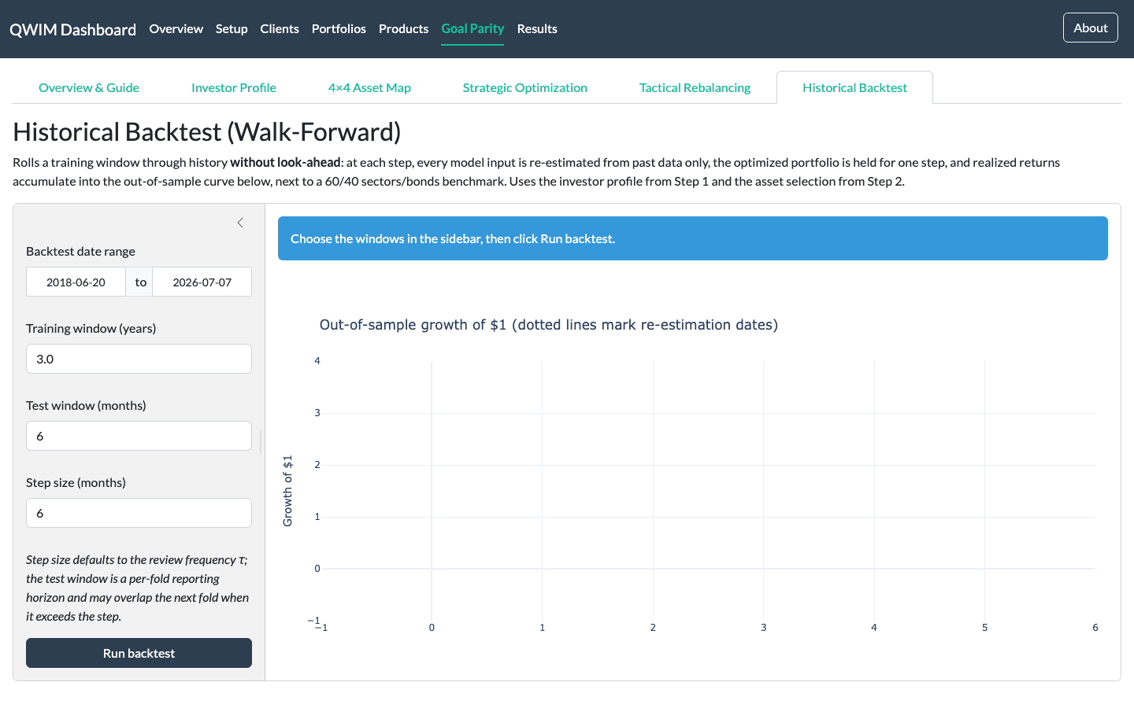
Goal Parity — Historical Backtest.

Backtest results (live run)
A completed run with the default settings (3-year training window, 6-month step). The talking point: Goal Parity targets smaller drawdowns and lower volatility than the 60/40 benchmark — it gives up some upside in strong bull markets in exchange for a smoother ride through stress periods. It is not trying to beat the benchmark's raw return.
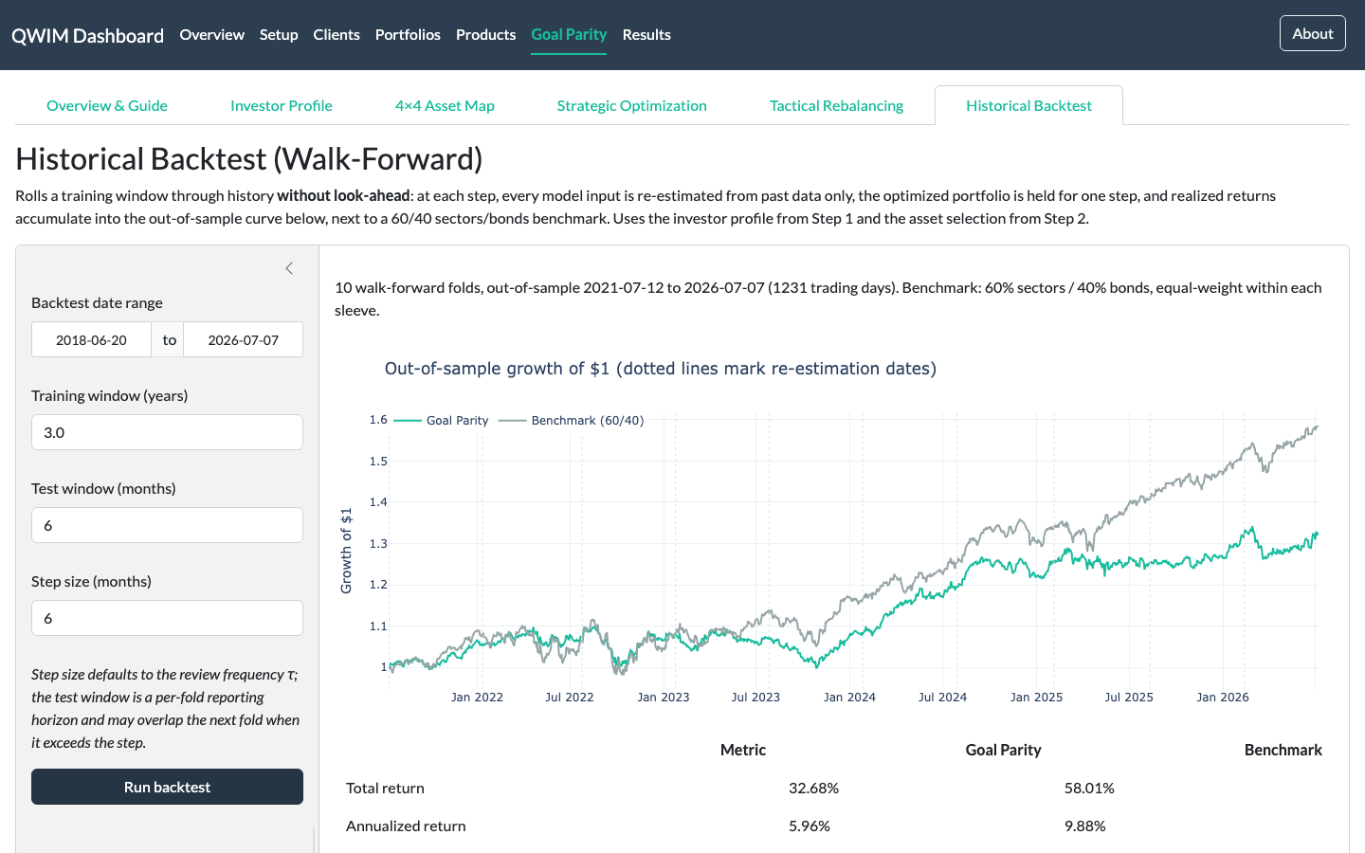
Historical Backtest after a completed run: out-of-sample equity curves and side-by-side performance metrics.

Practical notes for presenters
- Warning banners are features, not bugs: solver-failure and scarce-goal notes tell the advisor when judgement is needed — demo one deliberately if asked about model limits.
- Backtest guardrails reject impossible window configurations and warn on training windows under ~2.5 years.
- All figures are illustrative and do not constitute investment advice.

