機器學習HW2 - LDA

Part2

**W1**T = [-2.09, -10.46]

b1 = 28.12

CR1 = 94.00%

**W2**T = [-3.73, -7.85]

b2 = 31.05

CR2 = 94.00%

Average CR = 94.00%

Part3

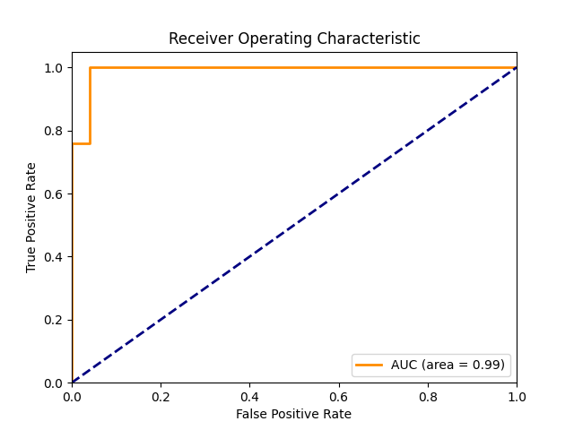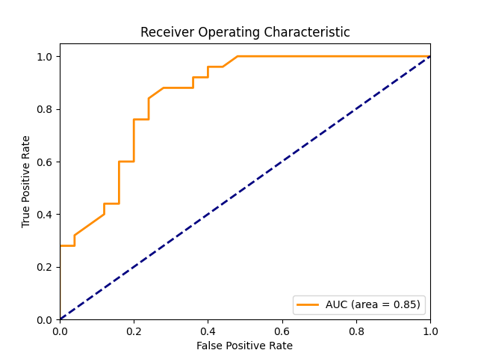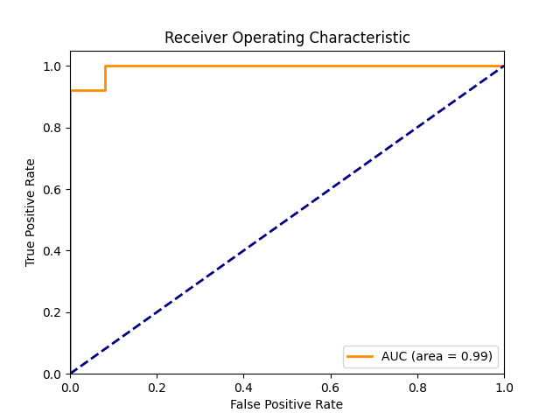

Part4

CR1 = 96.00%

CR2 = 96.00%

Average CR = 96.00%