**Jobvite – Nuview Data Join Tool: Overview and Instructions for Use.**Daniel Claborne – dclaborne@mercycorps.org

The purpose of this tool is to take employee records in csv format from both Jobvite and Nuview and match records from each source. The final result is a file containing employee information from NuView and matched records in Jobvite plus field that contains a unique value for a particular person-job combination (hereafter referred to as a position). Though there could be other options, Jobvite already provides a unique identifier for a position, and it seems most convenient to recycle this field for the final file.

**Explanation of Process**

The tool uses a simple join based on the “Application_ID” field in the Jobvite data, which contains a unique identifier for a particular position. Our task is to identify **positions** in the NuView data which correspond to a particular **position** in Jobvite, append the “Application_ID” from Jobvite to each of these records in NuView, and finally perform the join based on this field.

This is accomplished by first grouping the NuView data by its own position identifier column ‘Pos’. These groups are then reduced to a single row with the ***earliest date for that group*** and every row of the resulting table has the following conditions checked:

-The **first** name in NuView is present in the full name in Jobvite  
-The **last** name in Nuview is present in the full name in Jobvite  
-The Eml effective date in NuView is after the ***largest*** hire date in Jobvite

If both conditions are met, the AppID is appended, and the join is performed at the end of computation.

This works reasonably well, however it should be noted that there is room for error discussed in the “overview of data join subsets” section.

**Use**

Running the tool securely will require the installation of R and the shiny package. Download R from <https://cran.r-project.org/mirrors.html> and follow the installation instructions. Once finished, you should now have access to the R Gui: All Programs -> R -> <Your Version of R>, which will bring up a window called the R console awaiting user input.

First, install the shiny package by typing: install.packages(“shiny”) into this window and hitting Enter, R should automatically perform the necessary installations.

The provided folder contains a file called app.R, we want to be in the directory that contains this file. Do this by clicking File -> Change dir.. and then navigating to where the file is on your computer.

Now, click inside of the “R Console” window, type shiny::runApp(“app.R”) and hit enter. A window should open in your default browser running the app.

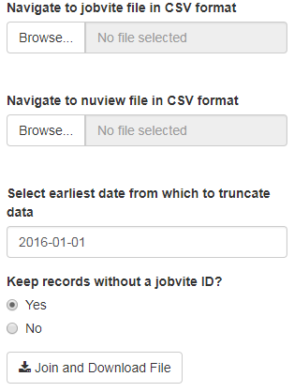

Figure 1: Data Join Interface

Use of the app itself is fairly straightforward. The first selection box takes Jobvite data and the second takes NuView data **both in csv format**.

There is an option to truncate data, which will cause the file returned to only contain records that have a Jobvite hire date and NuView Eml effective date that is past the selected date, by default this will be the minimum candidate hire date from JobVite.

Finally, there is a radio button menu which allows you to select whether or not you want NuView records without a matching Jobvite entry to be included in the final file.

After you have entered all the fields, hit the Join and Download File button; a progress bar should appear in the bottom right. Once complete a file named “joined_data.csv” should be sent to your default downloads folder.

**Overview of data join subsets.**

**Records that appear in Jobvite but do not appear in NuView:**

Positions that did not get a Jobvite ID may be due to one of the following reasons, from most to least common:

1. The position started outside the Jobvite data date range
2. The employee was an intern or consultant
3. The Jobvite position did not correspond to the positions listed for that employee in NuView
4. An Eml change in NuView was recorded as a new position in Jobvite
5. The employee’s name was spelled differently in each file
6. The employee held multiple positions and was hired at the same time

**Records that appear in Nuview but not Jobvite:**

I am unsure of the reason for these discrepancies, but the conditions for their occurrence seem to fall in one of these categories:

1. The position started before the Jobvite data date range
2. The employee held multiple positions over time
3. The employee had a short-term appointment