Agent Framework Report: Mastra Implementation

INTRODUCTION

- Brief overview of framework

Mastra is an opensource TypeScript framework used to build AI powered applications. It was founded in 2024 by Sam Bhagwat, Shane Thomas, and Abhi Aiyer. The framework raised an initial funding of $500k and is backed by Y Combinator. This funding has since increased to $13M with a 100+ investors, the largest investment in recent years. Mastra can be integrated with various frontend and backend frameworks like React.js, Node, and Next.js. Alternatively, it can also be used as a stand-alone server.

Some of its essential features include- Model Routing, Agents, Workflows, Human-in-the-loop, Context Management, Integrations, and Product essentials.

- Purpose of the report

Agentic frameworks have been primarily dominated by python-based frameworks, often making integration with JS/TS based applications much more complex. Lately new frameworks with JS/TS base have been developed and released, however they are still not widely used. This is owed to the lack of exposure and relevant guides/tutorials. After all, it is well known that it takes a steady climb for any new piece of technology to be widely received.
When it comes to Mastra, there’s a dearth of publicly available projects/discussions that clearly outline its key features, their advantages, and their setbacks. Through this report, these findings will be compiled into a comprehensive starting point for individuals interested in starting their own journey in JavaScript/TypeScript agentic frameworks. The secondary aim is to compare and contrast the framework with the other available alternatives.

FEATURES COMPARISON

- Cloud-hosted version availability

Mastra provides a platform named ‘Mastra Cloud’ for deployment, management, monitoring and debugging of Mastra applications. Agents, tools, and workflows are exposed as REST API endpoints when an application is deployed using Mastra Cloud. To be able to access Mastra Cloud users must sign up, as its still in beta as of November 2025. Mastra Cloud supports zero-config deployment, continuous integration with GitHub, and atomic deployments that package agents, tools, and workflows together. Users also provided with a dashboard for applications status, logs and a Studio for testing and debugging purposes. Third party Cloud Service providers like Amazon EC2 AWS Lambda and Cloudflare etc, may also be used for deployment purposes.

- Dockerized container version

Mastra allows user to create Docker containers of their applications locally. This is particularly useful when deploying applications using third party Cloud Service providers. The framework is stateless by default; hence it can easily be used by Docker containers, Kubernetes Clusters, Vercel, AWS ECS, and Fly.io etc.

- GUI and visualization capabilities

Mastra provides a playground along with the server’s API endpoint at run time. The playground comes with a plethora of useful features, as listed below:

- Agent usage: Developers can access and test out all their agents from the Agents tab. The playground also allows you to manually change Model settings for your agents and check logs.

- Agent Networks: This is currently an experimental feature. Agent Networks are used for multi-agent co-ordination and workflow orchestration. Enabled by calling the .network() method on the main agent.

- Tools: Using the tools tab developers can test the working of their tools without having their agents call the tools every time. Simply provide the desired input in the given input fields and generate the response in JSON format.

- MCP Servers: Mastra currently provides two Model Context Protocol classes-

- MCPClient: This class allows your Mastra application to connect to external services/tools using their MCP servers.
- MCPServer: Used to create an MCP server for your Mastra project. Thereby allowing external systems to access agents, tools and workflows from a Mastra project, given that they support the necessary protocols.

- Workflows: Creating workflows can be particularly useful when complex well-defined sequential steps are involved in a particular task. Workflows have the capability to call registered agents and tools when required. A workflow is made by developing each individual step using the ‘createStep’ class, these individual steps are then compiled into a workflow. Workflows are created using ‘createWorkflow’ and the steps are added sequentially using the ‘.then(stepName)’ method. The dashboard allows users to visualize each step of a workflow and test them individually.

- Scorers: An agent’s output quality is graded using scorers. When scorers are set up in a Mastra project, the live scoring can be viewed in the Scorers tab of the playground. Scorers help developers analyse how well their agents handle inputs, this is needed since agents do not have fixed pass/fail test cases as in the case of traditional programming.

- Runtime Context: Often the behaviour of an application must be determined based on information received at run time, also known as runtime context. This runtime context can be passed through input to an agent or can be entered as JSON objects through the Runtime Context tab.

- Uploads + Voice input: The playground by default supports multiple file uploads and voice inputs, at the same time, any output generated by an agent can be read out using the text-to-speech option that appears under each text output.
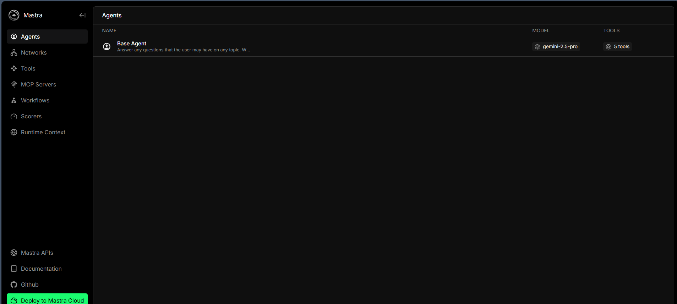
Fig I. Screenshot of the Mastra Playground
While the playground is an immensely useful feature, it cannot serve as a frontend when one wants to deploy their project as a complete application. Multiple AI UI frameworks like Vercel’s AI SDK, CopilotKit, Assistant UI, and HITL etc have been developed to easily create customisable frontends for Agentic chat-based projects.

As of November 2025, Mastra has rolled out a new feature- Mastra UI Dojo. The dojo helps Mastra users easily visualize how each framework’s frontend looks when it is at work. Designs can be tweaked simply by requesting the dojo agent to do so. Developers can play around to their heart’s content while trying to find a design that suits their fancy, all without having to run any code!
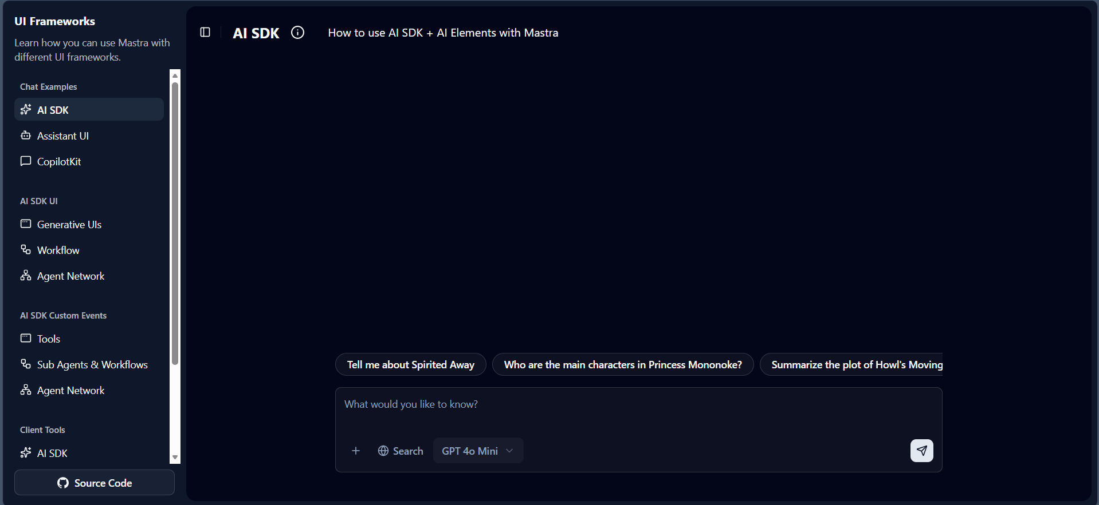
Fig 2. Screenshot of the UI Dojo

- Commercial license details

Mastra is licensed under the Apache License 2.0, a permissive open-source license that provides users with broad rights to use, modify, and distribute the software. It allows:
- Free use for any purpose, including commercial use
- Viewing, modifying, and redistributing the source code
- Creating and distributing derivative works
- Commercial use without restrictions
- Patent protection from contributors
The Apache License 2.0 is one of the most permissive and business-friendly open-source licenses available.

MEMORY MANAGEMENT

Memory management is at the core of every agentic system. Maintaining context by condensing relevant information is essential for any well-oiled agentic project to perform with expected results. Mastra’s memory system uses storage service providers, supported options include LibSQL, MongoDB, Postgres, and Upstash. To enable memory in a Mastra project, the memory service provider must be mentioned in the index.ts file, and to add memory to an agent simply pass a new instance of the Memory() class to the memory parameter. Memory is broken down into three types in Mastra– Semantic Recall, Message History and Working Memory.

- Built-in conversational memory

Mastra’s Message History translates to built-in conversational memory. A store of the most recent message sent by the user. This is set to 10 by default and can be changed using the parameter lastMessages in the memory's options parameter.

- Session storage

When older messages are no longer in the Message History, but are relevant to the current context, a RAG-based search is used. Vector embeddings are searched based on similarity. This helps maintain context over long conversations. The embeddings are done by Mastra’s memory providers; the user just has to set up the vector store, and to search for relevant vectors from the vector store a tool must be developed by the user.

- User memory

Mastra refers to User memory as working memory. All user information that is gathered over time from interactions is known as the working memory. This is key knowledge about the user that can serve an important role during new conversations. This may include the user's name, preferences, or field of work. The user memory is updated after each prompt to the agent.
Working memory can be found in two scopes:

- Thread-scope: Memory is stored within the session
- Resource-scope: Memory persists across different session of a single agent(resource).

WEB SEARCH TOOLS

When implementing web search in an agent there are two different routes that can be taken:
- Using an LLM that provides web search capabilities like Gemini 2.5 or OpenAI.
- Creating a custom web search tool using APIs.

- Tools library

When creating a custom web search tool, Mastra documentation recommends using Exa– a search engine designed for AI applications. It offers semantic search, configurable filters (category, domain, date range), and the ability to retrieve full page contents.

- Configuration options

Tools are created using the createTool. The input provided to any tool can be defined by a Zod object. Therefore, developers can determine how exactly the tool will operate and in what form the output will be generated, provided it falls within the purview of any third-party APIs that may be used in the tool.

- Performance and accuracy

The performance and accuracy of the web search tools rely on the third-party API used or the LLMs web search capabilities, depending on which method is used. When it comes to the API factors like retries, validation and the error handling implemented are crucial when determining the performance or accuracy. Developers can put some scorers in place to analyse the quality of the final output compiled by the agent, after the web search is implemented.

DOCUMENTATION AND CODE

- Versioning for implementation

In November of 2025 Mastra announced the release of their v1 Beta, a stable release is expected within a few weeks. Mastra did not introduce any new features with this release, it was made purely due to the large increase in productions they were being used in. All changes that have been made to the frameworks have been introduced via version 0.21, 0.22, and 0.23 etc and so on.

- Ability to document the code

Mastra is a framework that greets new update almost fortnightly, making it hard to keep up with changes unless you are subscribed to their newsletters or have their repo starred. Compared to some of the best frameworks out there Mastra is just a fledging and hence the sometimes-haphazard documentation is to be expected. Often one can find that the documentation mentions a method or parameter that has been removed in recent updates.

Mastra provides multiple sources that help users stay up to date:

      - Official Documentation: The Mastra documentation as mentioned above, can sometimes be outdated due to the rapid pace of change in the framework. The site also provides an AI chatbot to assist developers with any queries. This assistant can successfully handle simple questions but becomes a dud when hit with something slightly complex. You can compare it to being handed a puppy on a deserted island, not very useful, but not entirely useless either.

      - Blogs: The official Mastra website also has a tab for blogposts, which is used by the framework’s core team to make announcements and discuss important updates in more detail.

      - Books: The founders of Mastra have released 2 books covering modern concepts of agentic AI building. The content covers topics in a simplistic and interesting manner, providing a refreshing alternative to going through vast amounts of documentations.

      - Repository: With each new release the Mastra Github provides highlights of the release along with a complete changelog. Going through these logs is much more convenient for people who want to know about updates without having to go through detailed commentary.

TOOLKITS AND APIS

- Prebuilt toolkits

Prebuilt tools in Mastra include the Agent, createTool, createWorkflow classes that make creating agents, tools, and workflows a breeze. The Agent class also contains very helpful parameters that are otherwise complex to integrate in some other frameworks. This includes the voice input, which can be introduced simply by adding a Mastra supported voice model like Google voice as the voice parameter in your agent.

The built-in scorers, though not considered ‘tools’ are uber useful features to analyse the working of agents based on various judgement criteria. If none of the built-in scorers meet requirements then developers have the flexibility to create their own scorers.

When creating a new Mastra project the boilerplate code comes with a weatherTool and a workflow for the same. These inclusions are very helpful for newcomers to grasp how Mastra works, as it is substantially different from other existing agentic frameworks.

- API support and usage

For users who wish to integrate their Mastra services with other applications, Mastra’s Client SDK makes use of Agents, Tools, Workflows, Vectors, Logs, Telemetry, Observability and Memory APIs. These APIs are supported to make it possible for outside applications to manage Mastra features. The Mastra Client SDK provides a simple and type-safe interface for interacting with your Mastra Server from your client environment.

- Observability platforms compatibility

AI observability or AI Tracing provides specialized monitoring and debugging for the AI-related operations in your application. When enabled, Mastra automatically creates traces for agent runs, LLM generations, tool calls, and workflow steps with AI-specific context and metadata. AI traces consist of :

  - Configuring exporters: Exporters determine where your AI trace data is sent and how it's stored. Choosing the right exporters allows you to integrate with your existing observability stack, comply with data residency requirements, and optimize for cost and performance. Mastra provides the option to use internal exporters (Default i.e. local or Mastra Cloud) or external exporters like Arize, Braintrust, Langfuse, LangSmith, OpenTelemetry etc.

  - Set sampling strategies: Sampling allows you to control which traces are collected, helping you balance between observability needs and resource costs. Mastra is equipped with 4 types of sampling:

    - Always Sample
    - Never Sample
    - Ratio-Based Sampling
    - Custom Sampling

  - Run agents and workflows: Start using the agents and workflows normally so that the tracing data can be generated and exported for analysis.

WORKFLOW ANALYSIS

- How does the framework support workflow design

A Mastra workflow consists of multiple sequential steps in a properly defined order. Each individual step is created using instances of the createStep class and has well defined input/output structures. The main workflow is created using the createWorkflow class and each step is added sequentially using the .then(stepName) method

Conditional branching is a feature of workflows, where a developer may modify the execution paths of a workflow, depending on run-time data or the outcome of agents. They also promote parallel execution whereby tasks that are to be performed are not allowed to be carried out before others are done. In the case of long-running tasks, Mastra has the state preservation feature, and the workflow execution may be interrupted to allow some external input, e.g., human approval (human-in-the-loop) or other data provided by external APIs.

As workflows may call on agents as well as tools, they come in very handy when applying complicated decision trees or procedures. As a workflow design, Mastra enables automation of the processes that are based on research, analysis, validation, summarization, and integration of several external services. The Mastra Playground simplifies the process of debugging workflows as every action could be visually examined and tested.

REASONING AND THINKING TOOLS

- Analysis of reasoning tools

Mastra lacks any out-of-the-box reasoning tools but allows reasoning loops to be achieved using its agent architecture. The maxSteps can be set on agents, which means that they can analyse task goals, choose to use a tool, take actions, and assess the results in a repetitive process. It is very much related to such reasoning frameworks like ReAct (Reasoning + Acting): the agent thinks, calls a tool, watches the outcome, and keeps thinking on the new basis.

Using the scorers of Mastra, it is possible to introduce reflection and self-evaluation to determine the quality of output. In case the quality of the response is less than a specified threshold, the workflow or agent may restart the reasoning process with new instructions. The feature of multi-agent reasoning is backed by the experimental feature of Agent Networks that enables specialized agents to collaborate or argue over outputs before generating a final reply.

The flexible nature of Mastra guarantees that advanced logic, including multi-step analysis, comparative analysis, hypothesis testing and refinement of autonomous decisions, are able to be modelled with custom loops, scorers or with integrated agent-tool interactions. As the further development is likely to be improved after the release of v1, it is assumed that further versions of Mastra will be equipped with more sophisticated reasoning tools.

CONCLUSION

For a framework that has existed for approximately 1 year, Mastra has a lot to promise. Yes, at times you can end up in a spiral over something simple because of a mismatch in documentation, but the result is almost always worth it. Mastra has also introduced a lot of unconventional new features recently, which leads us to believe that it may be a front-runner for the best agentic framework in the near future.

Developers looking to explore and experiment with Mastra should definitely give their published books a read, especially if they’re new to the concept of agentic AI. The materials provide a lot of insight into the thought process behind the creation of the framework and the problems they’re trying to address with it. There aren’t many tutorials available online to learn from and the best option would probably be to just jump right in and get your hands dirty. Developers using Mastra should routinely check for version upgrades and new features.

At present it is much easier to work with frameworks that have a long-standing presence and a strong community since problems that you face have a high probability of being encountered– and solved, before. When it comes to Mastra, a lot of issues are possibly being discussed for the first time, which can be daunting for developers who like easy answers.

These minor issues are bound to fade away as the framework grows older, and it is going to be exciting to see it more widely adopted as the go-to TypeScript framework for agentic development.

