--A

Select FirstName, MiddleName, LastName

From Person.Person

Where ModifiedDate > '2014-01-01';

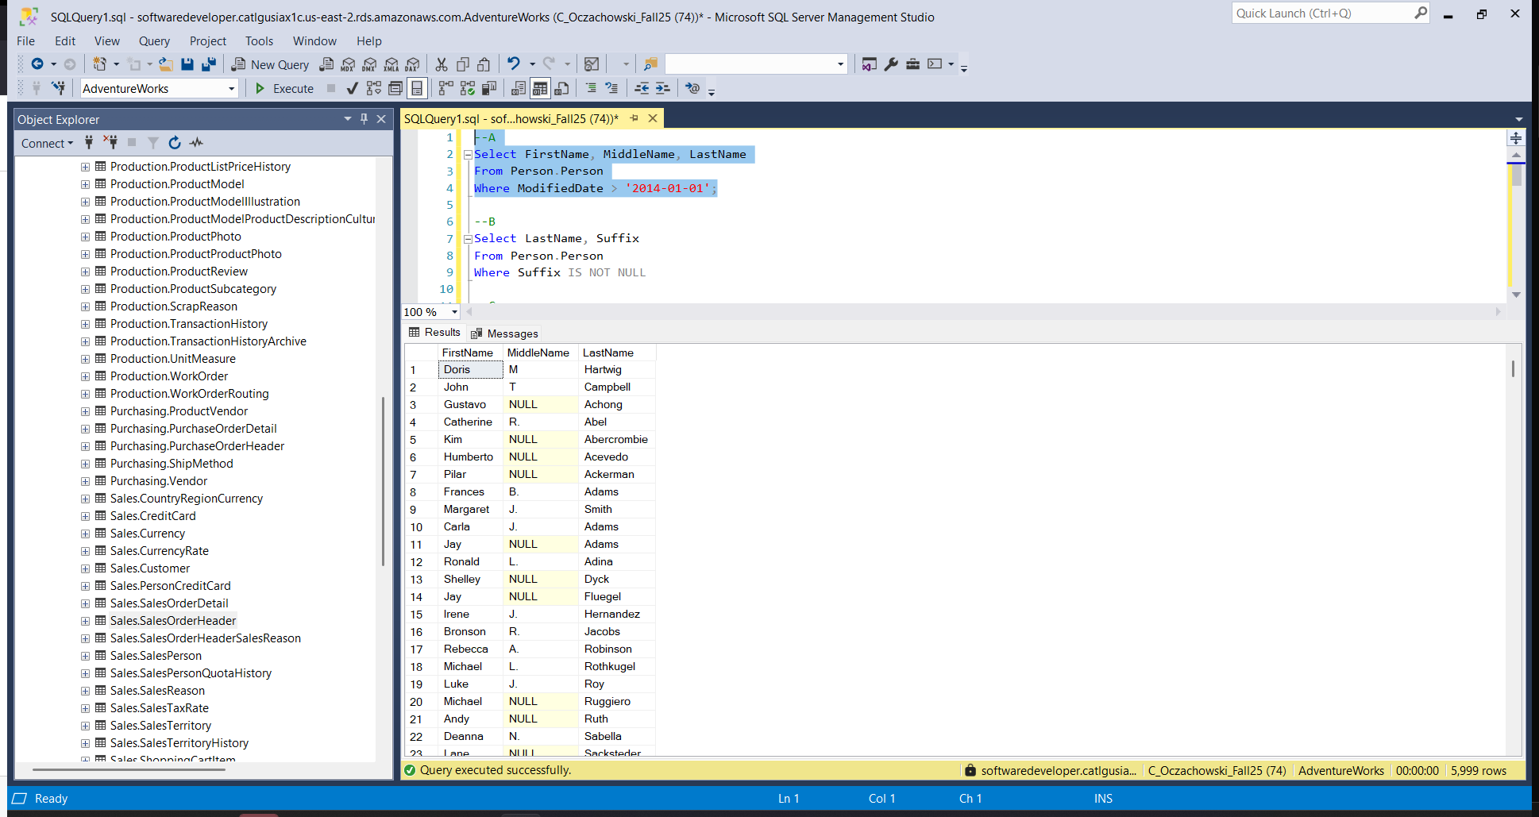

--B

Select LastName, Suffix

From Person.Person

Where Suffix IS NOT NULL

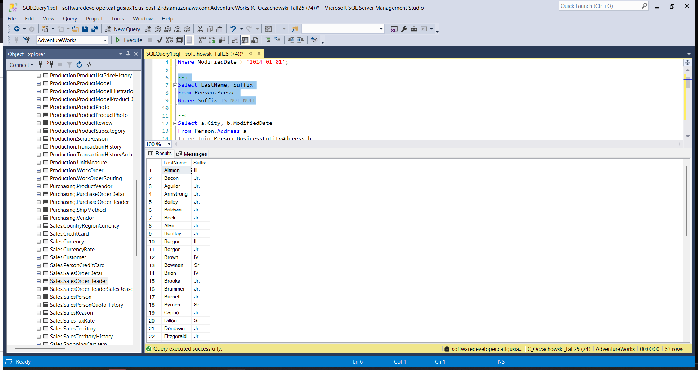

--C

Select a.City, b.ModifiedDate

From Person.Address a

Inner Join Person.BusinessEntityAddress b

On a.AddressID = b.AddressID

Where b.ModifiedDate > '2014-09-01'

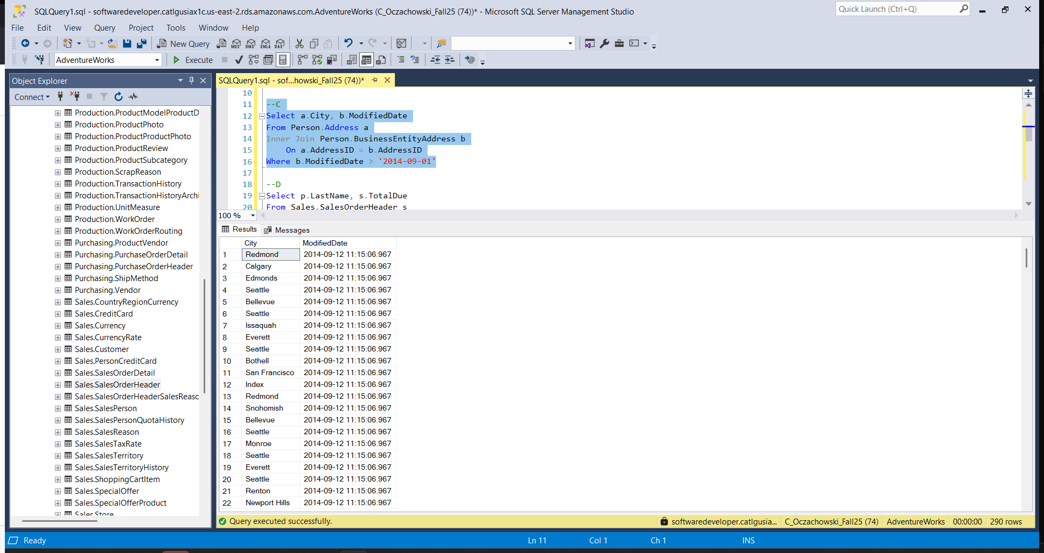

--D

Select p.LastName, s.TotalDue

From Sales.SalesOrderHeader s

Inner Join Sales.Customer c

On s.CustomerID = c.CustomerID

Inner Join Person.Person p

On c.CustomerID = p.BusinessEntityID

WHERE s.OrderDate >= '2013-07-01'

AND s.OrderDate < '2013-08-01'

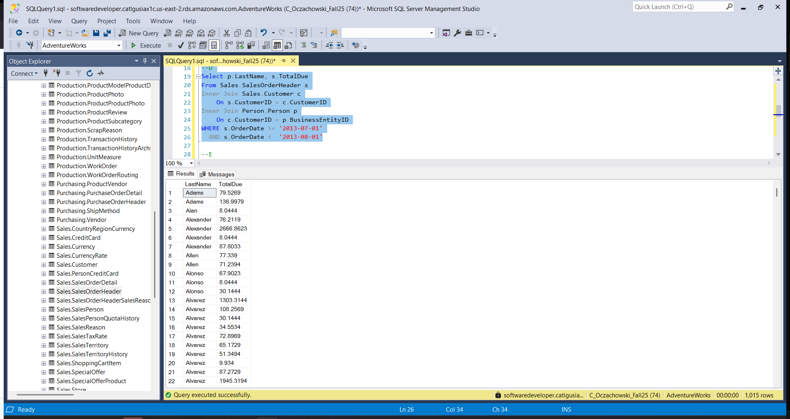

--E

Select Distinct CustomerID

From Sales.SalesOrderHeader

Where BillToAddressID != ShipToAddressID

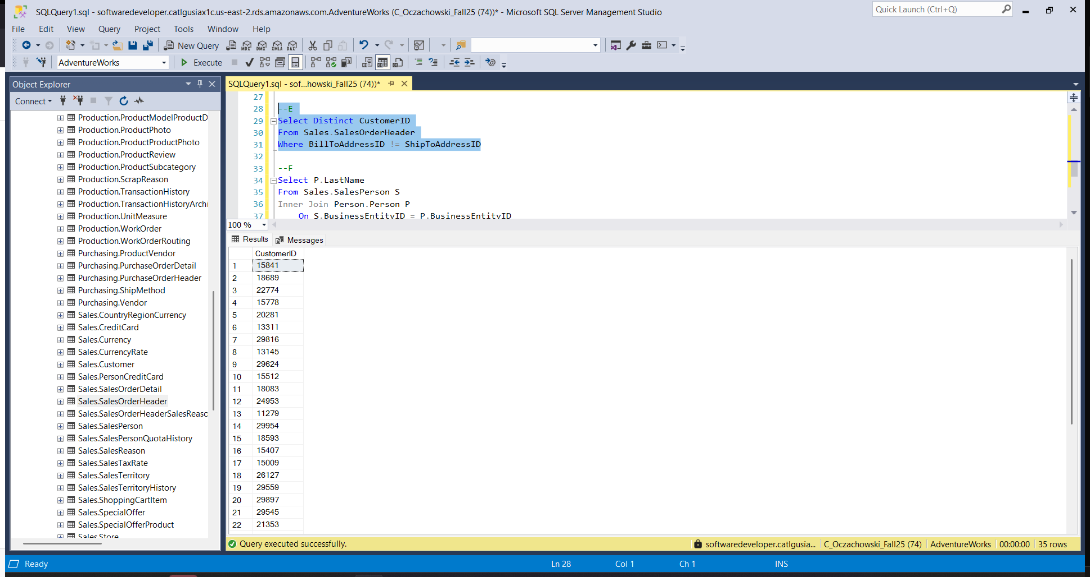

--F

Select P.LastName

From Sales.SalesPerson S

Inner Join Person.Person P

On S.BusinessEntityID = P.BusinessEntityID

Where S.SalesLastYear = 0

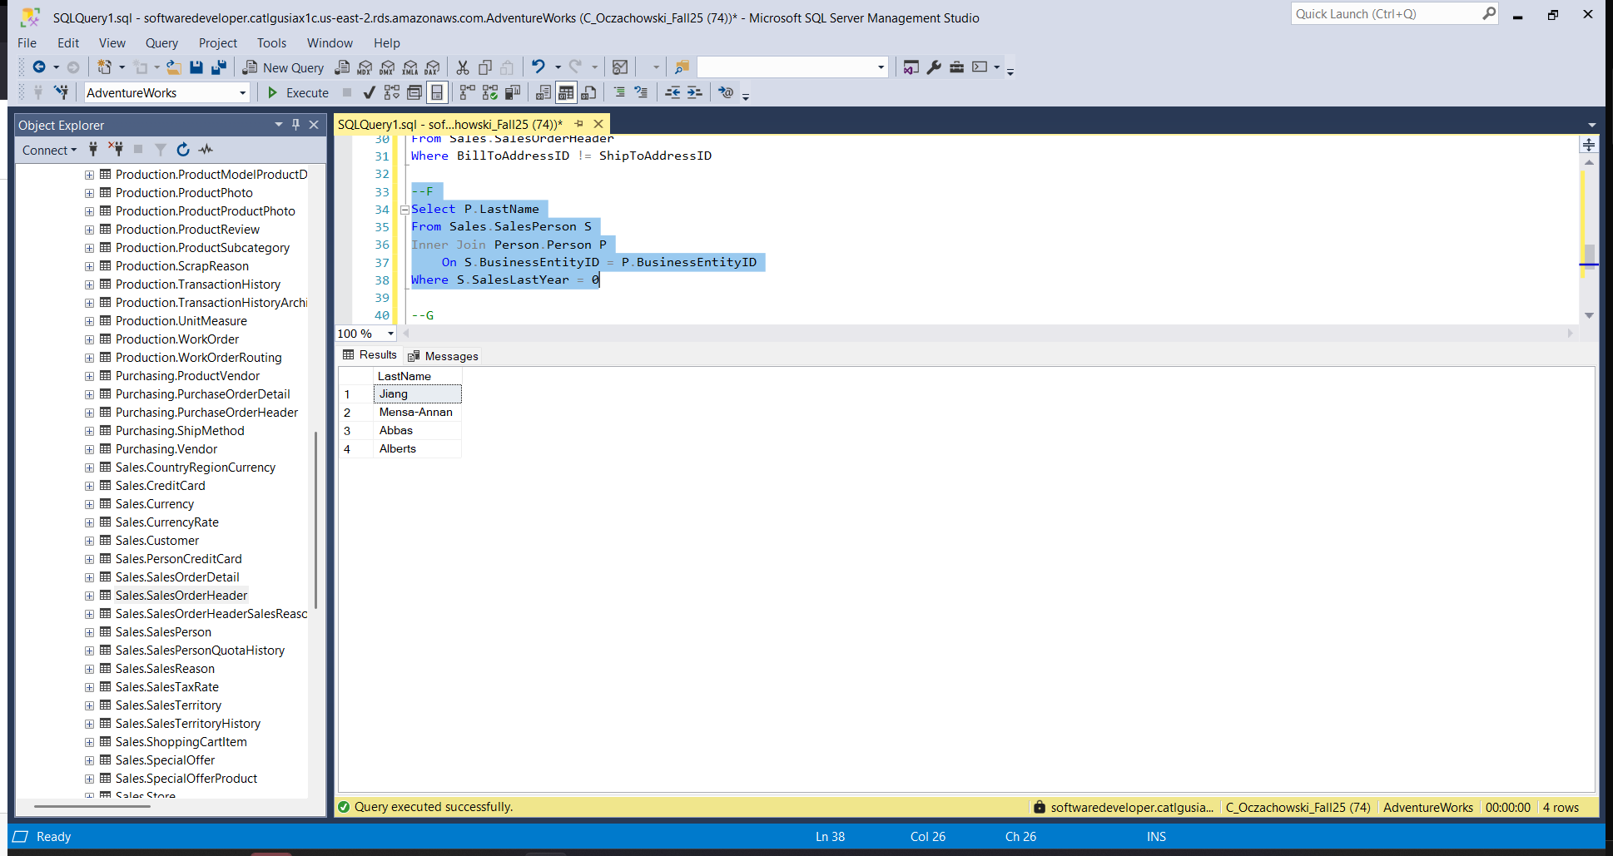

--G

Select FirstName

From Person.Person

Where FirstName Like '___d%'

OR FirstName like '___e%'

