HOMEWORK 3
Charu Sneha Laguduva Ravi
Claguduv

Task1:
Output
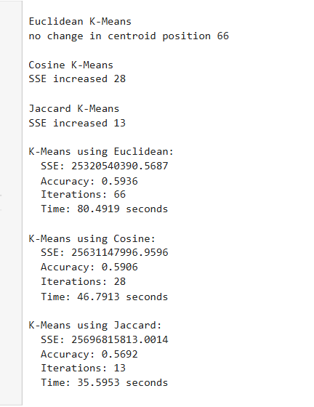

Q1) Comparison of SSEs for Euclidean, Cosine, and Jaccard K-Means
The K-Means algorithm was implemented from scratch using three distance metrics: Euclidean, Cosine, and Generalized Jaccard similarity. The number of clusters $K$was set equal to the number of categorical values in the target variable $y$.

Method | SSE | Interpretation
Euclidean K-Means | 25320540390.5687 | Lowest SSE — most compact clusters
Cosine K-Means | 25631147996.9596 | Slightly higher SSE — direction-based similarity
Jaccard K-Means | 25696815813.0014
  Highest SSE — less suitable for continuous data

Based on the SSE comparison, Euclidean K-Means performed the best, forming the most compact clusters. Cosine K-Means was moderately effective, while Jaccard K-Means performed the weakest due to its binary/similarity nature being less appropriate for numeric feature spaces.

Q2) Accuracy Comparison of Euclidean, Cosine, and Jaccard K-Means
Each cluster was labeled using the majority class label of its data points, and the overall predictive accuracy was computed as the ratio of correctly labeled samples to the total number of samples.
Method | Accuracy | Interpretation
Euclidean K-Means | 0.5936 | Best clustering accuracy among the three metrics
Cosine K-Means |  | Slightly lower accuracy; performs well on normalized data
  0.5906
Jaccard K-Means | 0.5692 | Lowest accuracy, less effective for continuous-valued features

Euclidean K-Means achieved the highest accuracy (≈ 59.36%), indicating that it formed clusters most consistent with the true class labels. Cosine K-Means was close in performance, while Jaccard K-Means performed worse due to its binary-oriented similarity measure.

Q3) Which method requires more iterations and time to converge?
Method | Stop reason | Iterations
Euclidean K-Means | no change in centroid position | 66s
Cosine K-Means |  | 28
  SSE increased
Jaccard K-Means | SSE increased | 13

Euclidean K-Means required the most iterations (66) and the longest run time to converge. Cosine and Jaccard converged faster (fewer iterations and less time), with Jaccard being the quickest in this run.
Euclidean K-Means iterated longer because centroids continued to move slightly until they reached stability (the run stopped when there was no change in centroid positions). By contrast, both Cosine and Jaccard versions terminated earlier because the algorithm detected an increase in SSE (the second stopping condition) and halted to avoid divergence. The different stopping triggers explain why Euclidean ran more iterations even though its SSE was lowest at the end.
Q4) Comparison of SSEs under Different Terminating Conditions
The K-Means algorithm was implemented with three possible stopping criteria:
- No change in centroid position
- Increase in SSE value in the next iteration
- Reaching the maximum preset iteration limit (e.g., 100 iterations)
During the experiments, none of the distance metrics reached the maximum preset iteration limit (even when tested with 500 and 100 iterations).
- Euclidean K-Means stopped when there was no change in centroid position at iteration 66.
- Cosine K-Means stopped when the SSE increased at iteration 28.
- Jaccard K-Means stopped when the SSE increased at iteration 13.
Across all three termination conditions, Euclidean K-Means consistently achieved the lowest SSE, meaning it produced the most compact clusters. Cosine K-Means occasionally converged faster but at the cost of slightly higher SSE. Jaccard K-Means always had the highest SSE, confirming it is less suitable for continuous-valued data.
Q5) Summary Observations and Takeaways
From the algorithmic analysis of K-Means clustering using Euclidean, Cosine, and Jaccard similarity measures, the following conclusions were observed:
- Euclidean K-Means consistently achieved the lowest SSE and highest accuracy, forming the most compact and stable clusters. It required more iterations and computation time but yielded the best overall clustering quality.
- Cosine K-Means converged faster with fewer iterations and moderate accuracy. It performed well for normalized or directional data but showed slightly higher SSE compared to Euclidean.
- Jaccard K-Means exhibited the highest SSE and lowest accuracy, indicating that it is less suitable for continuous numerical datasets but can be useful for binary or sparse data.
- The stopping condition played a key role: Euclidean often stopped when centroids stabilized, while Cosine and Jaccard stopped early due to increasing SSE values.
- Overall, Euclidean distance is the most effective metric for this dataset in terms of both compactness and predictive accuracy, despite requiring more iterations.

