Numerically compute the derivative of the Spike Count w.r.t Weight

With 100 data points:

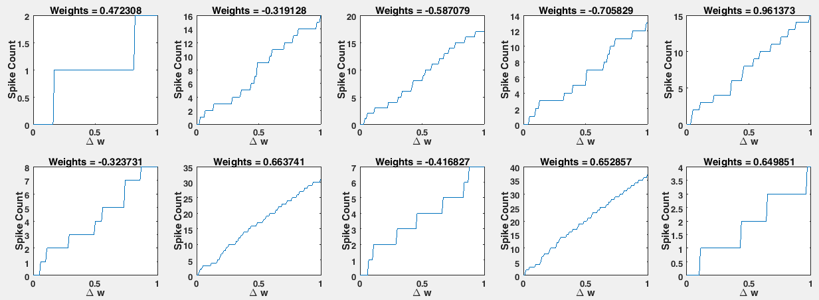

With 10 data points to check out the overall trend:

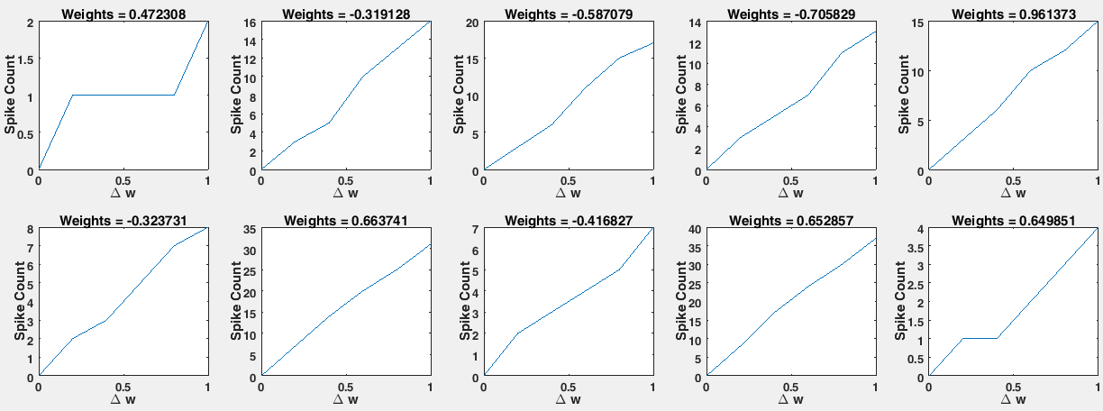

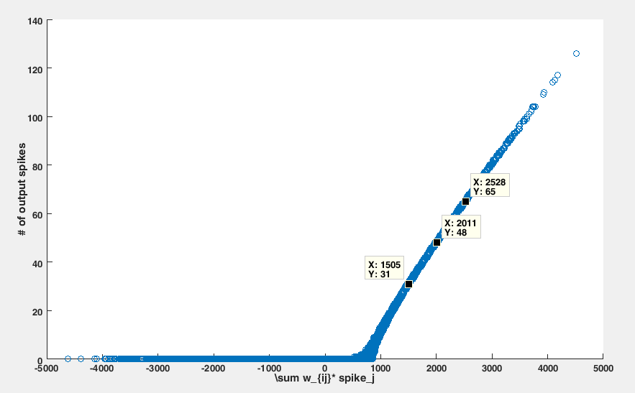

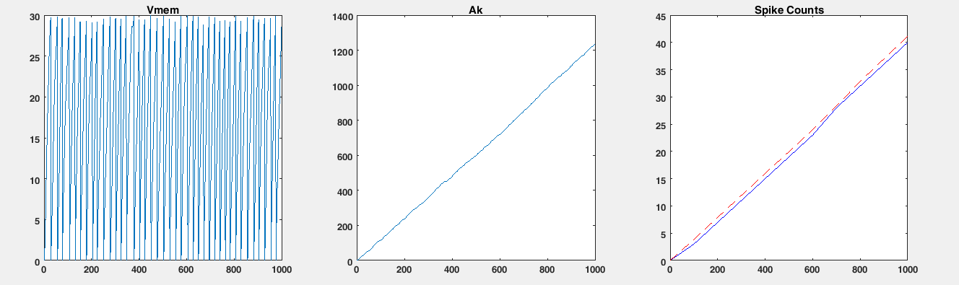

With weight (w_0) increases, the following figures show how the accumulative effect of each synapse will change:

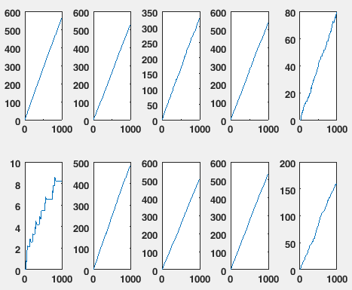

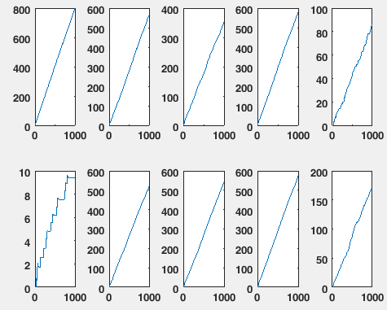

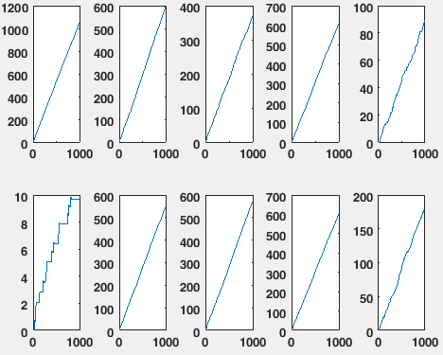

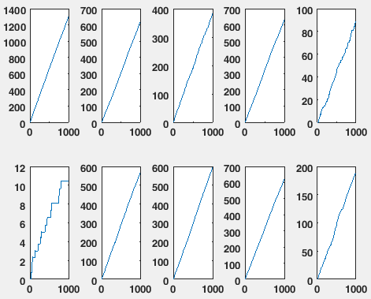

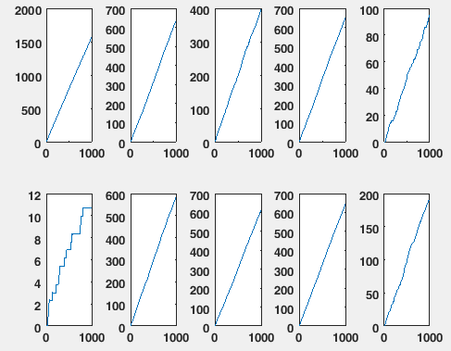

Indication:

We can see that by increasing the firing rate of the output neuron, we correspondingly increase the accumulative effect associated with other synapses.

So that means by increase the certain amount of the weight, we actually get more spikes than we expected.