Cirrus Technical Assessment Form:

Grant, Open Access Applications

**Note: this form is for grant or Open Access applications only. Technical Assessment forms for other access routes can be found on the Cirrus website at: http://www.cirrus.ac.uk/access**

**Instructions:**

1. Complete Section 1 below as fully as possible. If you have any questions or require clarification, please contact the Cirrus helpdesk ([support@cirrus.ac.uk](mailto:support@cirrus.ac.uk))
2. Return the completed form (as a Word document) to the Cirrus helpdesk ([support@cirrus.ac.uk](mailto:support@cirrus.ac.uk)).
3. The Cirrus CSE team will complete Section 2 and will contact you directly for more information if it is required. This may take up to 10 days from receipt of the completed form.
4. The CSE team will return the fully completed form to you so you can include it in your Grant/Open Access application.

**Notes:**

* Please indicate the funding body you are applying to in Section 1, Part 1.2.
* You must supply quantitative evidence that the codes to be used scale to the core counts requested (or technical justification of why Cirrus is the correct resource if you are running serial jobs). More details on the evidence required can be found in Section 1, Part 6.

Completion of this form implies permission for user details to be stored in the Cirrus and Research Councils’ databases and to be used for mailing, accounting, reporting and other administrative purposes.

# Section 1: Resources and Case for Support (*To be completed by the applicant*).

1. **Project Information.**
   1. **Project Title:** [Enter project title]
   2. **PI Name and Contact Details.**

|  |  |
| --- | --- |
| **Name:** | [Please Complete Table] |
| **Department:** |  |
| **Institution:** |  |
| **Position Held:** |  |
| **Address:** |  |
| **Postcode:** |  |
| **e-Mail:** |  |
| **Telephone:** |  |
| **Nationality:** |  |

* 1. **Contact details for application (if different from PI above)**

|  |  |
| --- | --- |
| **Name:** | [Please Complete Table] |
| **Department:** |  |
| **Institution:** |  |
| **Position Held:** |  |
| **Address:** |  |
| **Postcode:** |  |
| **e-Mail:** |  |
| **Telephone:** |  |
| **Nationality:** |  |

* 1. **Funding body:** [Enter funding body you are applying to (e.g. UKRI-EPSRC)]
  2. **Funding call:** [Enter name (and URL if available) to call you are applying to]
  3. **Proposed start date:** [Enter start date]
  4. **Proposed length of award:** [Enter award length you are applying for in months]
  5. **Proposed start date of Cirrus user:** [Enter start date]
  6. **Proposed length of Cirrus use:** [Enter project length]
  7. **Brief Project Summary**

Please note that this summary may be made available on the Cirrus website if the project is successful in receiving Cirrus time.

|  |
| --- |
| [Please insert a brief and high-level description of the aim of your computational project/work, one paragraph only and keeping within the space provided] |
|  |

1. **Previous Use of HPC/Data Analytic Resources.** 
   1. **Are you an existing Cirrus user?** [Yes/No]
   2. **Which other HPC/Data Analytic services have you used?**

[Enter list of other HPC services]

* 1. **If you have used other HPC/Data Analytic services, please provide a summary of the number of core hours used and the types of jobs run (codes, core counts, typical job lengths):**

[Enter summary of previous service usage]

1. **Cirrus Software and Support Requirements.**

## Summary of software requirements.

**What are the main codes you will be using? Please provide links to codes/software.**

[Enter list of codes with links to descriptions if possible]

**Software requirements (e.g. compilers, libraries, tools):**

[Enter list of software requirements to support your use of Cirrus]

## Support Requirements How do you plan to port and optimize your code on Cirrus (delete as appropriate)?

|  |  |
| --- | --- |
| Expertise in your group | Yes/No/NA |
| Cirrus CSE Support | Yes/No/NA |
| Other (please specify) |  |

**Please summarise any other support requirements for this project:**

[Enter any other support requirements]

1. **Proposed Use of Cirrus Resources.** 
   1. **Compute resource specification**

**Total Core-h:** [Enter total Core-h from resource calculation specified in Section 5 below]

**Total GPU-h:** [Enter total GPU-h from resource calculation specified in Section 5 below]

**Notional Cost:** [Core-h* £/Core-h or GPU-h* £/GPU-h]

£0.0092/ Core-h and £0.26/GPU-h for EPSRC Users

* 1. **Disk space requirements.**

There are two filesystems on Cirrus:

/home: For project critical files (e.g. source code).

/work: High-performance for input and output from calculations.

If you require more than the default, then you should specify this here and justify the space required in Section 5 (Case for Support) below.

|  |  |
| --- | --- |
|  | Storage |
| /home (required) | [default 10 GB] |
| /work (required) | [default 250 GB] |

**Disk Space:** [Specify disk space requirements if larger than default ]

1. **Usage Breakdown by 6-month Periods**

The total number of Core-h or GPU-h requested above must be broken down into 6-month *periods* that span the length of your total funding award (e.g. if your funding award is for 24 months and the Cirrus resources are required for the final 12 months of the award total then the allocation must be split into four 6 month periods with zero Core-h/GPU-h in the first two periods). Please add the correct number of rows to the table below for the total length of your funding award (e.g. for a 36 month award you would need 6 rows).

If your application is successful, then these period allocations will be enforced on Cirrus in the following way:

* Any unused allocation at the end of a period is lost
* You cannot move allocation between different allocation periods

|  |  |
| --- | --- |
| **Period 1 (months 0-6)** | [e.g 1000 Core-h, 350 GPU-h] |
| **Period 2 (months 7-12)** |  |
| **Period 3 (months 13-18)** |  |
| **Period 4 (months 19-24)** |  |
| **Period 5 (months 25-30)** |  |
| **Period 6 (months 31-36)** |  |

1. **Description of Resources Requested**

Please provide a brief summary (maximum 1 page) describing how you arrived at the values for the resources requested in Section 4 above. This should cover:

* Justification for the compute resources requested (how did you arrive at the total Core-h specified in 4.1 above)
* Justification of the disk space requested if more than the default (how did you arrive at the figures specified in 4.2 above)

[Enter description]

1. **Scaling Evidence to Support Proposed Use of Cirrus**

The number of Core-h/ GPU-h requested and the job sizes specified in Section 6 above must be backed up by quantitative evidence that the code scales efficiently to the job sizes requested (unless the jobs are all serial). The evidence must include:

* A graph or table of the *runtimes* and *speedup* for a similar problem using the code on Cirrus or another HPC system. The speedup should be provided relative to the smallest number of cores that can be used feasibly (see examples below).

If the application is developing new algorithms for which scaling data is not yet available then the proposed scaling should be justified with appropriate references and descriptions.

If you plan to run serial calculations only then please provide a technical justification of why Cirrus is the correct resource for this work.

If you require help in evaluating the speedup of a code on a particular problem then please contact the Cirrus Helpdesk (support@cirrus.ac.uk)

[Enter scaling evidence/justification]

Example speedup table:

|  |  |  |  |  |  |
| --- | --- | --- | --- | --- | --- |
|  | **Runtime / s** | | | |  |
| **Cores** | **Run 1** | **Run 2** | **Run 3** | **Mean** | **Speedup** |
| **96** | 625.7 | 613.4 | 634.6 | 624.6 | 1.00 |
| **192** | 318.5 | 312.5 | 323.1 | 318.0 | 1.96 |
| **384** | 159.7 | 161.2 | 157.4 | 159.4 | 3.92 |
| **768** | 81.2 | 81.4 | 81.1 | 81.2 | 7.69 |
| **1536** | 45.4 | 45.0 | 46.1 | 45.5 | 13.73 |

Example speedup graph:

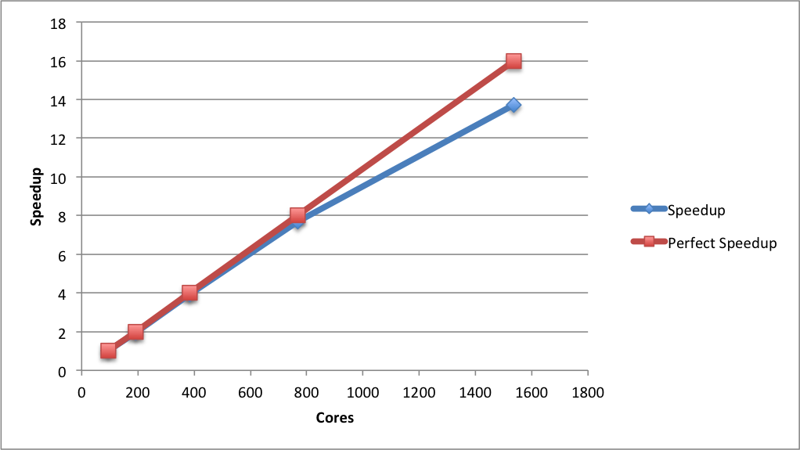

1. **Data Management and Transfer**

This section asks some basic questions about the data generated on Cirrus by the proposed calculations.

**7.1 How many files are typically produced by each job?**

[Enter the estimated number of files. This does not need to be exact, order of magnitude is sufficient here. For example, 1000 files per job. You should also state how these files are organised; for example, are they all stored in one directory or is there a hierarchy of directories?]

**7.2 How much data is read in by each job?**

[Enter estimated total size in MiB/GiB/TiB]

**7.3 How much data is produced by each job?**

[Enter estimated total size in MiB/GiB/TiB]

**7.4 What percentage of the produced data do you expect to transfer off Cirrus?**

[Enter estimated percentage]

**7.5 How do you plan to transfer data off Cirrus?**

[Please describe the mechanism you will use to transfer data from Cirrus to external sites for further analysis or archive. Please also state the sites that you will be transferring data to. You should also state roughly the amount of data that will be transferred in each transfer instance (i.e. how will the transfers be batched up).]

# Section 2: Technical Assessment (*To be completed by CSE team).*

**Date Received by CSE Service:** [Enter received date]

|  |  |
| --- | --- |
| Do the applicants have the technical expertise required for the proposed work? | Yes/No |
|  | |

|  |  |
| --- | --- |
| Is the software specified technically suitable for Cirrus? | Yes/No |
|  | |

|  |  |
| --- | --- |
| Is the compute time requested reasonable and have the resources requested technically justified? Are the storage requests reasonable? | Yes/No |
|  | |

|  |  |
| --- | --- |
| Is the data management and transfer plan reasonable and technically sound? | Yes/No |
|  | |

**Is the application, as outlined above, suitable for access to the Cirrus service?** **Yes / No**

|  |
| --- |
| Does the project require the technical capabilities of Cirrus?  Would a different computing resource be more appropriate? |
|  |

**Name:** [Enter name]

**Position:** [Enter job title]

**Date:** [Enter date completed]