Step 1: Fetch x-csrf-token  
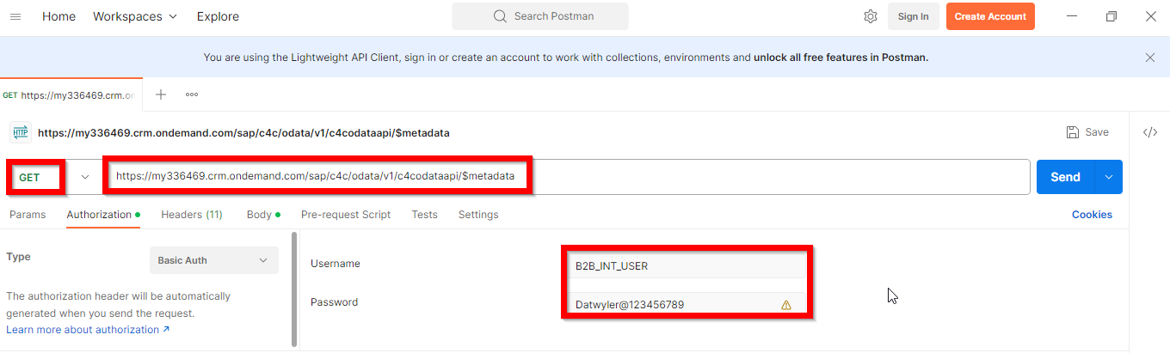  
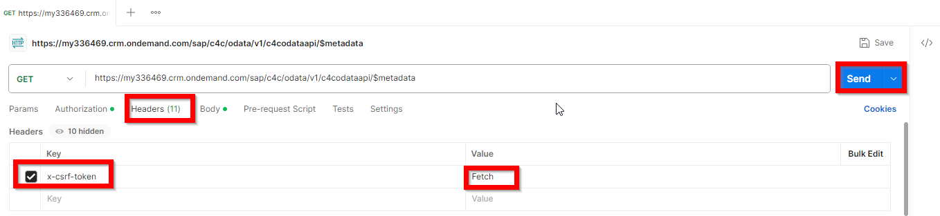  
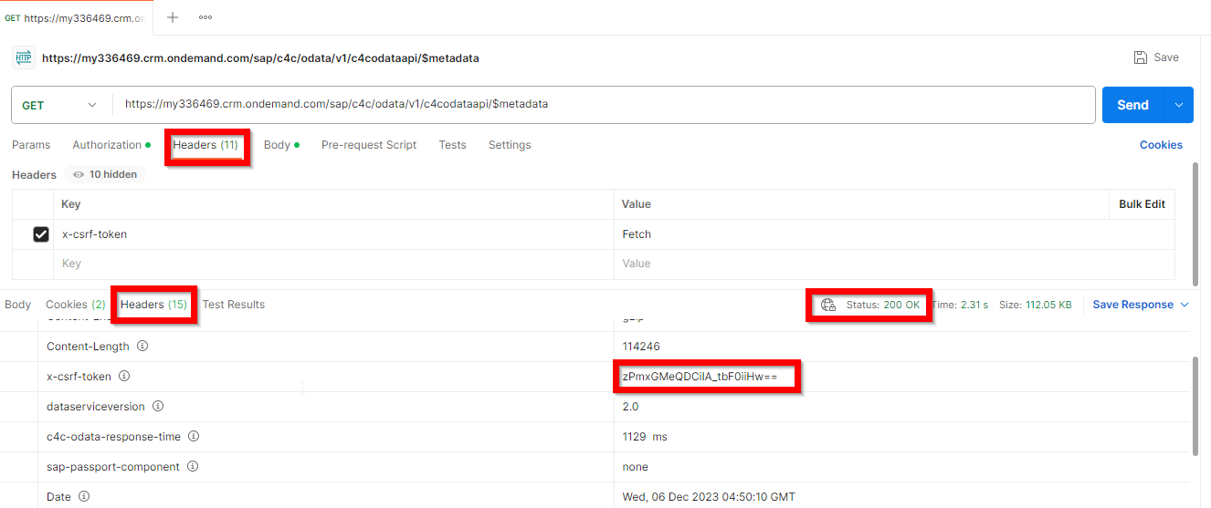  
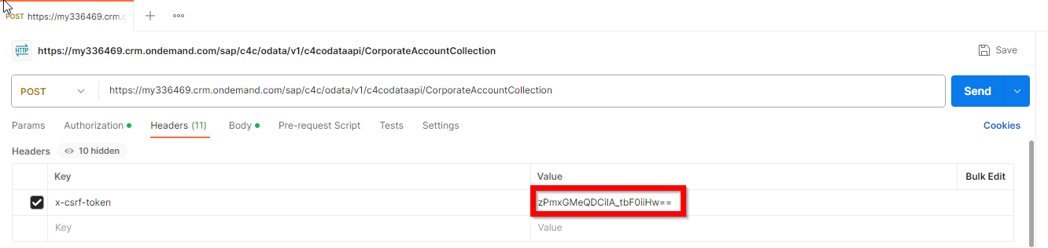  
  
Step 2: Fetching sample records.   
Login to C4C and search for GI data (filter data using Business field)and replace id in below links   
https://my336469.crm.ondemand.com/sap/c4c/odata/v1/c4codataapi/CorporateAccountCollection?$filter=AccountID eq '1000618'  
https://my336469.crm.ondemand.com/sap/c4c/odata/v1/c4codataapi/SalesQuoteCollection?$filter=ID eq '3275'  
  
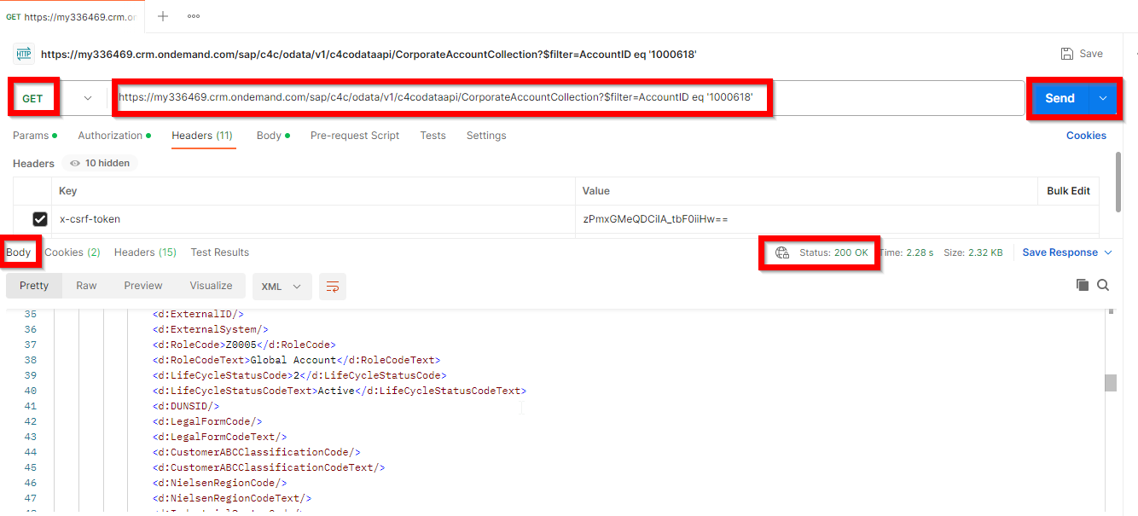  
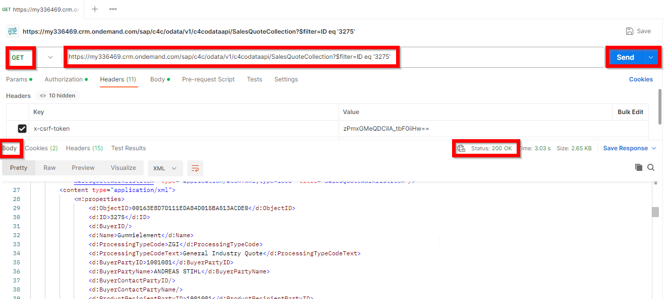  
Step 3: Using reference data creating new account and sales quote  
Account Creation Body:  
{

        "RoleCode": "BUP002",

        "LifeCycleStatusCode": "2",

        "Name": "Test Acc Creation ",

        "AdditionalName": "V2",

        "CountryCode": "DE",

        "HouseNumber": "123",

        "Street": "Test Street 1",

        "City": "Test City",

        "StreetPostalCode": "123",

        "Phone": "123456789",

        "Mobile": "123456789",

        "Fax": "123456789",

        "Email": "test@test.com",

        "WebSite": "http://www.test.com/",

        "LanguageCode": "EN",

        "OwnerID": "46",

        "Business": "141",

        "GeoRegion": "N3"

}

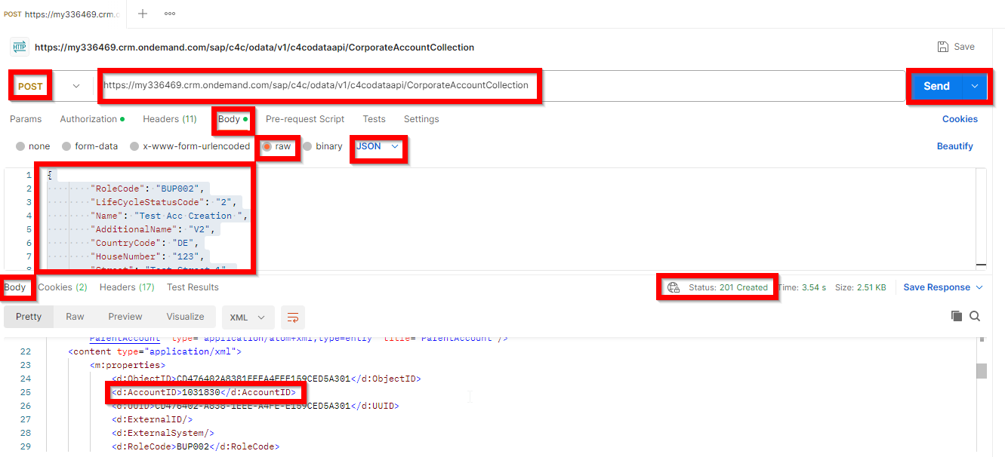  
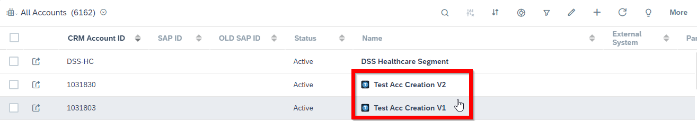  
  
Sales Quote Creation Payload:  
{

        "BuyerID": "1031830",

        "Name": "Test Sales Quote Creataion V1",

        "ProcessingTypeCode": "ZGI",

        "BuyerPartyID": "1031830",

        "ProductRecipientPartyID": "1031830",

        "EmployeeResponsiblePartyID": "8000000039",

        "SalesUnitPartyID": "AU_6000",

        "SalesOrganisationID": "AU_6000",

        "DistributionChannelCode": "01",

        "RequestedFulfillmentStartDateTime": "2023-12-09T22:00:00Z",

        "TimeZoneCode": "UTC",

        "CurrencyCode": "MXN",

        "DocumentLanguageCode": "EN",

        "DeliveryPriorityCode": "3",

        "ProbabilityPercent": "25.00",

        "Marketsubsegment": "381",

        "ProductionSite": "SMX",

        "SalesOrg": "SMX",

        "Segment_KUT": "GI"

        }

