Claire Lynch

November 23, 2020

IT FDN 100 A

Assignment 06

https://github.com/claire-al/IntroToProg-Python-Mod06

To-Do List with Functions

# Introduction

This week I expanded on my To-Do List script, by incorporating functions into it. I learned how to define the parameters in functions, how to call a function, how to use a return value or values, as well as understanding the difference between global and local variables. I also got more in-depth about how to use the debugger tool on PyCharm, and learned how to create a GitHub webpage.

# Functions

Functions group statements together, so that when the function is called in some other part of the script, it’ll do the grouped statements together. It can be useful to use a function if there’s some task you’re doing multiple times in your script, such as adding two values together at numerous points in a script. When writing a function, it may have parameters, which are values that are being passed in to be processed in the function. At the end of a function, you might return a value or values.

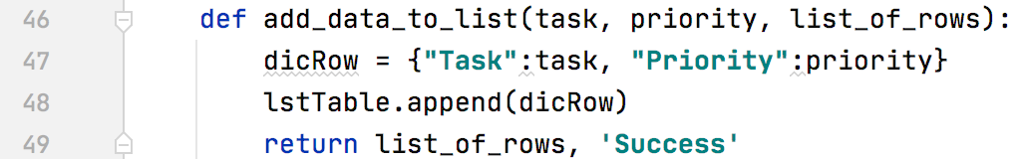

***Figure 1.1: An example of a function in my Assignment6 script. The function is named add_data_to_list, and it takes in task and list_of_rows as parameters. This function returns list_of_rows, and ‘Success’.***

# Global and Local Variables

Global variables can be used anywhere in a script, since they are defined outside of any function and instead in the “body” of the script. Local variables exist only in the function they’re defined in.

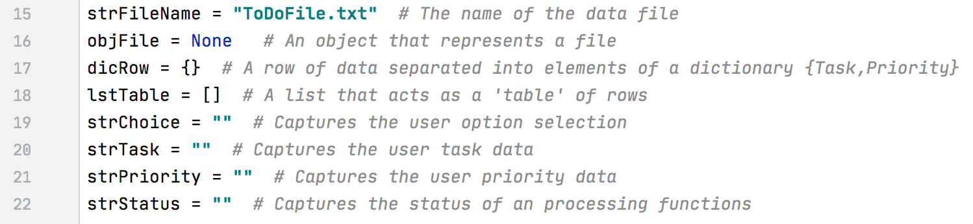

***Figure 2.1: Some global variables in my script.***

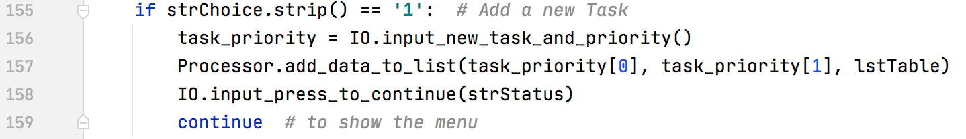

***Figure 2.2: task_priority would be a local variable, because it is only defined and can only be used in this part of the script.***

Debugging

The debugging tool is a useful tool to quickly find and fix issues with your script. In multiple instances in writing my script, I would write something that didn’t do what I wanted it to do. So to better understand and visualize what was going on, I used the debugger tool to step into the functions I was having trouble with and move through them, step-by-step, until I figured out where the issues were.

GitHub Webpage

Once again, I created a repository on GitHub named IntroToProg-Python-Mod06, which is where I uploaded my files. I created a GitHub webpage, which in future assignments, is where I’ll also document my knowledge in addition to this document.

Writing My Script

Writing this script was challenging in some ways, but easier in others. Although for Assignment 5 I was unsure of how I felt about having some of the script written, I found it much easier for this assignment. At first, it was challenging as I had to spend time understanding what was already written and what I actually needed to do, but once I did that, it made writing the actual script much quicker, which I really think is due to spending that “extra” time at first to understand what was going on. It was also nice to pull ideas from Assignment 5 into this assignment, since they’re accomplishing the same task, despite this script being function-based. The one thing I struggled with was keeping the script organized and minimizing areas of code that I wasn’t currently using, because otherwise I got confused and overwhelmed.

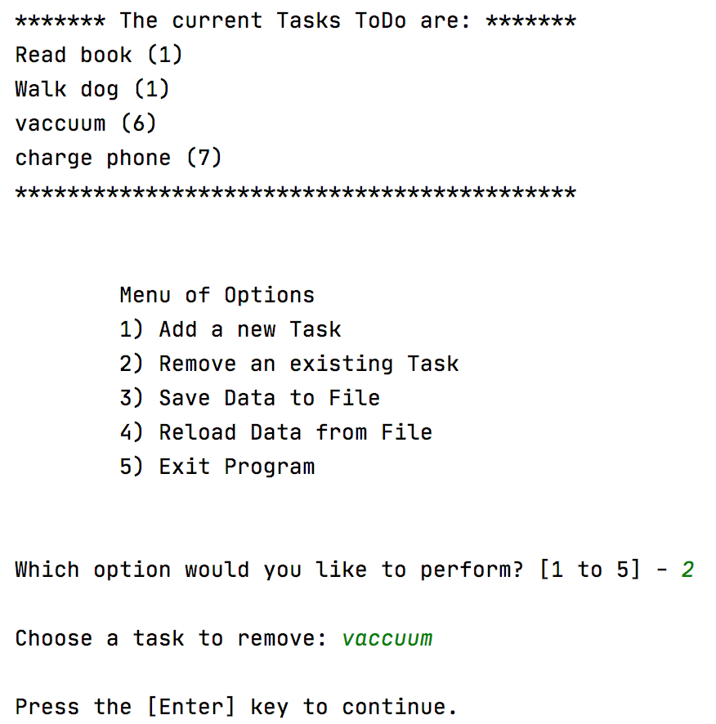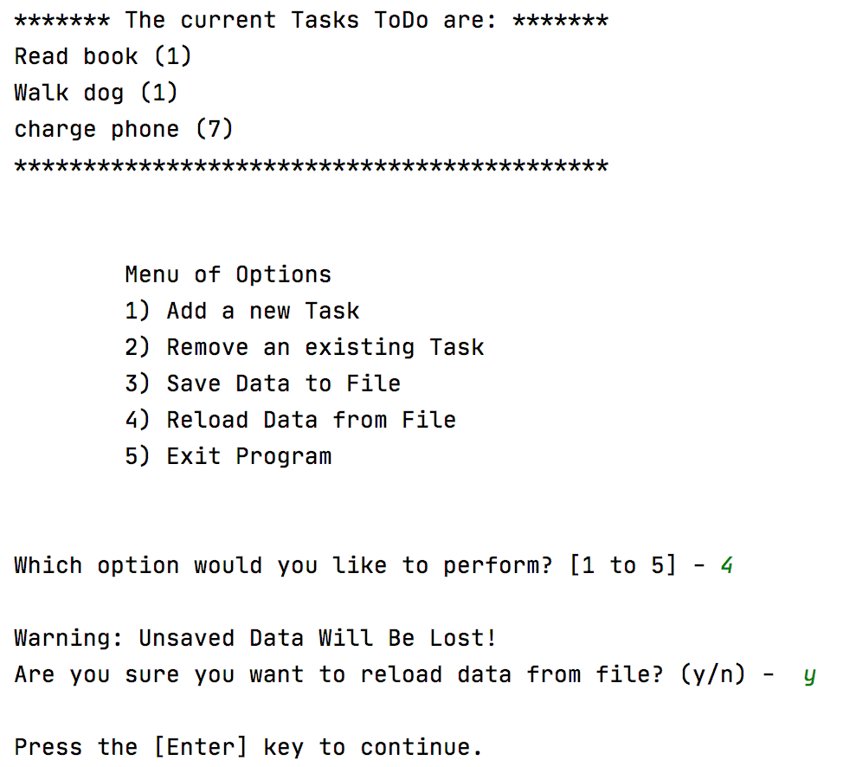

***Figure 3.1: An example of my script running on IDLE.***

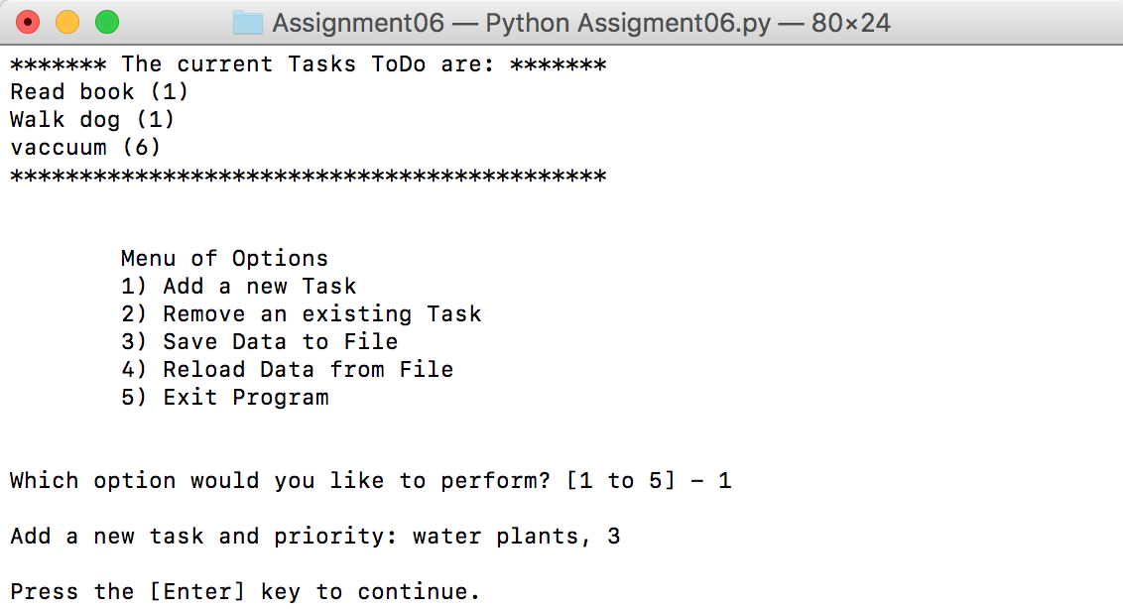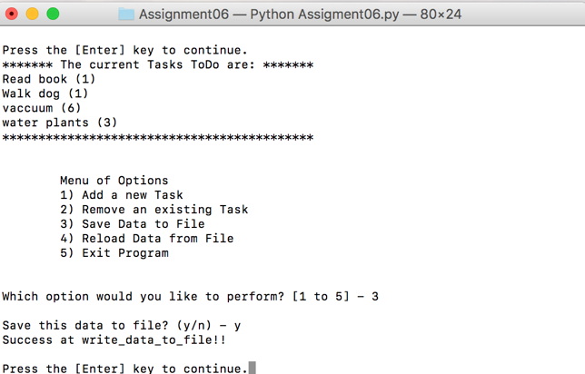

***Figure 3.2: An example of my script running from Terminal.***

# Summary

I really enjoyed writing this script! I liked the idea of using functions but struggled to use them when I tried in previous assignments, but having much of the script already written helped me write the functions for this program. I’m excited to use more functions in my future scripts, and I feel like I have a better understanding of how they work, as well as global and local variables, debugging, and GitHub, which will help me on the next assignments.