CMSC 150

Project

AY 2019-2020

SOLVERS and

OPTIMIZATION

BY: CLAIRE DANIELLE U. ERA

**user manual**

TABLE OF CONTENTS

estimation: polynomial regression solver 1-3

SELECT INPUT FILE 1

CHANGE DEGREE 2

CHANGE INDEPENDENT VARIABLE 2

GET ESTIMATE 2

RESULTS 3

optimization: simplex solver 4-6

INPUT VALUES IN TABLE 4

OPTIMIZE 5

SEE SPECIFIC TABLEAU 5

RESULTS 6

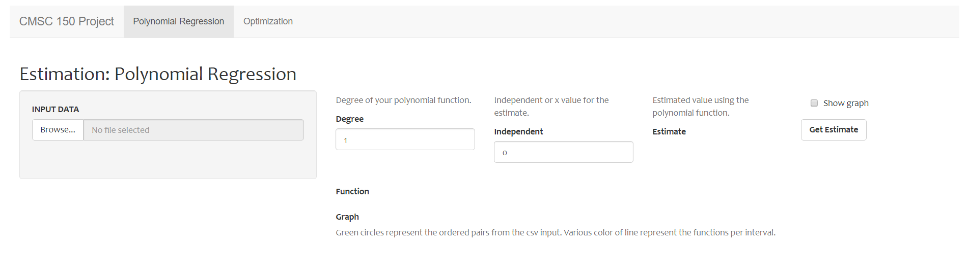

Fig. 1. Overview of Polynomial Regression Solver

1. Polynomial regression solver
2. Select input file

The solver only accepts (.csv) input files formatted like the example in Figure 2, corresponding to x and y values. After successfully uploading input data, the solver will show the uploaded data (Figure 3).

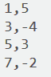

Fig. 2 Sample input file

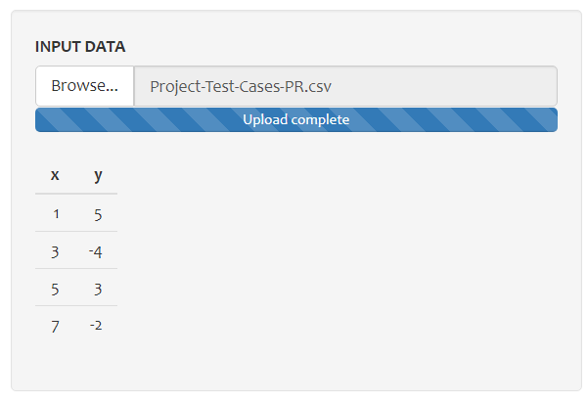

Fig. 3. Uploaded data

1

1. change degree

In the input field as illustrated in Figure 4, change the degree of the desired estimation of the polynomial function.

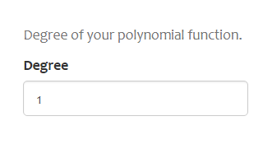

Figure 4. Degree input field

1. change independent variable

To get an estimate for a function value / independent variable, change as indicated in Figure 5.

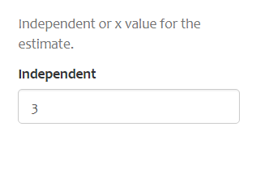

Fig. 5 Function Value Field

1. get estimate

Click on the button in Figure 6 to generate an estimate using the polynomial regression solver

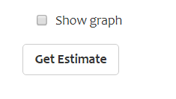

Fig. 6 Get Estimate button

2

1. results

After pressing the Get Estimate button, the solver will generate the a) corresponding function, b) corresponding function value estimate and c) a graph illustrating the function estimate, as shown in Figure 7.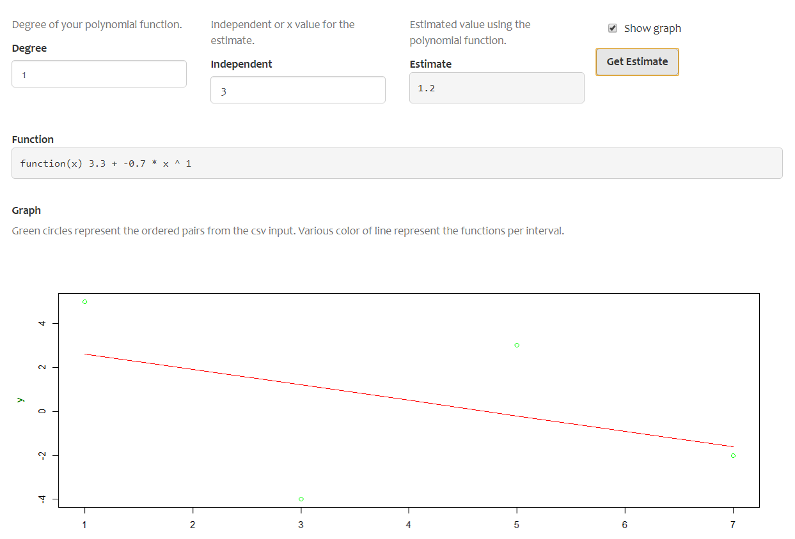

Figure 7. Overall result of the function estimate

3

1. optimization: simplex solver

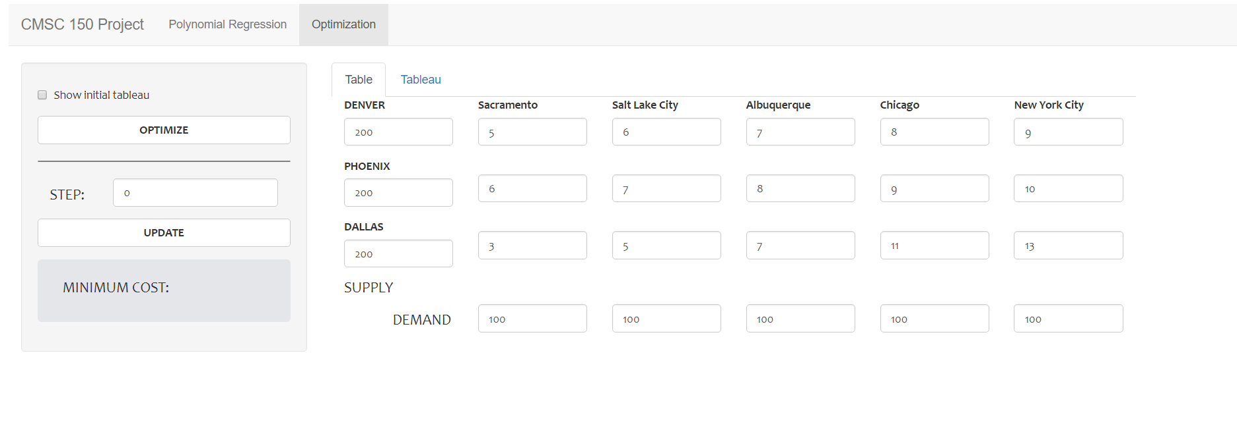

Fig. 9. Overview of the simplex procedure

1. INPUT VALUES IN TABLE

Enter specific values for computing cost when supplying to five different locations from three different plants. The demand fields are in the bottom part of the table and the supply fields can be changed in the first column of the table (Figure 9).

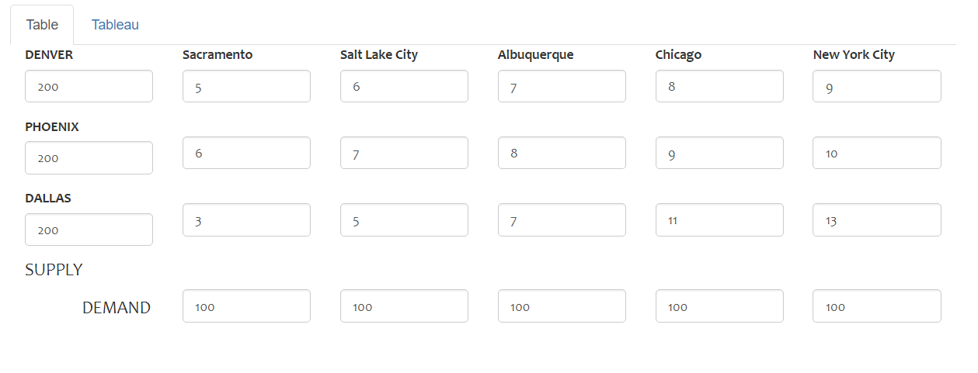

Figure 9. Input fields in the table

4

1. OPTIMIZE

Before clicking on the ‘Optimize’ button, the user has the option to show the initial tableau in the solution (Figure 10 and 11).

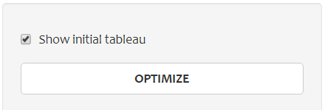

Fig. 10 Optimize button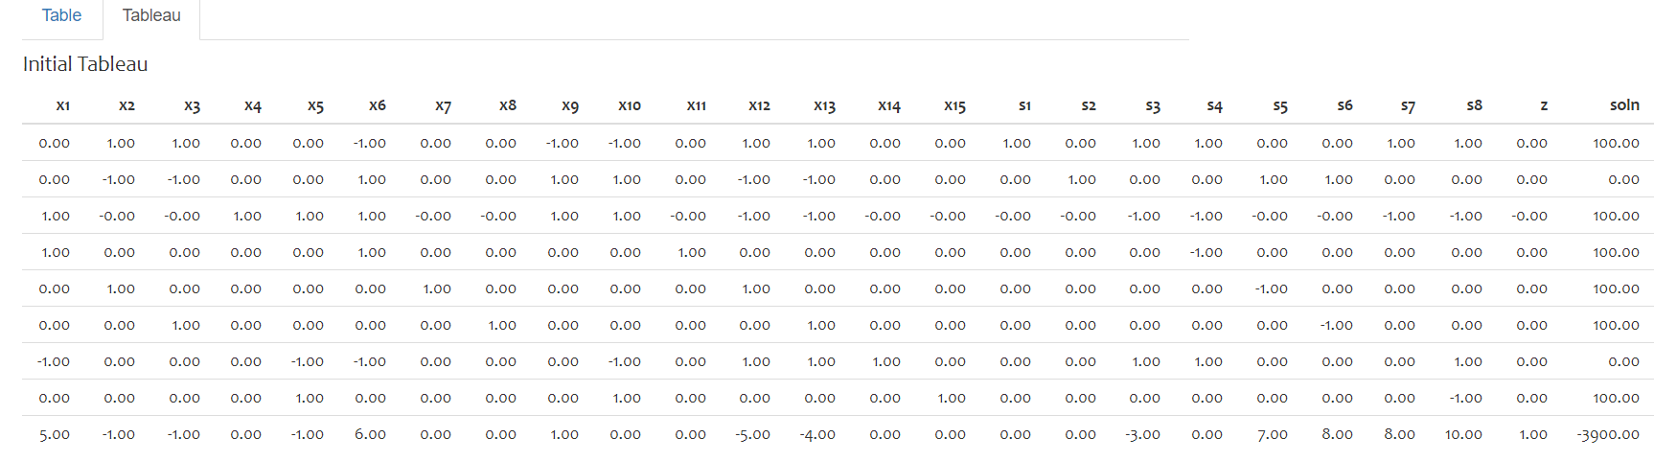

Fig. 11 Initial tableau illustrated when the checkbox is ticked

1. SEE SPECIFIC TABLEAU

The solver has the option of seeing only the specific result of the tableau depending on the current steps it took. If the entire solution took 5 steps to be optimized, the user can change the step from 1-5. Beyond the values, there will be no output to be shown (Fig. 12).

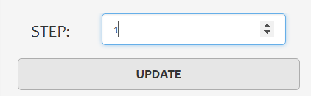

Fig. 12. Update button and input field for changing step number

5

1. RESULTS

Figures 13 and 14 have corresponding illustrations of the whole simplex solver.

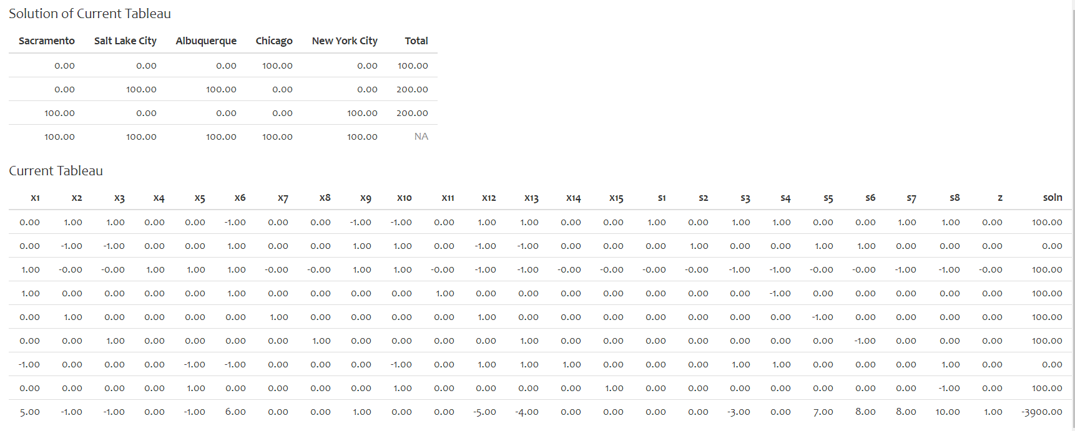

Fig. 13 Solution table for each 5 locations and current tableau

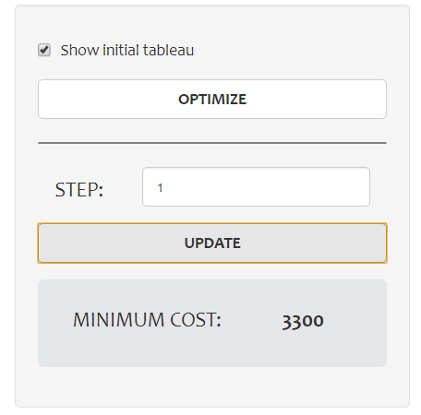

Fig. 14 Overall view of the modifications the user can tweak

6