University of California, Los Angeles

Framing Food and Authority:
A Social Media Analysis of Nutrition Influencers and
Audience Reactions

Marvin Deng, Cynthia Li, Claire Nabours, BingHong Ni, and Lily Wu
Digital Humanities 120
Professor Sabo
December 10, 2025

Abstract
In recent years, social media has become the main place where people get their health information, replacing traditional sources like doctors or government agencies. As a result, influencers on these platforms now play a major role in shaping how the public understands nutrition science. Many of these influencers lack formal training in nutrition, yet they still have significant influence over audiences through persuasive language and emotional appeals.
This project examines Nina Teicholz, one such influencer, to understand how she builds credibility and shapes public conversations on Twitter/X. We focus on her language choices, how she frames nutrition topics, and her patterns of audience engagement. Teicholz advocates for low-carb, high-fat, and animal-based diets—positions that contradict the dietary guidelines recommended by most public health organizations (Storz and Ronco; Volek et al.; Hoenselaar). Her stance places her at the center of ongoing debates about nutrition science and who should be considered a trusted authority. Her tweets often provoke strong emotional reactions and generate considerable public debate, making her a valuable case study for examining how influencers shape health discourse online.
Our research question is: How does Nina Teicholz use language and framing strategies to build authority around nutrition science on Twitter, and how do audiences respond with support, skepticism, or resistance? To address this question, we draw on digital rhetoric and discourse studies, using theories of epistemic authority, identity construction, and emotional influence in online health communication (Multas and Hirvonen; Lee and Theokary). Rather than evaluating the scientific accuracy of Teicholz's claims, we focus on understanding the persuasive techniques she employs and how audiences negotiate her credibility. By examining both her original tweets and the replies and quote tweets they generate, we can analyze how language serves as a tool for claiming expertise and shaping what counts as credible knowledge in contested domains like nutrition.

For our methodology, we combine close reading of selected tweets with controversy mapping and text analysis methods. We apply sentiment analysis and social network analysis to a dataset of Teicholz's posts from 2022 to 2024. We focus especially on tweets that generated high engagement, controversy, or backlash. We follow the approach Ellis et al. used, and we create linguistic and network visualizations that map out how users interact with and respond to Teicholz's claims. To analyze sentiment, we apply VADER and BERT models. These models capture the emotional tone in the replies, and from this we can see patterns of polarization. For the network analysis, we look at clusters of interaction and how ideological alignment shows up in the data. When we put all these methods together with qualitative discourse analysis, we're able to examine both the rhetorical form and the relational structure.

The scope of our research includes approximately 680 original tweets by Teicholz and over 560 public replies and quote tweets. Our data-driven and interpretive approach allows us to trace how rhetorical authority is built and challenged in real time. Our analysis focuses especially on posts related to dietary policy, government guidelines, and metabolic health, topics that repeatedly attract polarized attention and signal deeper tensions in the cultural politics of health (Cena and Calder; Goedeke et al.; Najjar). By situating our work within the broader conversation on influencer epistemology and contested science communication, our project contributes to the growing field of digital humanities by illustrating how authority, controversy, and emotional dynamics intersect in the everyday digital performances of nutrition influencers. Our findings show that influencers like Teicholz don't just reflect what people already think—they actively shape what gets recognized as credible health knowledge

Literature Review
Our research looks at how nutrition influencers on social media build authority and convince audiences to follow controversial diets, especially when there's a lot of scientific uncertainty. Previous studies have looked at either the science of different diets or how influencers communicate, but not many have examined how the unclear nature of nutrition research actually helps influencers gain authority online. We're trying to fill this gap by studying how Nina Teicholz promotes low-carb diets through her language, tone, and framing strategies on X (formerly Twitter).

Much literature confirms there is no singular or universally accepted definition of a “healthy diet,” leaving room for competing interpretations. Cena and Calder offer a foundational review of healthy dietary patterns, emphasizing whole-diet approaches over nutrient-specific claims (Cena and Calder). Their summary of global consensus guidelines establishes what evidence-based nutrition looks like. This article frames a professional benchmark against which we contrast the simplified, reductionist claims advanced by Teicholz. Her promotion of rigid carnivore and low-carb regimens ignores the flexibility upheld by consensus science.

Additional studies support our understanding of the ambiguity that influencers exploit. Volek et al. argue for the metabolic benefits of low-carb diets, while Storz and Ronco highlight nutrient deficiencies. Goedeke et al. further complicate the picture by showing that carnivore diets meet some nutrient benchmarks while failing others. These different conclusions demonstrate that nutrition science is still being debated and can be exploited by people like Teicholz, who say they're cutting through all the confusion.

Scientific complexity alone does not explain why audiences are receptive to nontraditional voices. Hoenselaar examines how official dietary guidelines misrepresented research on saturated fat. He identifies internal inconsistencies in public health messaging (Hoenselaar), which creates tension around institutional authority and suggests it can be challenged. Influencers like Teicholz use these inconsistencies to their advantage. They position themselves as people trying to correct mistakes, not just as contrarians. When they point out flaws or potential bias in official recommendations, they build a sense of independence that appeals to audiences who are already skeptical of mainstream advice.

Persuasive communication isn't just about content—it also depends on how messages are structured and how they spread. Tripathi et al. created a three-step model of persuasion in nutrition content: attention, retention, and action. This model demonstrates that emotional appeals and storytelling are necessary to move people from simply seeing content to actually changing their behavior (Tripathi et al.). The way they emphasize trust-building is similar to the tactics Teicholz uses to keep her audience engaged. Our project extends this model from YouTube to X, demonstrating how its persuasive logic holds across platforms.

Ellis et al. also analyze nutrition discourse on Twitter. They find that posts with high engagement tend to use simplified language and emotional tone (Ellis et al.). Through network analysis, they demonstrate that influence comes more from communicative style and social positioning than from having credentials or expertise. This study connects to our methods and backs up our argument that Teicholz's rhetorical success depends on how she presents information. While Ellis et al. map broad topic-level discourse, we focus on a single influencer to examine the mechanics of trust, contestation, and rhetorical legitimacy.

Together, these sources show that nutrition communication online is shaped by more than just facts. It is structured by ambiguity, trust, and social performance. Our project adds a multi-level analysis of how one influencer navigates these dynamics to position herself as an authority and how her audience negotiates that authority in a contested space. By combining sentiment analysis, topic modeling, and engagement mapping, we illuminate how scientific complexity becomes a resource for persuasive storytelling.

Platform, Topic, and Selection Criteria
Our study uses Twitter/X as the primary platform for examining Nina Teicholz’s communication strategies and the ways audiences respond to her messages about nutrition science. Twitter’s design creates an environment where authority is negotiated in real time. Because users can immediately challenge, support, or reinterpret posts, the platform allows us to analyze both how Teicholz constructs her credibility and how audiences participate in reinforcing or contesting it. Focusing on Twitter connects directly to our research question by allowing us to observe not only Teicholz’s rhetorical strategies but also the networked interactions that shape her perceived authority within contentious nutrition debates.

The topic of this study centers on the strategies Teicholz uses to position herself as a credible figure within nutrition science and the forms of audience response these strategies generate. Teicholz is a relevant case because her critiques of mainstream dietary guidelines have attracted substantial attention, high engagement rates, and polarized responses. Her tweets often frame her as a corrective voice challenging institutional authority. For example, one tweet from our dataset states “The government HAS NO CAPS ON CHOLESTEROL… for a reason. The evidence wasn’t there.” (Tweet ID 1902826613655355550). Posts like this position her as someone unveiling overlooked truths, making her a useful subject for analyzing how expertise is constructed outside traditional scientific channels.

Our dataset includes publicly available tweets, replies, and quote tweets collected using the Twikit API. Only posts accessible at the time of collection were included, and no private or deleted material was scraped. To analyze audience composition, we later categorized the accounts Teicholz mentioned into experts, media organizations, and others. This allowed us to track her outward communication patterns, such as whether she cites research actors or engages primarily with general audiences. Data excerpts in this paper are anonymized when referencing non-public figures. We do not include their names or full replies but instead summarize audience reactions. For example, some replies criticized her interpretation of CDC guidance, others expressed support for her dietary advice, and some described personal health experiences. These examples show the diversity of audience engagement from critical debate to supportive commentary and were used in aggregate for analysis rather than to identify individual users.

Several limitations accompany this study. Because we analyze only public Twitter activity, our findings cannot account for private communications or interactions occurring on other platforms where Teicholz may engage differently. The dataset represents a particular timeframe and may not fully capture evolving communication strategies or shifts in audience composition over longer periods. Our computational tools, such as sentiment scoring and classification, may oversimplify complex or sarcastic expressions, introducing errors in interpretation. Despite these constraints, the dataset offers a detailed view of Teicholz’s public-facing discourse and the responses it generates, enabling a systematic approach to studying online authority construction.

Data snippets support key findings throughout the analysis. For instance, counts of mentioned accounts show that expert accounts appear 35 times, media accounts 14 times, and “other” accounts 160 times, demonstrating that most interactions occur outside formal scientific or journalistic communities. All examples follow research-ethics guidelines by avoiding identification of individual non-public users while highlighting patterns essential to answering our research question.

Methods
To understand how Nina Teicholz communicates authority and interacts with her audience on Twitter, we scraped her tweets and replies using a Python script. We focused on her most widely viewed tweets and replies with the most likes to capture posts with the highest public engagement. After constructing the dataset, we applied calculations to measure patterns in her communication and the structure of her interaction network. These quantified how often she mentions others, how broadly she reaches different communities, and how her messaging reflects audience priorities.

The five calculations used in this analysis were:
- In-Degree Centrality (Mention Frequency)
- Out-Degree Centrality (Interaction Breadth)
- Mention Network Density (Structural Sparsity)
- Audience Composition (“Populist” Ratio)
- Topic-Sentiment Analysis (Audience Response by Theme)

1. In-Degree Centrality (Mention Frequency)
In-degree centrality was calculated to measure how often each user was referenced by Nina, with higher values indicating accounts she cited more frequently. The formula was In-Degree Centrality(v) = in-degree(v) / (N − 1), where in-degree(v) is the number of times Nina mentioned a user, and N is the total number of nodes (229). Since Nina is the only author, every mention originates from her, and each account receives either zero or one incoming edge. Using this formula, Nina’s in-degree centrality is 1/(299 − 1) = 1/298 = 0.004386.

2. Out-Degree Centrality (Interaction Breadth)
Out-degree centrality was used to quantify how many unique accounts Nina mentions, with higher values indicating broader outreach. The formula was Out-Degree Centrality(v) = out-degree(v) / (N − 1), where out-degree(v) is the number of unique users Nina mentioned (228) and N is the total nodes (229). Using this formula, Nina’s out-degree centrality is 228 / 228 = 1.0.

3. Mention Network Density (Structural Sparsity)

Density measures how many edges exist in a network relative to the maximum possible, with low values indicating sparse interaction. It was calculated as D = E / (N * (N − 1)). With 229 nodes, 229 actual edges, and 52,212 possible edges, the density is 229 / 52,212 = 0.004386, or 0.0044, indicating an extremely sparse network.

4. Audience Composition (“Populist” Ratio)
This calculation determined whether Nina Teicholz prioritizes experts or the general public by categorizing the accounts she mentions. Percentages were calculated as Account Percentage =
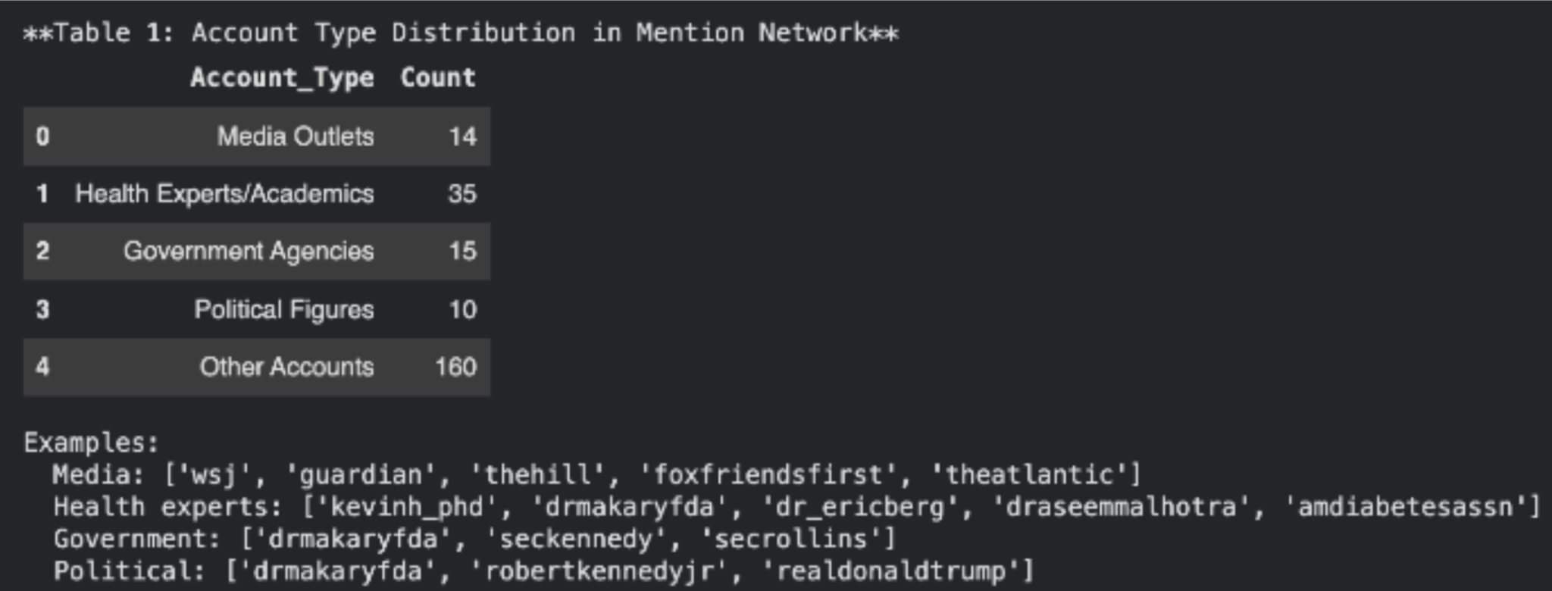
Table 1: Account Type Distribution in Mention Networks
Count of Specific Category / Total Mentioned Accounts × 100. Of the 229 total nodes, 160 were categorized as “Other,” producing 160 / 229 = 0.69869, or approximately 70 percent. As shown in Table 1, about 70 percent of all mentioned accounts fall into the “Other” category.

5. Topic-Sentiment Analysis (Audience Response by Theme)

To assess audience reactions, LDA topic assignments were linked to RoBERTa-derived sentiment scores for 568 replies, ranging from -1 (strongly negative) to +1 (strongly positive). For each topic, we calculated the mean sentiment and the percentage of positive, neutral, and negative replies. For example, Topic 8 had 33 replies totaling +11.187, yielding a mean of +0.339 and 57.6 percent positive responses.
Topic | Keywords | Replies | Mean Sentiment | Positive | Negative
8 | guideline, dietary, new, usda | 33 | +0.339 | 57.6% | 27.3%
6 | weight, loss, better, nutrition | 54 | +0.192 | 48.1% | 29.6%
3 | disease, guideline, chronic, american | 13 | -0.559 | 0.0% | 69.2%
1 | diabetes, type, disease, people | 26 | -0.436 | 7.7% | 61.5%
Table 2: Topic-Sentiment Analysis Summary

To understand Nina Teicholz’s communication strategies, we visualized her Twitter activity, examining network structure, hashtag use, audience reactions, and the thematic organization of her posts.

The five visualizations included in this analysis were:
- Hashtag Network Density
- BERT Sentiment Analysis
- LDA Intertopic Distance Map
- BERT Intertopic Distance Map
- Topic-Sentiment Distribution

1. Hashtag Network Density
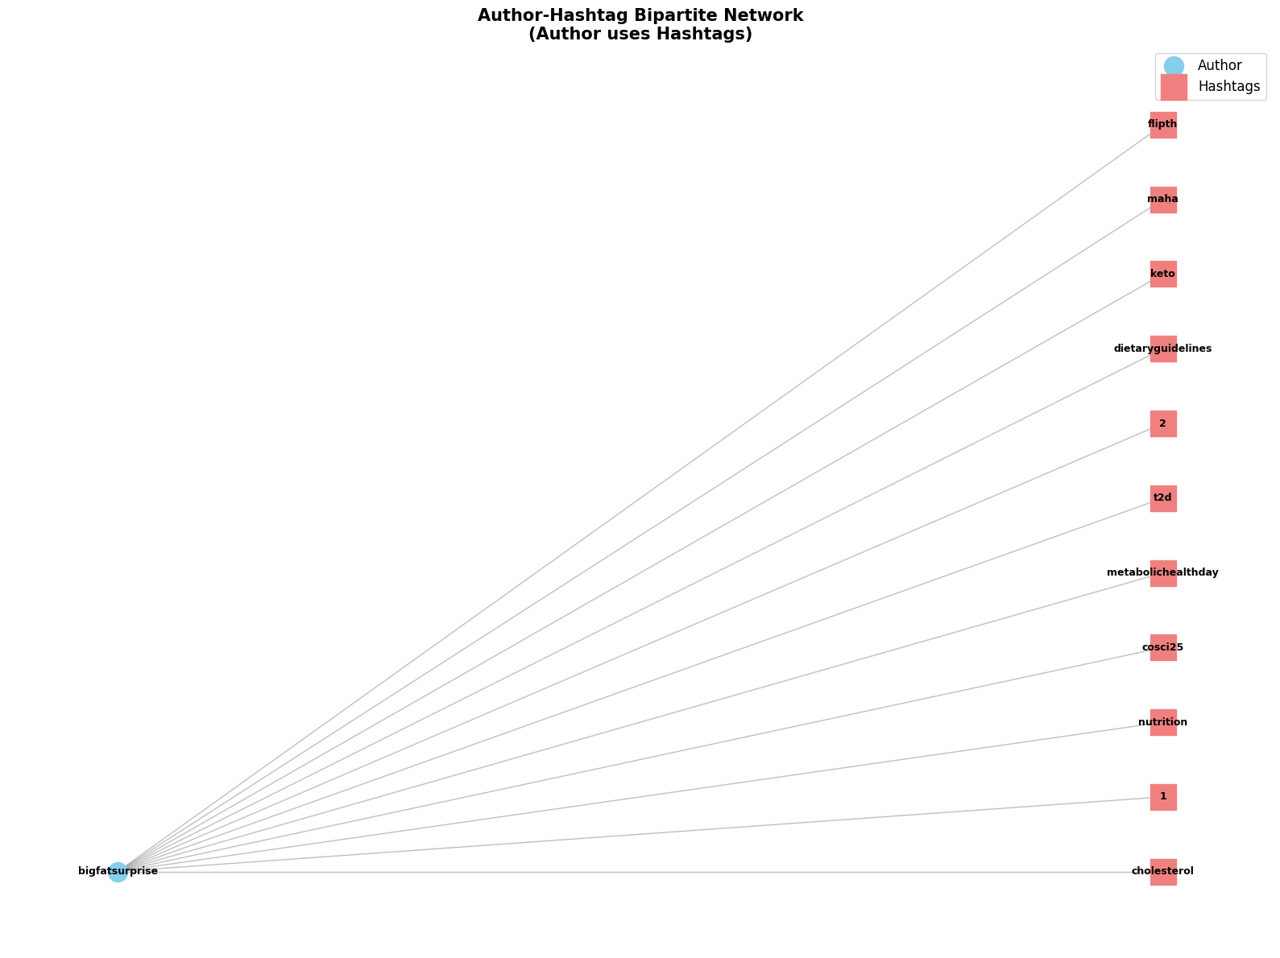
Figure 1: Author-Hashtag Bipartive Network Visualization

The author-hashtag bipartite network (12 nodes, 11 edges, density 0.1667) was used to examine Nina Teicholz’s topical framing strategy (Figure 1). All 11 hashtags have maximum degree centrality of 1.0, each connecting to the single author node. The projected hashtag network is fully connected (density 1.0), showing all hashtags co-occur across her tweets. These measures provide the structural basis for understanding how Teicholz deploys hashtags within her discourse.

2. BERT Sentiment Analysis
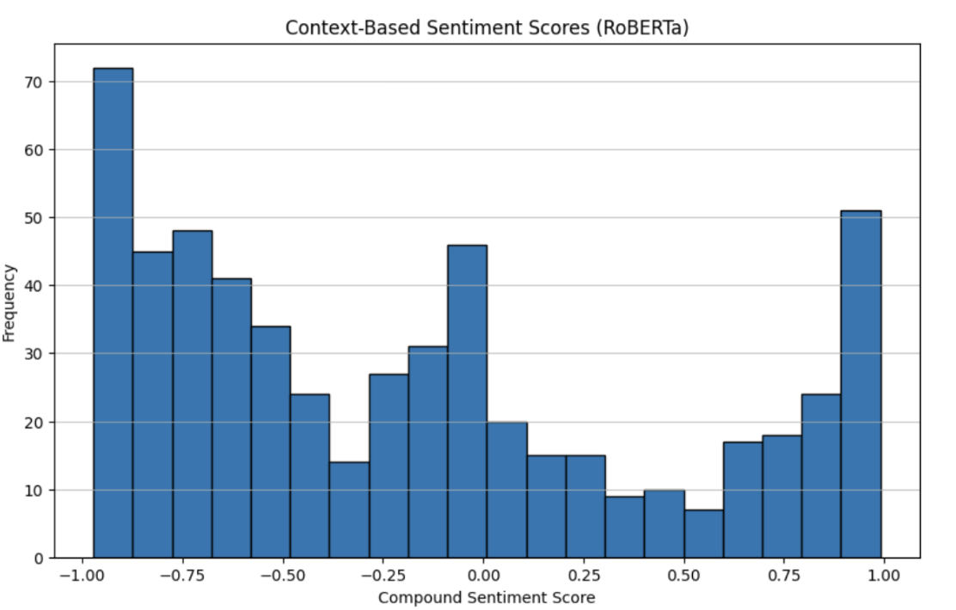
Figure 2: Context-Based Sentiment Scores Histogram

VADER sentiment analysis was inconclusive, as most replies were categorized as neutral, likely because tokenization evaluated individual phrases without full context. To address this, we applied a BERT transformer model for context-aware sentiment analysis, better suited for nuanced language, including sarcasm. Using these BERT-derived scores, Figure 2 shows the sentiment histogram of replies to Nina’s posts.

3. LDA Intertopic Distance Map
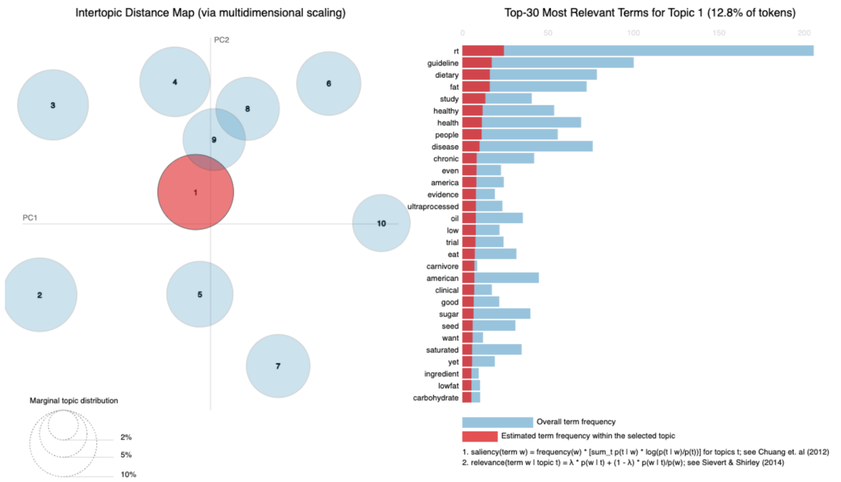
Figure 3: LDA Intertopic Distance Map & 30 Most Relevant Terms
The intertopic distance map from Run #3, shown in Figure 3, was used to examine the semantic relationships among topics in Nina’s tweets. This visualization plots topics in a two-dimensional space based on their similarity, allowing us to identify clusters, separations, and thematic patterns across the model output.

4. BERT Intertopic Distance Map
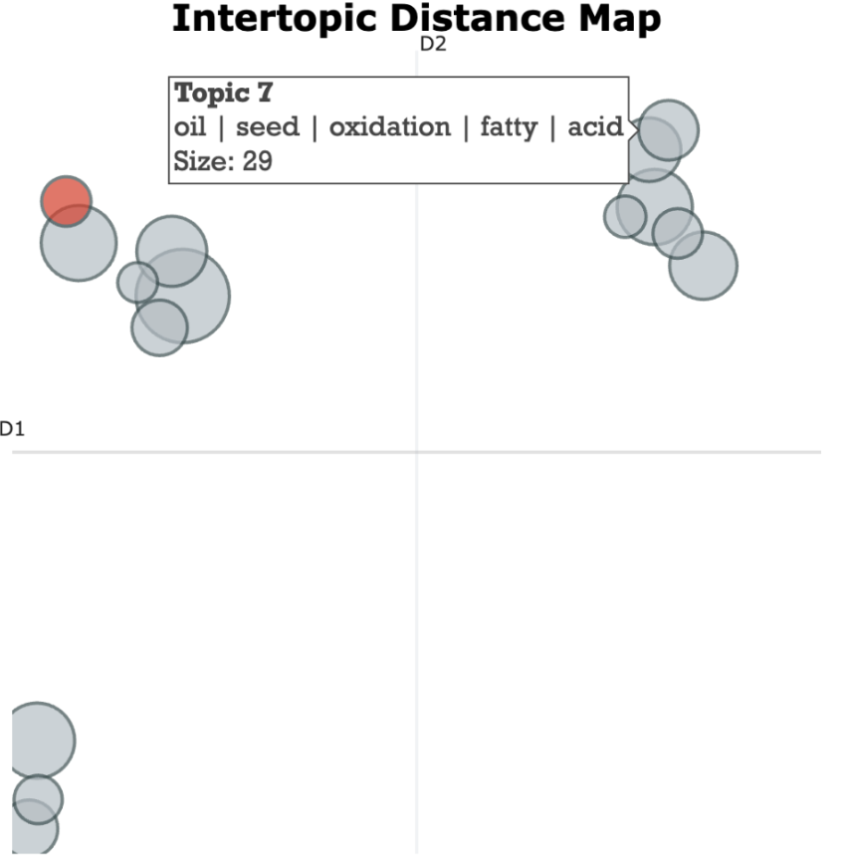
Figure 4: BERT Intertopic Distance Map

The intertopic clustering of Nina’s posts was examined to identify how her tweets group into broader thematic categories. This clustering approach allows topics to be interpreted in relation to one another, highlighting how different themes form coherent regions within the model’s semantic space.

5. Topic-Sentiment Distribution Visualization
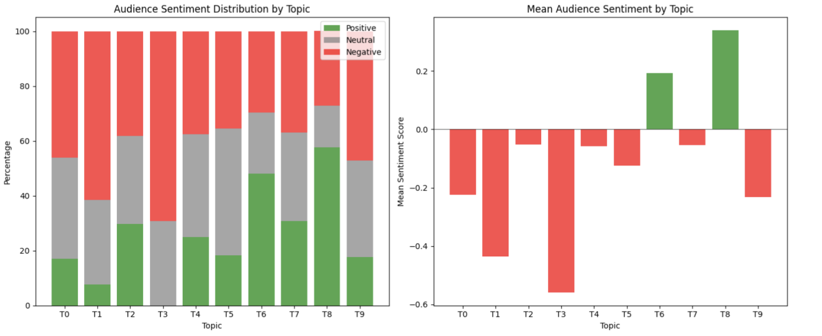
Figure 5: Topic-Sentiment Distribution Visualization
The topic-sentiment visualization (Figure 5) shows audience sentiment across ten LDA topics using two charts. The left panel presents a stacked bar of positive, neutral, and negative replies per topic, while the right panel shows mean sentiment per topic. Together, they reveal patterns in how audiences respond to different aspects of Nina’s messaging.

Findings
Our methods yielded key insights into Nina Teicholz’s communication strategies and audience responses. Nina’s very low in-degree centrality shows she is rarely mentioned by others, and her references are spread across many accounts. Since each account receives only one mention from her, she reaches a wide audience rather than interacting repeatedly with a small group. With an in-degree value of 0.004386, it is clear she is not a central conversational hub, as her interactions are mostly one-way. This pattern targets multiple communities, such as nutrition researchers, policymakers, low-carb advocates, and public-health critics. Overall, her posts function less as two-way exchanges and more as outward-facing signals that influence audiences.

Out-degree centrality shows Nina reaches the maximum possible value, mentioning nearly every other account in the network at least once. This indicates broad outward communication and suggests her posting behavior aims to reference, tag, or signal many different individuals and communities rather than engage deeply with a smaller circle. Her out-degree of 1.0 reflects a broadcasting style, amplifying accounts and positioning content to circulate widely. Combined with low in-degree, this pattern emphasizes outward dissemination over reciprocal dialogue, highlighting her deliberate communication approach.

Network density further illustrates this one-way communication. With a density of only 0.0044, Nina’s posts create minimal interaction among users, confirming she does not facilitate a community conversation. Interaction remains centered on her original posts, reinforcing a broadcasting strategy rather than fostering dialogue among users.

This pattern aligns with her populist approach to authority. About 70 percent of accounts she mentions fall into the “Other” category, with limited engagement with credentialed experts (35 mentions) or media actors (14 mentions). Limiting interaction with formal authorities positions her as an independent corrective voice offering alternative interpretations of nutrition science and establishing credibility with her audience.

Audience responses, measured via sentiment analysis, vary systematically across content types. The sentiment histogram demonstrates polarization, with most replies highly positive (+0.9 to +1.0) or strongly negative (−0.9 to −1.0), while neutral or mild responses are rare. Topic-level sentiment analysis reinforces this: critiques of USDA dietary guidelines (Topic 8) and weight-loss content (Topic 6) receive the most positive responses, while disease-related topics (Topics 1 and 3) provoke the strongest negative reactions.

Network and topic analyses show how Nina constructs authority through framing. Hashtags integrate scientific concepts, institutional critiques, and sociopolitical slogans, weaving a cohesive narrative. Topic clustering reveals three thematic categories: nutrition science critique and policy debate, applied health and diet interventions, and food system/industry critique. Together, these findings indicate Nina uses strategic language and framing to assert authority in nutrition debates, eliciting polarized responses and shaping public perception.

These limits also shape interpretation. Since the network reflects only visible replies and mentions, Nina’s low in-degree and absence of reciprocal dialogue may partly reflect platform behavior rather than her full communication practices. Sentiment patterns may shift with a larger or cross-platform corpus. Even with these constraints, the dataset offers a reliable view of her public-facing authority strategy and allows us to systematically address our research question.

Conclusion
This project examined how Nina Teicholz constructs authority on Twitter/X and how audiences respond to her rhetoric. Using network analysis, sentiment modeling, and controversy mapping, we found that Teicholz employs a broadcast-style communication strategy. Her out-degree centrality is maximized (1.0), while her in-degree is minimal (0.0044), showing she frequently mentions others but is rarely engaged in return. She overwhelmingly interacts with general users (~70%), rarely citing experts or media (~21%). This sparse, one-way structure (density = 0.0044) reflects authority built through wide reach rather than reciprocal dialogue.

These findings align with Multas and Hirvonen’s view that influencer credibility stems from narrative authenticity rather than credentials, and with Lee and Theokary’s argument that emotional tone outweighs factual accuracy. Teicholz receives the most positive responses when critiquing institutions (Topic 8, mean sentiment +0.339) and the most negative when discussing diseases (Topics 1 and 3, -0.436 and -0.559), supporting Ellis et al.’s claim that communicative framing shapes influence. Our sentiment histogram (Figure 2) confirms a polarized response pattern with minimal neutrality.

Through controversy mapping, we visualized how Teicholz’s rhetorical strategies structure the discourse. This method helped reveal how she uses emotionally charged narratives to navigate contested scientific terrain. By framing nutrition science as corrupt or misleading (Cena and Calder; Hoenselaar) and amplifying scientific ambiguity (Goedeke et al.; Volek et al.), she positions herself as a corrective authority figure. Her influence thus depends less on evidence and more on strategic framing, emotional tone, and digital positioning.

Several limitations offer directions for future research. Our dataset includes only public Twitter activity from 2022 to 2024 and excludes other platforms like TikTok, Instagram, or YouTube, where visual and video rhetoric play larger roles. This scope limits our ability to track long-term shifts in strategy or cross-platform adaptation. Sentiment models may also misread sarcasm or technical language, and our aggregate analysis does not distinguish between audience subgroups. As a result, we cannot determine whether critical replies come from experts, rival communities, or casual users. Future research could expand across platforms, segment user types, and incorporate interviews to better understand motivations and variation in response, offering a fuller view of influencer authority in digital health discourse.

Our findings show that Teicholz’s influence is grounded in selective framing, emotionally charged messaging, and the strategic use of contested scientific spaces. By engaging broadly with general users and minimizing interaction with experts, she constructs authority through reach and tone rather than reciprocal dialogue or credentialed expertise. This pattern, highlighted through controversy mapping, illustrates how scientific uncertainty becomes a rhetorical asset, allowing her to position herself as a corrective voice outside institutional channels.

Based on this analysis, we recommend that public health organizations prioritize trust-building strategies that address uncertainty directly and use emotionally resonant, accessible storytelling. Platform designers should reassess how algorithmic structures reward one-directional broadcasting and explore ways to promote dialogic engagement. Researchers may find greater impact by collaborating with trusted community figures who already hold influence in online health spaces. Finally, media literacy educators should help audiences identify patterns of emotional framing and rhetorical authority that signal strategic provocation. These approaches can support more effective and credible communication in increasingly polarized health information environments.

Mass Communication
We created a publicly available website using WIX to make our findings accessible. The website uses clear, concise language and visually organized data. We included headings and subheadings for clarity, avoided jargon, and explained important topics for broader audiences.

Here is our Mass Communication website: https://cnabours.wixsite.com/framingfoodauth

Works Cited
Cena, Hellas, and Philip C. Calder. “Defining a Healthy Diet: Evidence for the Role of Contemporary Dietary Patterns in Health and Disease.” Nutrients, vol. 12, no. 2, 27 Jan. 2020, pp. 1–15, pmc.ncbi.nlm.nih.gov/articles/PMC7071223/, https://doi.org/10.3390/nu12020334.
Ellis, Cassandra H., et al. “Social Network and Linguistic Analysis of the #Nutrition Discourse
on the Social Network Platform X, Formerly Known as Twitter.” Social Network Analysis
and Mining, vol. 14, no. 1, 20 Dec. 2024, https://doi.org/10.1007/s13278-024-01404-9.
Goedeke, Sylvia, et al. “Assessing the Nutrient Composition of a Carnivore Diet: A Case Study Model.” Nutrients, vol. 17, no. 1, 31 Dec. 2024, p. 140, https://doi.org/10.3390/nu17010140.
Hoenselaar, Robert. “Saturated Fat and Cardiovascular Disease: The Discrepancy between the
Scientific Literature and Dietary Advice.” Nutrition, vol. 28, no. 2, Feb. 2012, pp. 118–123, https://doi.org/10.1016/j.nut.2011.08.017.
Lee, Michael T., and Carol Theokary. “The Superstar Social Media Influencer: Exploiting
Linguistic Style and Emotional Contagion over Content?” Journal of Business Research,
vol. 132, no. 2021, Aug. 2021, pp. 860–871, www.sciencedirect.com/science/article/abs/pii/S0148296320307657, https://doi.org/10.1016/j.jbusres.2020.11.014.
Multas, Anna-Maija, and Noora Hirvonen. ““Let’s Keep This Video as Real as Possible”: Young
Video Bloggers Constructing Cognitive Authority through a Health-Related Information Creation Process.” Journal of Documentation, vol. 78, no. 7, 31 May 2021.
Najjar, Rami. “The Impacts of Animal-Based Diets in Cardiovascular Disease Development: A Cellular and Physiological Overview.” Journal of Cardiovascular Development and Disease, vol. 10, no. 7, 30 June 2023, pp. 282–282, https://doi.org/10.3390/jcdd10070282.
Storz, Maximilian Andreas, and Alvaro Luis Ronco. “Nutrient Intake in Low-Carbohydrate Diets in Comparison to the 2020–2025 Dietary Guidelines for Americans: A Cross-Sectional Study.” British Journal of Nutrition, vol. 129, no. 6, 22 June 2022, pp. 1023–1036, https://doi.org/10.1017/s0007114522001908. Accessed 22 Nov. 2025.
Tripathi, Jayanshi, et al. “The Three-Step Persuasion Model on YouTube: A Grounded Theory Study on Persuasion in the Protein Supplements Industry.” Frontiers in Artificial Intelligence, vol. 5, no. 838377, 12 Oct. 2022, https://doi.org/10.3389/frai.2022.838377.
Volek, Jeff S., et al. “Expert Consensus on Nutrition and Lower-Carbohydrate Diets: An Evidence- and Equity-Based Approach to Dietary Guidance.” Frontiers in Nutrition, vol. 11, no. 1376098, 29 Feb. 2024, https://doi.org/10.3389/fnut.2024.1376098. Accessed 22 Nov. 2025.

