Veille technologique

Feedly

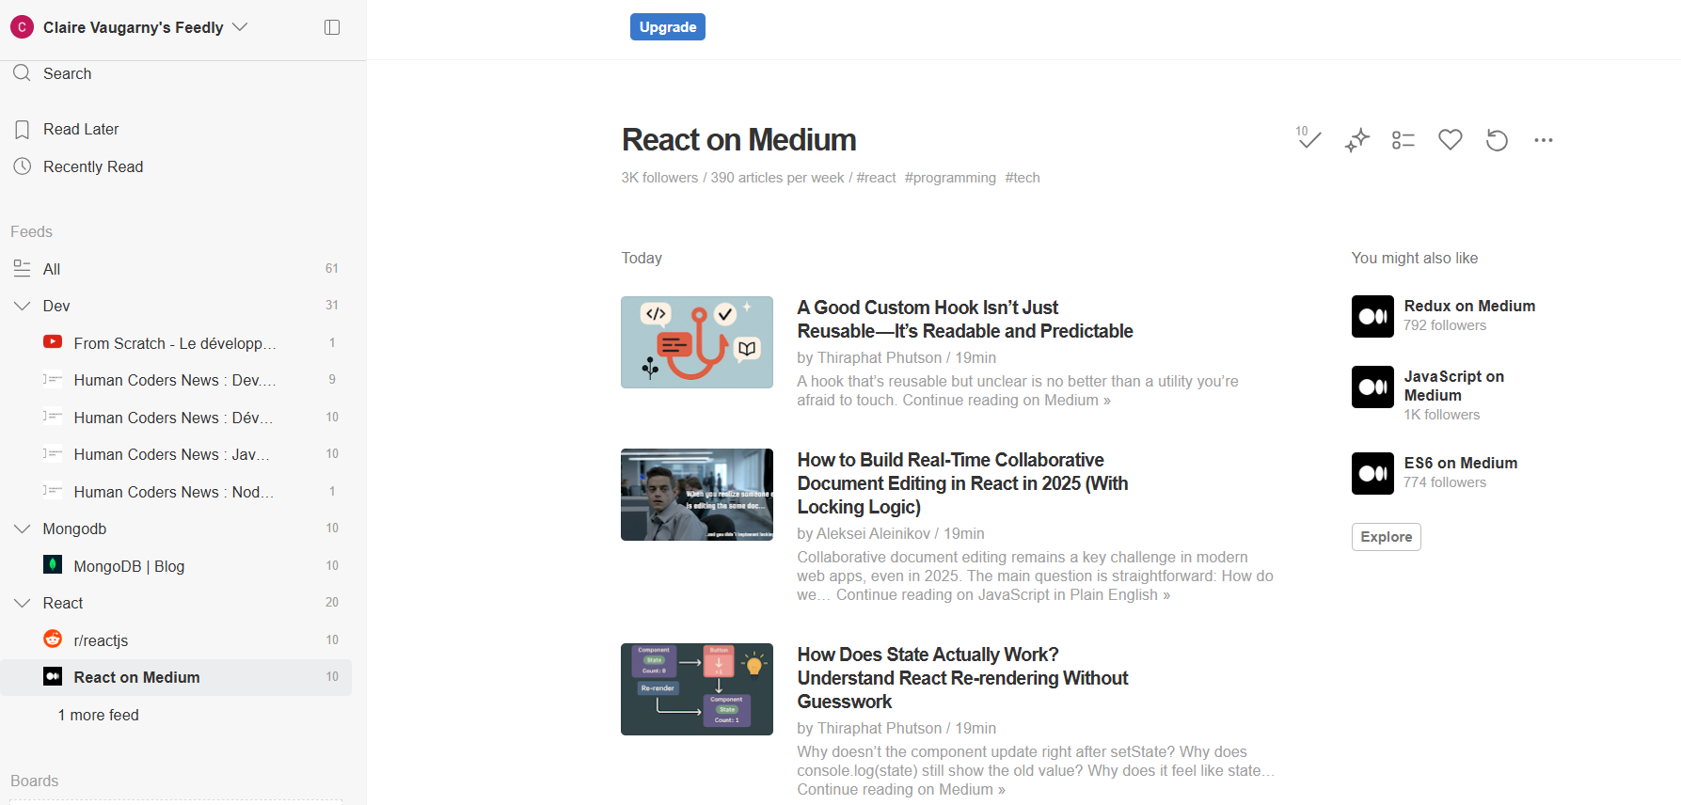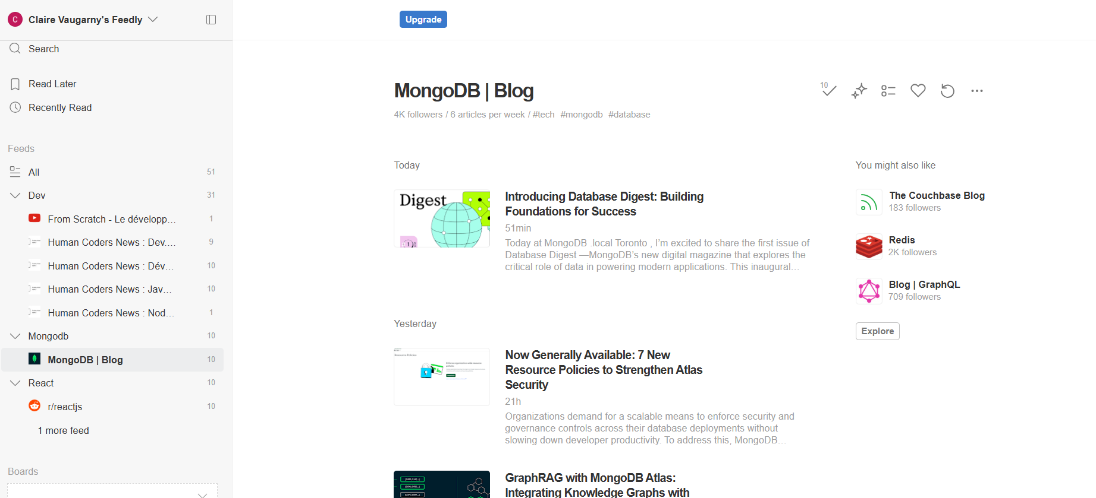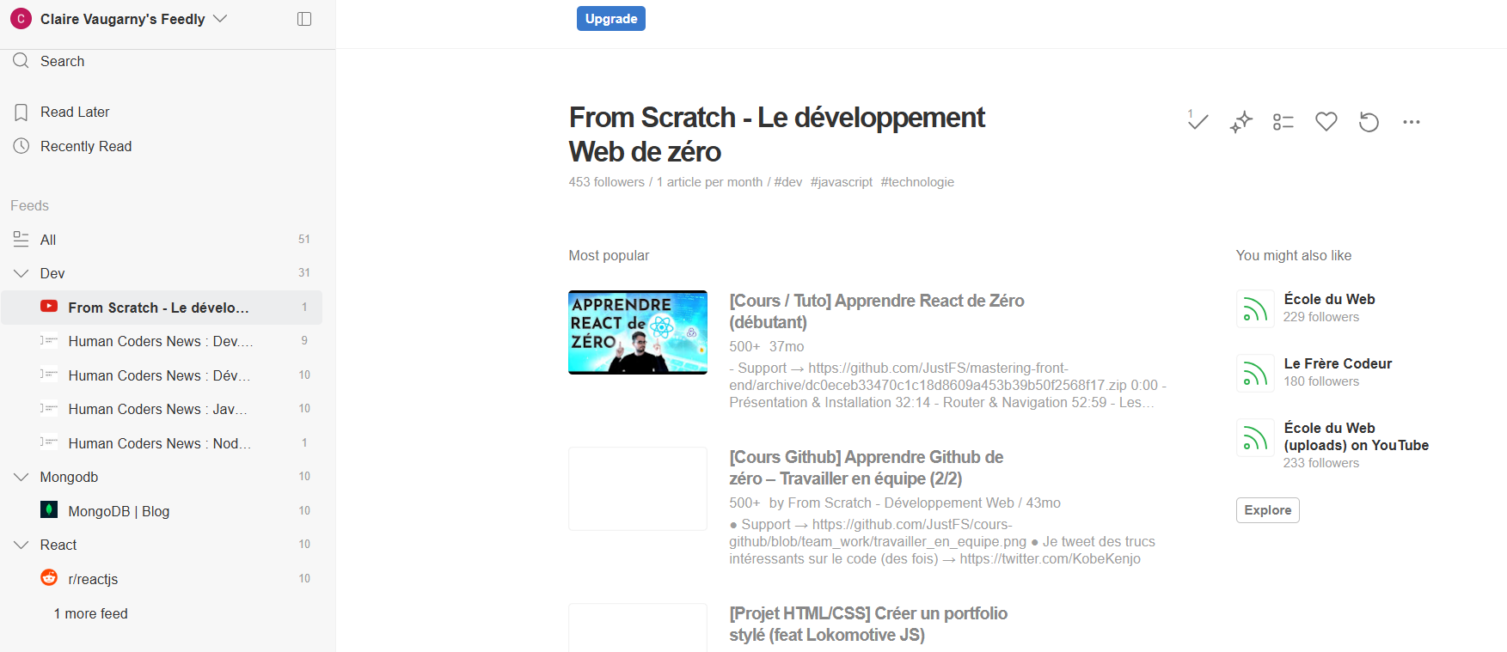

Notions associées au projet Menu Maker
SQL ? NoSQL ?
https://www.c-sharpcorner.com/article/difference-between-nosql-and-sql/?ref=dailydev&fbclid=IwY2xjawJrUBtleHRuA2FlbQIxMAABHpNL-8c6j1z4YhnCsxeOyOm41hh5O6ZkKM9Va-RF9BwZQkNUb0qcsagM1-30_aem_TWe2NTh_5NXcF5R4vU-j0A
https://awstip.com/sql-nosql-whats-your-take-1be662f067ab
MongoDB :
https://amplication.com/blog/plugging-into-mongodb?ref=dailydev&fbclid=IwY2xjawJrT-dleHRuA2FlbQIxMAABHoW92KDdS_gjbrRfkZDpDE1y1JN2dHjOz3PO5wDtbHB4f-mTVKKhSPwdFEXt_aem_I6jIMsWRS5OzofRQejzD3Q

Outils pour le gestion de PDF :
https://blog.logrocket.com/generating-pdfs-react/?ref=dailydev&fbclid=IwY2xjawJrUA9leHRuA2FlbQIxMAABHuYQXfTyYTt8Kk1D7dbGwngqCpUJue7xVOGr0Vc1OJBisyfGLVTE_wpFus7b_aem_lfS3RzEmUcwQHuT9sfMNCA

https://www.syncfusion.com/blogs/post/best-react-pdf-viewers/amp?ref=dailydev&fbclid=iwy2xjawjrubnlehrua2flbqixmaabhpnl-8c6j1z4yhncsxeoyom41hh5o6zkkm9va-rf9bwzqknub0qcsagm1-30_aem_twe2nth_5nxcf5r4vu-j0a

Protocole HTTPS :
https://www.youtube.com/watch?v=WIMKeyJ60Rw

Développement web
Frameworks et librairies :
https://richestsoft.com/fr/blog/10-most-popular-front-end-frameworks/
https://www.weblineindia.com/fr/blog/best-backend-frameworks/

Accessibilité :
https://www.youtube.com/watch?v=hwfXnyMurgc
https://www.youtube.com/watch?v=Z6Zd9ZNrvIs
Sécurité :
https://www.youtube.com/watch?v=V2kck-rC2jk
https://fr.wix.com/blog/securite-web

