# Introduction to Amazon bookstore database management system

**Challenges**

Amazon, the world’s largest bookstore, has been listing up to 32.8 million books for sale comprising by 2014. The Amazon online bookstore covers up to 19 languages and 7 formats of books including Paperback, Hardcover, Kindle Edition, and Audible Audio Edition, etc. Moreover, it is reported by Amazon Statistics that Amazon has up to 310 million active customers in 2018. Facing such a huge demand and an enormous inventory of books, how can Amazon maintain its daily operation?

**Solution**

To help Amazon manage its huge amount of data and maintain the right balance of stock in its warehouse, we designed a relational database via MySQL platform to store and retrieve information about books, customers, orders and purchases in 9 tables for Amazon bookstore. It allows Amazon to manage millions of customers’ personal information and their daily order records. In the meanwhile, this database system also records all the books’ information including ASIN number, title, author, publisher, group as well as format, and traces daily book purchase records.

**Necessity**

The database is quite necessary especially when Amazon is trying to grow its business in the future with high volume of data. The database leads to the advancement of inventory automation, resulting in higher profits and productivity for Amazon’s business. Furthermore, it is an essential tool for Amazon to increase its customers’ satisfaction and boost competitiveness.

The reasons of necessity of this database are:

1. Prevent fraud to reduce opportunity costs

Overstocking incurs unnecessary costs and overselling leads to lost sales, both resulting in reducing profits. The bookstore database can avoid these problems by allowing Amazon to understand the real-time stock levels for each book, including when the stock is going in and out.

2. Easy for analyzing and forecasting

Identifying trends and forecasting future demand is very essential for Amazon to meet customers’ need. But without a database, it is impossible to manually analyze such a huge amount of sales data efficiently. Therefore, the database enables Amazon to identify weekly or monthly demand by analyzing data to notice what’s selling quickly and react to the market instantly by adjusting the stock in its warehouse.

3. Reduce labor costs

Without a database, it will cost Amazon plenty of money in labors to check books’ quantities on the shelves. But it is unrealistic when there are millions of books in stock. So a database is very necessary as it can be integrated with checkout systems to update the stock level automatically to reduce labor costs and improve productivity.

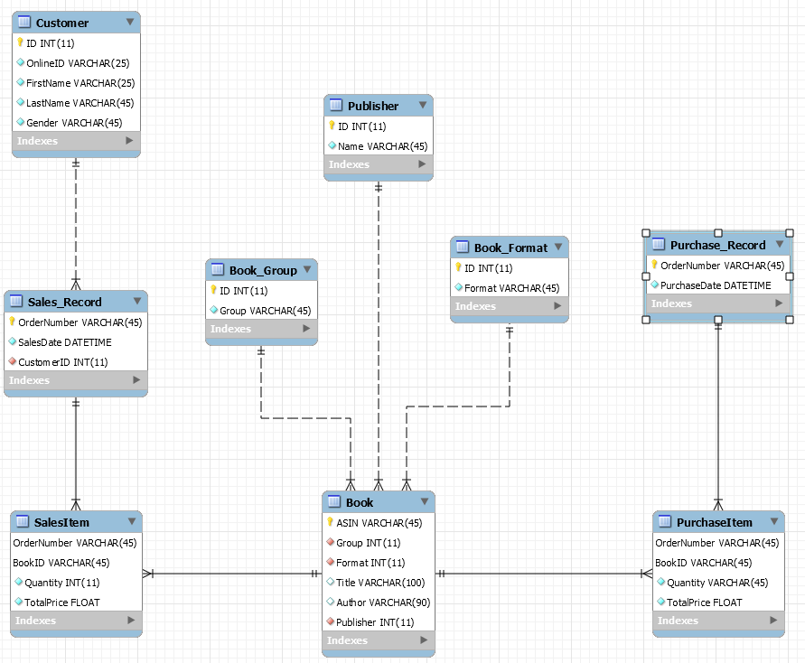

Reference:

<https://www.kaggle.com/ucffool/amazon-sales-rank-data-for-print-and-kindle-books#amazon_com_extras.csv>

<https://www.nchannel.com/blog/amazon-statistics/#AmazonStatsInfo>

<https://smallbusiness.chron.com/importance-inventory-databases-retail-40269.html>

We’ve designed a relational database via MySQL platform to store and retrieve information about customers, orders, books and purchases with 9 tables for Amazon bookstore.

Customer has a one to many relationship with Sales_record, because one customer is allowed to place multiple orders within a day but the same order can’t be placed by different customers or online users. Sales_record has a many to many relationship with the book because within one order customer can order different books, and the same book can be ordered in different orders.

And these two tables are linked by the SalesItem table, with OrderNumber and BookID as the composite primary key.

It’s in the same case with the Purchase_Record and the book, the book store may order the same book in different orders, and within the same order, the book store can order different books vice versa. And these two tables are linked by the PurchaseItem table, with OrderNumber and BookID as the composite primary key.

*Book* has a many to one relationship with *Publisher,Book_Format, Book_Group* for the simple reason that multiple books can be published by the same publisher and share the same Book Format and Book Group, while each book can only one publisher and belongs to a single format and group.