为Windows Media Player插件添加一个关联的变量m_Ctrplay，在窗口类中定义private的CString型全局变量m_strFilePathName;

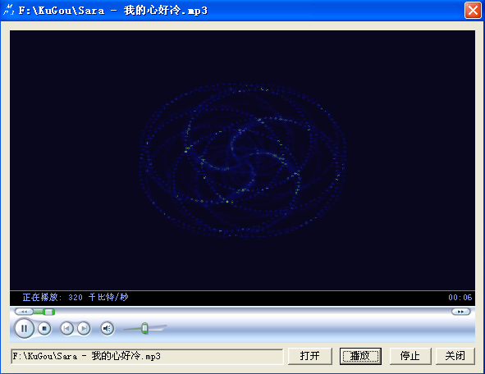

添加四个按钮和一个文本编辑框，添加相应的响应函数，代码如下：

void CMediaPlayDlg::OnOpen()

{

// TODO: Add your control notification handler code here

CFileDialog dlg(TRUE,_T(""),_T(""),

OFN_HIDEREADONLY|OFN_OVERWRITEPROMPT,

_T("(*.*)|*.*|(*.mp3)|*.mp3|(*.avi)|*.avi|"));

if (dlg.DoModal())

{

m_strFilePathName=dlg.GetPathName();

SetDlgItemText(IDC_EDIT,m_strFilePathName); //文本编辑框显示打开的文件

}

}

void CMediaPlayDlg::OnPlay()

{

// TODO: Add your control notification handler code here

if (m_strFilePathName!="")

{

m_Ctrplay.SetUrl(m_strFilePathName);

}

SetWindowText(_T(m_strFilePathName)); //标题栏显示正在播放的文件

}

void CMediaPlayDlg::OnStop()

{

// TODO: Add your control notification handler code here

m_Ctrplay.close();

}

void CMediaPlayDlg::OnClose()

{

// TODO: Add your control notification handler code here

CMediaPlayDlg::OnOK();

}