**21. Prior to commencement of task, build a wireframe denoting location of all key elements**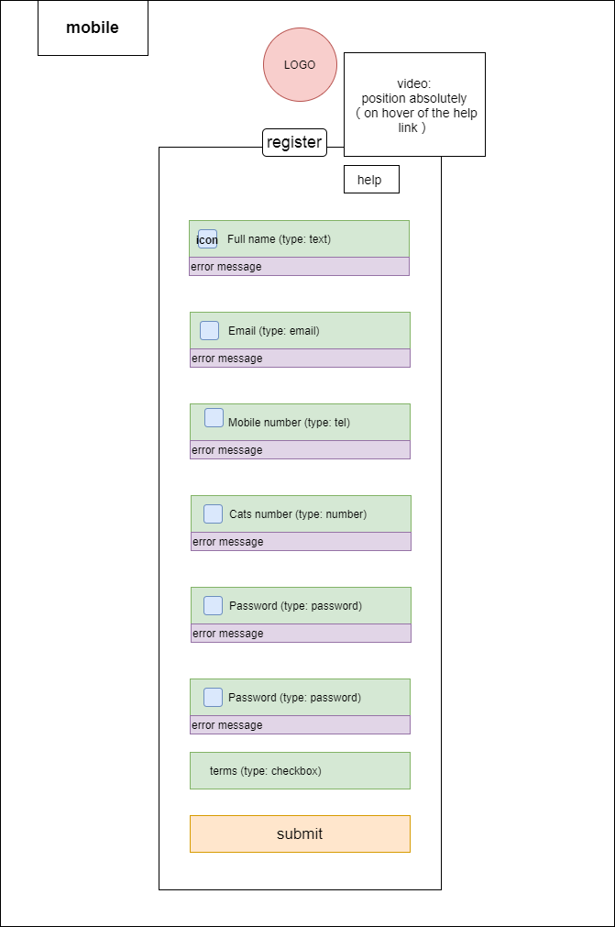

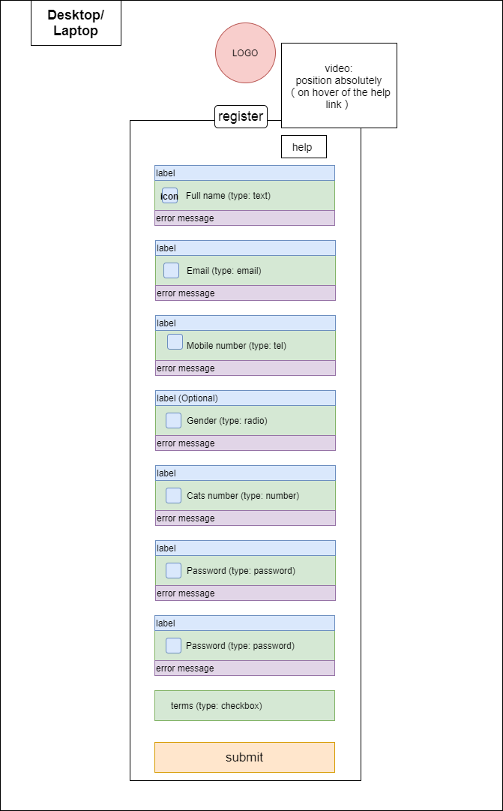

**22. Confirm how images chosen for each input are photographically relevant to the type of input being sought.**

All the images chosen were quite self-explanatory such as the people icon for the “full name”, an envelope for the “email”, Mars and Venus for the ‘Gender’, a phone for “mobile number”, and the lock is used for the “password”. Beside, a cute cat paw was selected to welcome the new cats. Another reason to use those images is also trying to minimum amount of works needed for any new users to start with the system, less time taken for them to understand how to complete the registration.

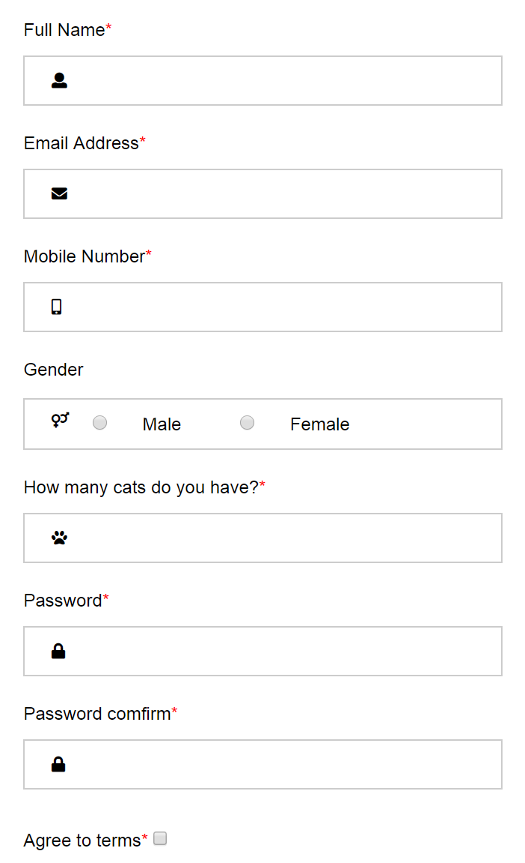

**23. What is it that you are trying to convey in the logo design created?**



The logo is created by Inkscape and it is for Feanor. Feanor is an organiser of cat shows based from Qld and provides a platform to all exhibitors in Australia.

Generally speaking, logo is considered as the face of a company and very often it also presents the company’s core business, Feanor’s logo was designed with that in mind.

When looking at the logo, the first thing comes to user’s mind is a cute cat face, it was drawn based on a lovely cat photo displayed on Feanor’s website. And not like a normal cat pic, the company’s name is used to fill up the cat face, it demonstrates Feanor’s business scope is all about cats, and it also says if you want to see the face of ‘cat’ just come to Feanor’s shows!

In addition, the yellow colour was chosen to make the logo cuter, and people could feel more positive and comfortable when looking it.

**24. What WHS principles were followed while working on this project?**

The guiding principle of the WHS Act is that all people are given the highest level of health and safety protection from hazards arising from work, so far as is reasonably practicable. the cost of eliminating or minimizing the hazard or risk.

Because of poor posture, poor technique, and overuse, it is easy to develop a RSI (Repetitive Strain Injury) for a computer user. To prevent RSI (Repetitive Strain Injury) here are three pieces of equipment that require special attention:

Keyboard: positioned above the thighs, shoulder is able to reach the keys with your elbows at side and bent at 90 degrees, and forearms roughly parallel to the ground. If the elbows are at more than a 90 angle, it will surely tire you out quickly.

Mouse: just to one side of the keyboard, so that lean, stretch, or hunch are not need to make it work. Many people have one shoulder noticeably lower than the other - this can be caused by repetitive stretching for a mouse;

Monitor: directly in front of the user (not off to the side), such that the eye level is somewhere between the top of the screen and 20% from the top. The screen should be about 15-25 inches from eyes

Reference: Repetitive Strain Injury: How to prevent, identify, and manage RSI (2020). Available at: https://web.eecs.umich.edu/~cscott/rsi.html (Accessed: 22 March 2020).

View - Queensland Legislation - Queensland Government (2020). Available at: https://www.legislation.qld.gov.au/view/html/inforce/current/act-2011-018 (Accessed: 22 March 2020).