圖表

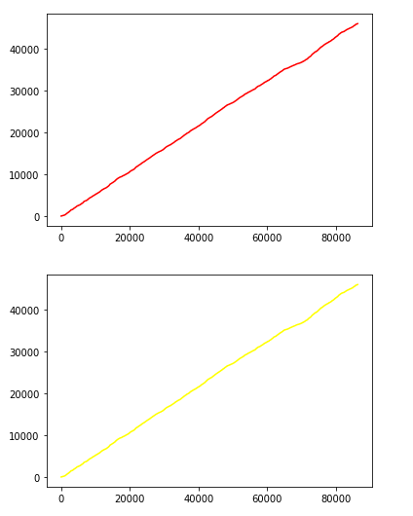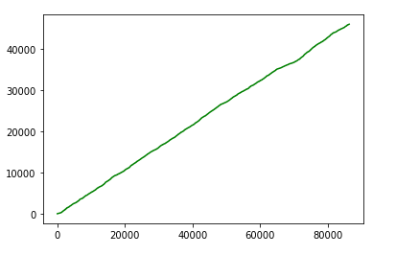

principle 3 (Threshold)

principle 1 (Best)

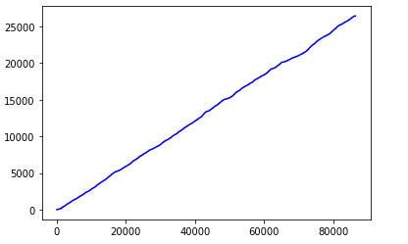

principle 2 (Entrophy)

principle 4 (My own)

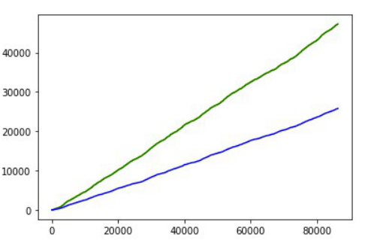

all principle

source code

# change

# principle_1 ## Pnew > Pold

if P_big > P[now_B[0]]: # P[big] > now_B[0]

now_B[0] = big

hoff[0] += 1

# principle_2 ## Pnew > Pold & Pold < T

if P[now_B[1]] < -110 and P_big > P[now_B[1]]: # T = -110

now_B[1] = big

hoff[1] += 1

# principle_3 ## Pnew > Pold + E "

if P_big > (P[now_B[2]]+5): # E = 5

now_B[2] = big

hoff[2] += 1

# principle_4 ## Pold < -125

if P[now_B[3]] < -125 and P_big > P[now_B[3]]:

now_B[3] = big

hoff[3] += 1

my own principle：

當Pold < - 125(Pmin)，換成表現最好的basement

整體handoff 數量因為標準很低，會變得比較少，但平均power就如同以下的數字，我的principle power表現就會比較差。

按照老師公式的avg_power：(按principle 順序)

-0.5728848620628028

-0.5728848620628028

-0.5740901137778274

-0.5881055804793571

total_power/total_cars_amount：

-114.8101402354717

-114.8101402354717

-115.05168112367527

-117.86047884905803