Topic: create
this code create two thread, and let it run. I run it twice. The picture below shows the results. The first one shows that the foo function in thread 1 can’t finish the line with line end, and the bar function in thread 2 begin to run, it interrupt the thread 1’s printing process.

So, I don’t know when those thread begin to run exactly, and which run first. This may cause some unexpected results.

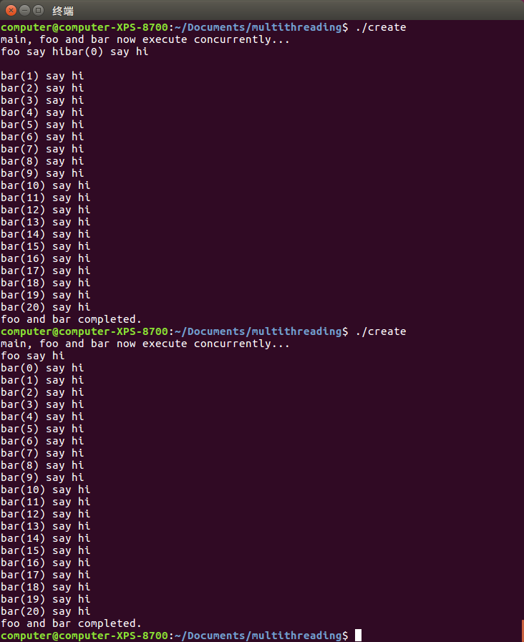

Join
if a thread finished before be joined, can join still success?
It seems thread will not begin to run immediately after it’s been created and constructed, it start to run after it’s joined.

Lock
it seems if lock in a loop, it will cause dead lock. Even when set sleep time between two loops. Does this mean it doesn’t really unlock the resources, untill a function end.

