**Procedure: Processing benthic photos for benthic cover and urchins**

*July 2022 – Claire Attridge & Kieran Cox*

*Barkley Sound kelp and bioacoustics*

**1) Point analysis with ImageJ**

Set the image scale using the diameter of the plumb line washer

Draw a line across the widest part of the washer using the ‘straight line’ tool

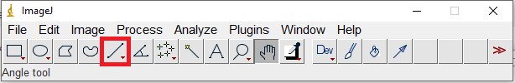

Go to *Analyze > Set Scale* and input the known distance of the washer (3.6 cm)

Record dimensions of the image (see top left corner) into the respective excel columns

Lay out the circles for multipoint analysis

Go to *Analyze > Tools > Grid*

Because the scale area has been set, the option will show as ‘area per point’ and not ‘area per pixel’

Select the grid type as ‘circles’ and manipulate the ‘area per point’ until you have 80-120 circles on your image (this area represents the coverage of an imaginary square surrounding a given circular point on your image)

Check the options for ‘bold’ and ‘center on image’ to enhance clarity for analysis

Use the multipoint tool to quantify your image cover

Double click the ‘multipoint’ tool from the tool bar

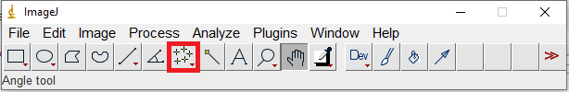

First place a null ‘0’ marker anywhere on the image (except for your analysis points).

Then, use the ‘Counter’ selection to start filling numbered dots into your analysis points based on the corresponding Excel doc columns/cover types.

Once complete, use the keyboard shortcut ‘Alt + y’ to display your final counts by cover type.

Fill these count values into the respective columns of the Excel doc row.

*\*Note: To delete a point, hold ‘ctrl’ and click on the point*

*\*Note: Images can be skipped/omitted if they are not of sufficient quality for analysis (e.g., too blurry, overexposed, …)*

**2) Size classifying urchins**

*\*Note: This process should be completed for each image following its analysis of benthic cover.*

First, count the abundances of each urchin species visible in the image (*Mesocentrotus franciscanus, Stronglyocentrotus droebachiensis, Stronglyocentrotus purpatus*) and record into the respective Excel doc columns.

Next, using the image scale already set for the benthic cover analysis, go back to the ‘straight line’ tool.



With this tool, draw a line of diameter across the widest portion of a visible sea urchin.

Hit ‘ctrl + m’ to record this distance.

Continue the above two steps to record the diameters of all visible sea urchins in the image (add further columns to the Excel doc as needed to accommodate more measurements).