**Procedure: Processing benthic images for substrate & invertebrates**

*Author: Claire Attridge*

*Origin date: July 2022*

*Kelp forest communities*

**1) Point analysis with ImageJ**

Set the image scale using the diameter of the plumb line washer

Draw a line across the widest part of the washer using the ‘straight line’ tool

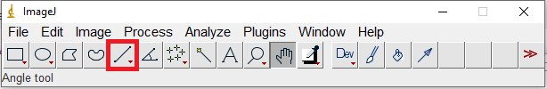

Go to *Analyze > Set Scale* and input the known distance of the washer (3.6 cm)

Record dimensions of the image (see top left corner) into the respective excel columns

Lay out the circles for multipoint analysis

Go to *Analyze > Tools > Grid*

Because the scale area has been set, the option will show as ‘area per point’ and not ‘area per pixel’

Select the grid type as ‘circles’ and manipulate the ‘area per point’ until you have 48 circles on your image (this area represents the coverage of an imaginary square surrounding a given circular point on your image).

Check the options for ‘bold’ and ‘center on image’ to enhance clarity for analysis

Use the multipoint tool to quantify your image cover

Double click the ‘multipoint’ tool from the tool bar

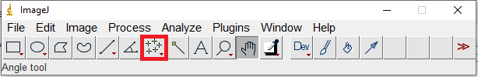

First place a null ‘0’ marker anywhere on the image (except for your analysis points).

Then, use the ‘Counter’ selection to start filling numbered dots into your analysis points based on the corresponding Excel doc columns/cover types.

Once complete, use the keyboard shortcut ‘Alt + y’ to display your final counts by cover type.

Fill these count values into the respective columns of the Excel doc row.

*\*Note: To delete a point, hold ‘ctrl’ and click on the point*

*\*Note: Images can be skipped/omitted if they are not of sufficient quality for analysis (e.g., too blurry, overexposed, …)*

**2) Benthic invertebrate identification (RLS)**

*\*Note: This process should be completed for each image following the analysis of benthic cover.*

To compliment the Reef Life Survey (RLS) method data, we will identify and count the abundance of large sessile invertebrates. Specifically, orange sea cucumbers (*Cucumaria miniate*)and anemones (*Urticina piscivora*, *Metridium farcimen*, *Cribrinopsis albopunctatus*…)…etc. When possible, ID and count by species. Group to larger family when not possible.

For each analyzed image, count the number of each species observed and record in the appropriate column of the data sheet. Add new columns as needed for additional species.

**3) Size classifying urchins**

First, count the abundances of each urchin species visible in the image (*Mesocentrotus franciscanus, Stronglyocentrotus droebachiensis, Stronglyocentrotus purpatus*) and record into the respective Excel doc columns.

Next, using the image scale already set for the benthic cover analysis, go back to the ‘straight line’ tool.



With this tool, draw a line of diameter across the widest portion of a visible sea urchin (not including to the tips of the spines).

Hit ‘ctrl + m’ to record this distance.

Continue the above steps to record the diameters of all visible sea urchins in the image (add further columns to the Excel doc as needed to accommodate measurements of more individuals).

*\*If the full body of an urchin is not visible (i.e., obscured by rocks or algae), use your best judgement to either i) omit measurement of the individual if it is not possible to be accurate, or ii) make a reasonable estimation as to where the urchin’s body ends underneath the obscuring object.*