Problem 2:
Define the term frequency–inverse document frequency (TF-IDF) statistic.
- TF-IDF: TF i.e. Term Frequency refers to the number of times a term occurs in a document. This gives weight to each term. High term frequency means high weight of the term such as to be interpreted as a relevant term. However, words like ‘like’, ‘the’, ‘for’ and so on would easily have a higher weight in any documents. But these words would not mean they are relevant since they give us no good information about the data domain or about our analysis. This is when IDF i.e. Inverse Document Frequency is brought to reduce the weights of these highly occurring words. Thus, helping us eliminate non-significant highly frequent terms. Thus, TF-IDF is a good way to extract only informative and frequent-enough words from our dataset.

max_df: This parameter is used to exclude the terms from our vocabulary that has a document frequency; greater than a specified threshold. This parameter helps us eliminate words that occur too frequently in our documents i.e. corpus-specific stop words; thus, making them non-relevant.

min_df: This parameter is used to exclude the terms from our vocabulary that has a very low document frequency; lower than a specified threshold. This parameter helps us eliminate words that occur seldom in our documents; thus, making them non-relevant too.

N-gram range: This range is used to extract terms from our documents as a set of words. That is if n=1 it gives terms only as a set of 1 word. These are called the unigrams. If for instance, n=2 it gives terms only as a set of 2 words. These are called as bigrams. In such a way, we can get terms from our documents as set of range i.e. min_n and max_n and thus returns terms from the dictionary as set of minimum words (min_n) in a set to maximum words (max_n). This forms the n-gram range.

On exploration of the values of min_df and max_df, when we first begin with keeping min_df = 0.1 & max_df = 0.8, the way this can be interpreted is the vectorizer should ignore the words that appear in less than 10% of the documents (pertaining to the min_df value) and it should also ignore words that appear in more than 80% of the documents (pertaining to the max_df value). This is obtained by keeping the n_gram range as {1,1}. This gives us only 349 features extracted from our training corpus. Keeping the max_df constant, when we reduce the min_df the number of features obtained increase to 911. At this stage when we change value of max_df from 0.8 to 0.9; the number of features reduce to 880. These changes in values of min_df and max_df clearly help us understand the elimination of irrelevant features from our dataset.
Also as we change increase the n-gram range, the number of features keep increasing and also the time execution for the vectorizer class rises. Keeping min_df = 0.01, max_df = 0.95 constant, we vary the n-gram range and get the results as follows:
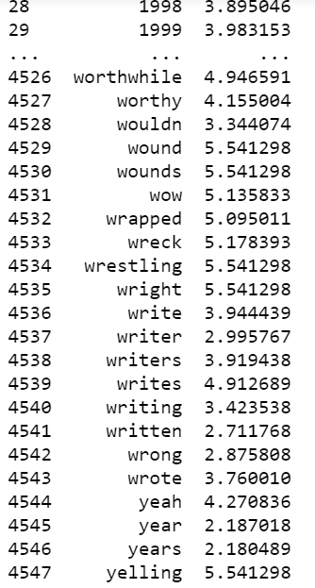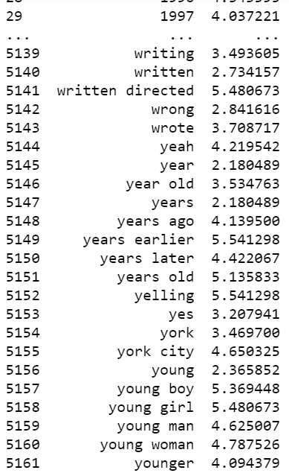
N-gram range 1, 1 – 4556 features N-gram range 1, 2 – 5169 features
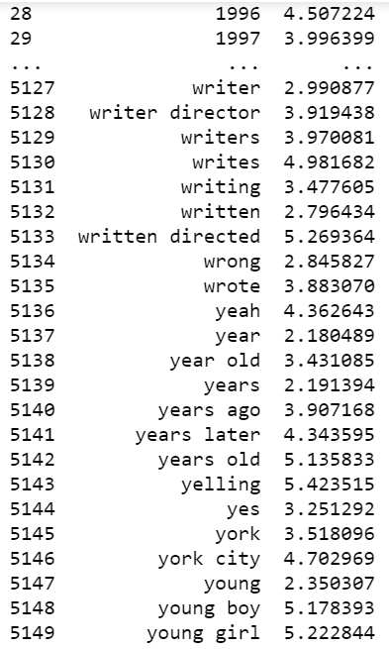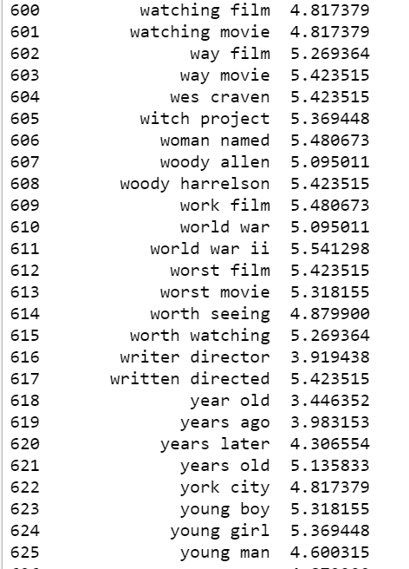
N-gram range 1, 3 - 5157 features N-gram range 2,3 – 627 features

