**Previous and ongoing approach of integration of IFC and CityGML or transformation:**

1. Integration frameworks from IFC to CityGML

Integration frameworks such as the framework of (IFG, 2007) for exchanging building information between CAD systems and GIS using IFC, the framework of (Nagel, 2007) for automatic transformation of IFC building models into CityGML, and the framework of (Isikdag & Zlatanova, 2009b) for automatic generation of buildings in CityGML using BIM based on definition of building semantics and components.

1. Bidirectional conversion or integration between IFC and CityGML

Extended discussion such as the conceptual requirements discussion by (Nagel et al., 2009b) for converting CityGML to IFC models, and the Application Domain Extensions (ADE) proposed by (Van Berlo, 2009) for integrating Building Information Model (BIM) data based on the open standard Industry Foundation Classes (IFC) into CityGML.

1. Commercial software products

Commercial software products and conversion tools IFC to CityGML such as IfcExplorer (IFCExplorer, 2010) and FME (Safe Software, 2010)

From a broad perspective, the work above can be classified in terms of framework development, discussions on requirements and development of conversion tools.

***IFG Project***

The framework of the IFC for GIS (IFG) project (in 2003) aimed to exchange building information between CAD systems and GIS using IFC. The project succeeded in creating a mapping specification from an XML version of IFG geometry to GML and vice versa.

***Nagel’s framework of conversion of IFC to CityGML***

A framework was proposed by Nagel (2007) which aimed at producing algorithms that automatically transform IFC building models into CityGML models. This research focused on only level of detail LOD1 and LOD2 of CityGML and the purpose of the algorithms is to create a geometrically and semantically valid representation of LOD1 which can also be applied to LOD2.

***Isikdag and Zlatanova’s advanced framework***

Isikdag and Zlatanova (2009b) have extended Nagel’s framework by proposing a framework for automatic generation of buildings in CityGML using BIM and its building semantics and components. It generated semantic and geometric mappings between IFC and CityGML for each LOD of CityGML.

***A 3D Conversion Framework by Thomas Kolbe***

Following the holistic view of 3D city modeling aspects, a team led by Thomas Kolbe at the Technical University of Berlin proposed a framework that integrates 3D graphics/data of buildings and urban areas stored in (X3D, DXF, KML, COLLADA, etc.) with semantic data in a CityGML target schema that represents an intermediate layer for the conversion process.

(Geometric/graphics Models 🡪 Semantic City Model 🡪 Building Information Model)

(X3D, DXF, KML, COLLADA 🡪 CItyGML 🡪 IFC)

***The development of the CityGML -- GeoBIM extension***

Léon (2009) demonstrated the latest application domain extension (ADE) which converts building information model (BIM) data based on the open standard IFC into CityGML (van Berlo, 2009). They extended CityGML with rich semantic information of IFC and ADE.

***Unified Building Model***

The Unified Building Model is a meta-oriented approach that can be used for full integration of IFC and CityGML so that IFC can be traced to CityGML and vice versa. The reference ontology in this study is defined as more expressive reference ontology for IFC and CityGML semantic models; the unified model is defined as a superset model that is extended to contain all the features and objects from both IFC and CityGML building models.

***Commercial software products:***

Commercial software products for conversion from IFC to CityGML: IfcExplorer (IFCExplorer, 2010) and Safe Software (Safe Software, 2010).

The contributions to the research area of IFC and CityGML integration can be

summarised as:

(a) an approach to a unidirectional conversion with a focus on converting geometries (mostly from IFC to CityGML, not the other way around),

(b) a discussion about what should be done in terms of integration of theoretical frameworks, i.e. how it should be done is not sufficiently implemented yet,

(c) focus on down-grading IFC to lower LODs in CityGML,

(d) discussion on rich semantics of IFC and how it can be utilized for more detailed CityGML models.

Available data transformation models and applications:

X3D, DXF, KML, COLLADA, CAD, BIM, IFC, GIS, GML, CityGML

Challenges:

1. Old buildings are not represented as BIM or not completed, so it makes integration even harder.

2. Not enough experiment data and verification methods of the mappings and the conversion results.

3. For the GeoBIM project, the conversion results cannot be displayed correctly in some viewers such as LandExplorer, but other views such as FZK viewer work well.

4. After certain conversion the size of the CityGML files is significantly larger than the original IFC files; they are increased by a tenfold or more.

5. Right now most of the research is focused on the major and basic components of the building. Only few research papers mentioned the conversion of utility elements, and just a start point of this area.

6. The UBM simplifies the geometric architecture, so the mappings are not very accurate in the case of complicated of geometric representation.

7. There is not any efficient evaluation strategy to evaluate which framework is better and more accurate.

8. The research works above have all different focus, such as LODs, bidirectional, semantic and geometric mappings. It is hard to create a framework to cover all of them, so we may need some use cases and scenarios to evaluate which approach it better.

The figures below are the schemas of IFC and CityGML, and some are related to LoDs:

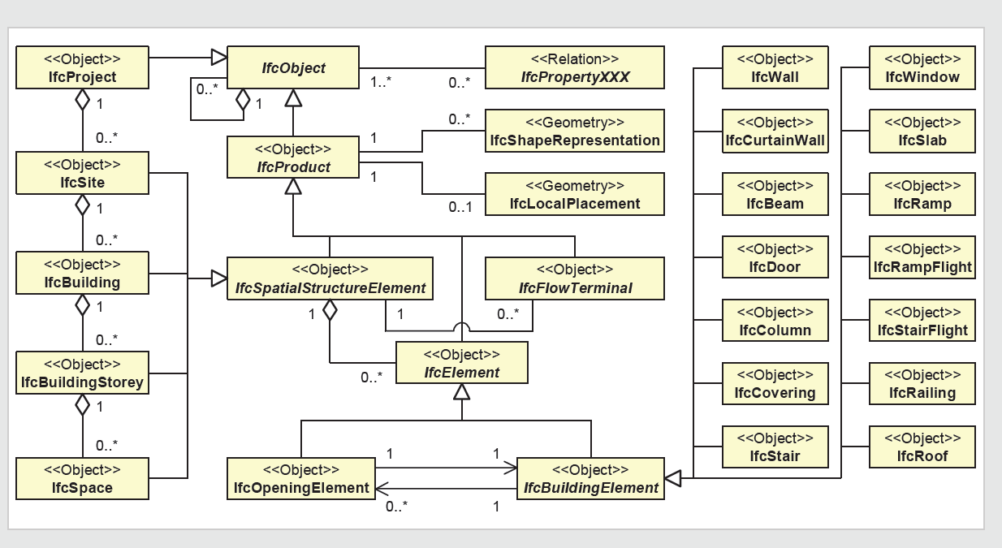

IFC building model

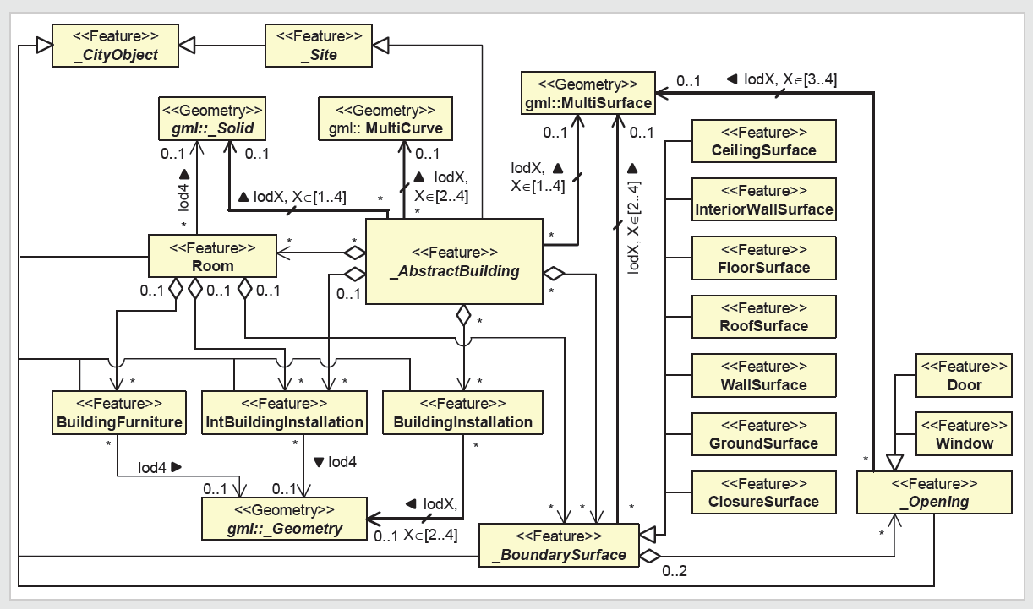

CityGML building model

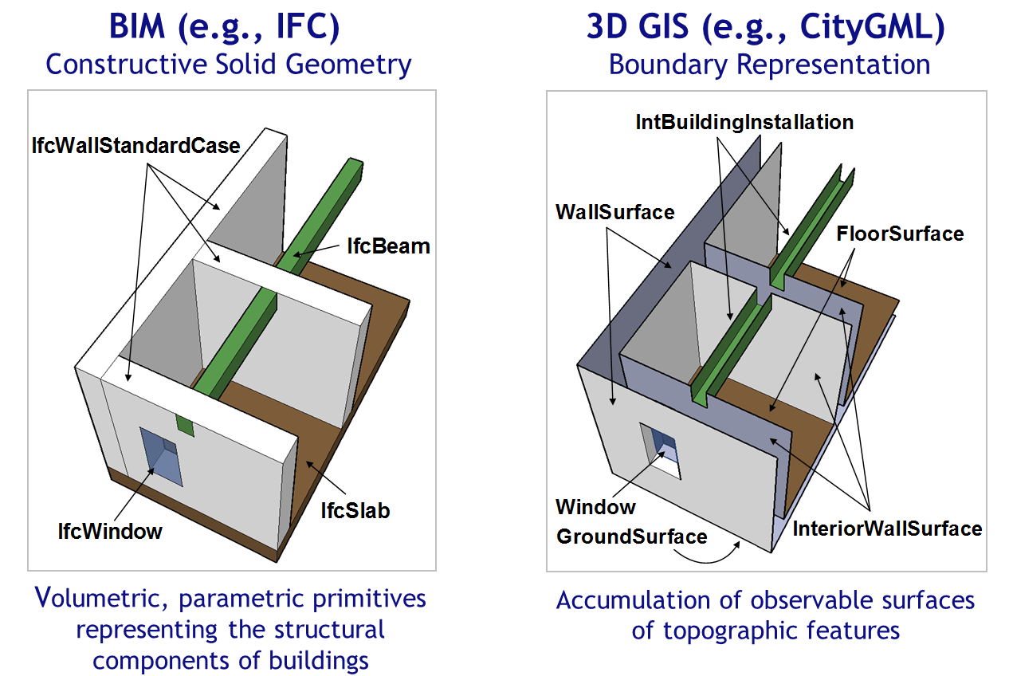

Comparison of IFC and CityGML on representation

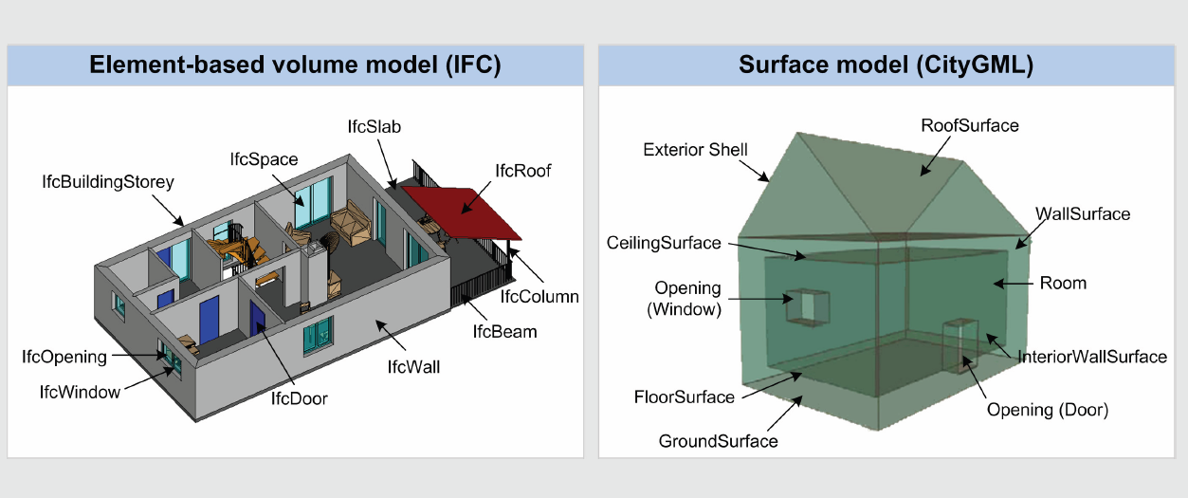

Comparison of IFC and CityGML on building component

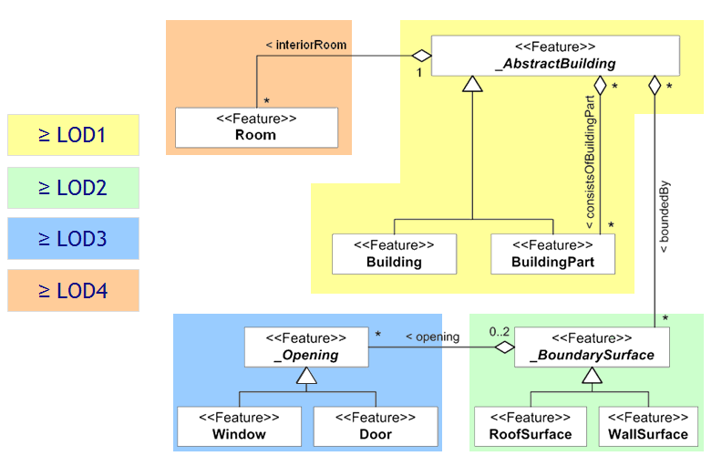

CityGML of all levels of details

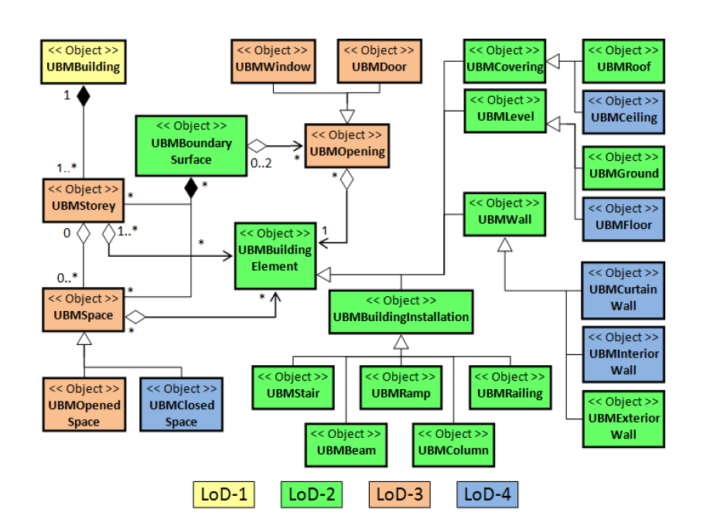

UBM of all levels of details