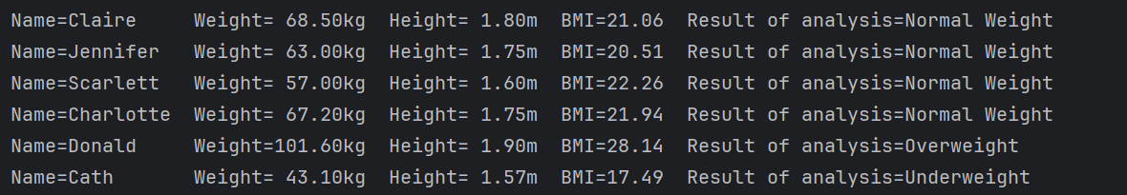

*Note for future assignments- do I include the line before the output that just has the file address ("C:\Program Files\Eclipse Adoptium\jdk-17.0.15.6-hotspot\bin\java.exe" "-javaagent:C:\Program Files\JetBrains\IntelliJ IDEA 2025.1.2\lib\idea_rt.jar=51642" -Dfile.encoding=UTF-8 -classpath C:\Users\clair\IdeaProjects\BMIApp\out\production\BMIApp BMIApp?) and do I include the Process finished with exit code line? Also, did I do the header correctly? I have the assignment info in the header for BMIApp, but I also included headers on the three other files since theyre their own java files as well. Feel free to email me [claireejane05@gmail.com](mailto:claireejane05@gmail.com) if you have a relevant answer, for my own peace of mind! Thank you.