

HRP-816 | 11/21/2024

**FORM: External IRB Study Update**

RAMS amendment smartform is used to notify local IRB of study changes approved by the external IRB of record.[1]

**basic information**

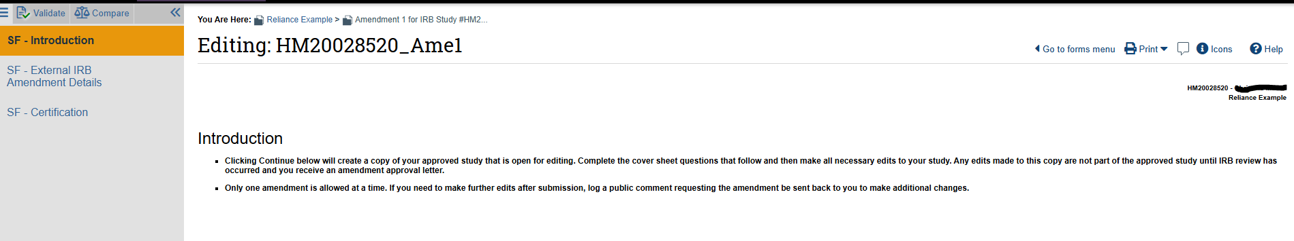

**Study Update Information**

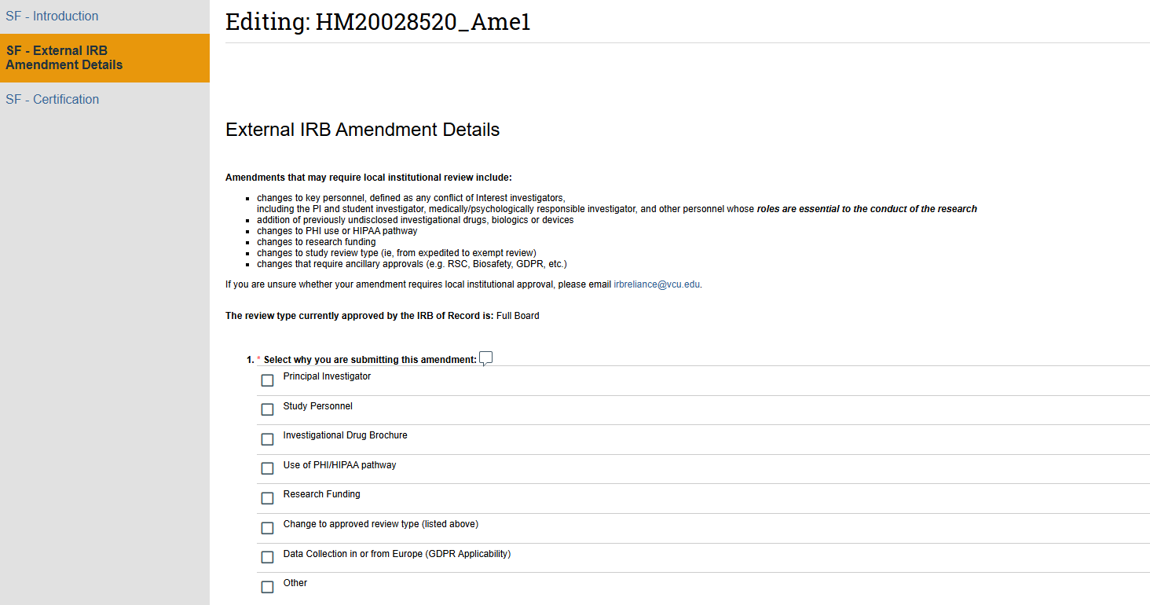

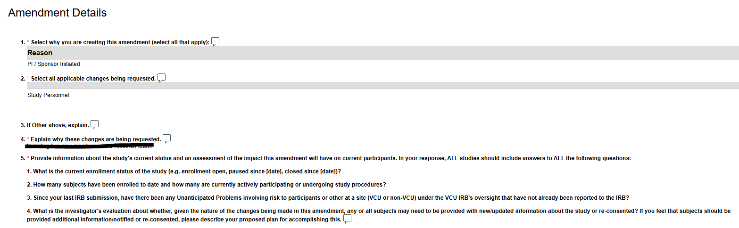

**Site Investigator Acknowledgement**

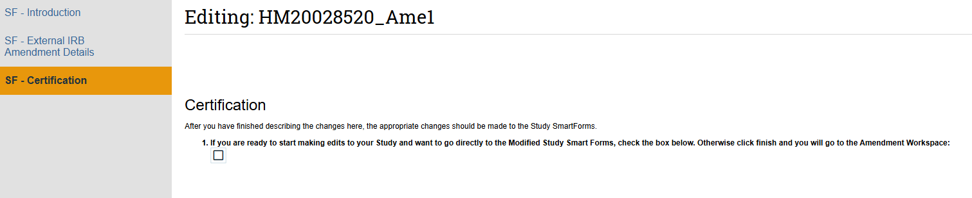

1. This document satisfies AAHRPP element I-9