ESM206-assignment4

Claire Madden, Bridget Gibbons, Andrew Paterson

11/12/2018

# Part 1 (Claire)

## Joining, by = c("SITE", "YEAR")

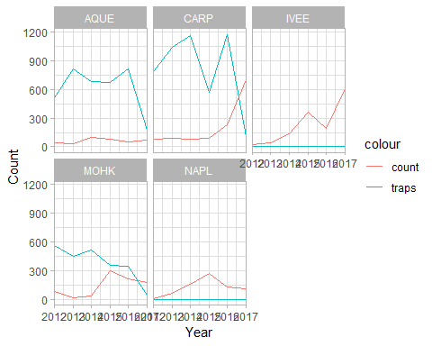 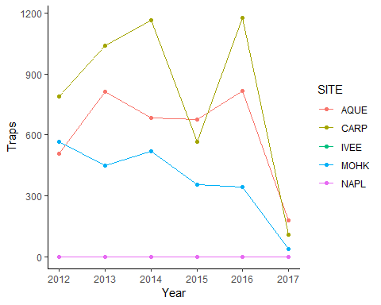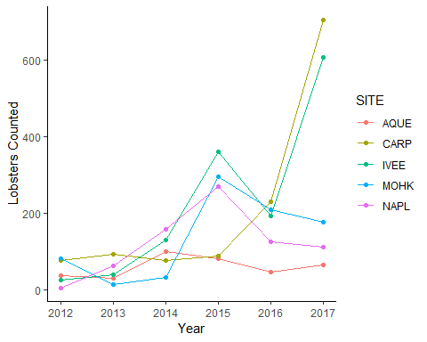

**Figure 1: Fishing Pressure at Five Locations in the Santa Barbara Channel (2012-2017)** Total annual number of commercial lobster trap bouys counted at Arroyo Quemado, Carpinteria, Isla Vista, Mohawk, and Naples reefs. Data collected in lobster fishing season (October through March) every two to four weeks.



# Part 2 (Andrew)

size_2017_col

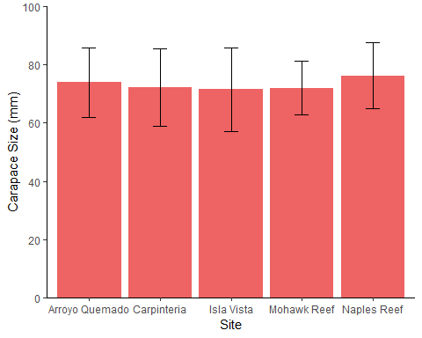

size_2017_boxplot

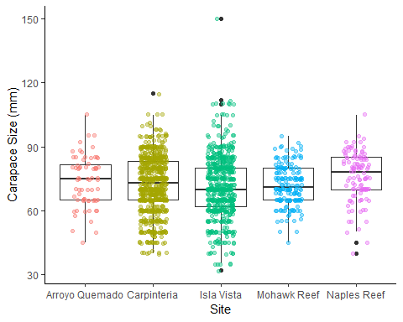

**Figure 1: Mean Lobster Carapace Length at Five LTER Sites in the Santa Barbara Channel in 2017**

## # A tibble: 5 x 3  
## Site `Mean Size` `Sample Size`  
## <chr> <dbl> <int>  
## 1 Arroyo Quemado 73.9 67  
## 2 Carpinteria 72.2 705  
## 3 Isla Vista 71.4 606  
## 4 Mohawk Reef 72 178  
## 5 Naples Reef 76.2 112

Site

Mean Carapace Size (mm)

Sample Size

Arroyo Quemado

73.90

67

Carpinteria

72.23

705

Isla Vista

71.45

606

Mohawk Reef

72.00

178

Naples Reef

76.23

112

# Part 3 (Bridget)

# The following chunks are comparing 2012 and 2017 for each site individually

**Figures 4-5: Lobster Carapace Sizes at sites inside Marine Protected Areas (2012 and 2017)** Lobster carapace (mm) data collected at two Long-Term Ecological Research sites within Marine Protected Areas in the Santa Barbara Channel: Isla Vista (n=26 in 2012, n=606 in 2017) and Naples Reef (n=6 in 2012, n=112 in 2017). Mean lobster size only differed significantly between 2012 and 2017 at Isla Vista; pairwise comparison at Naples Reef yielded no significant difference (IN LINE REFERENCING).

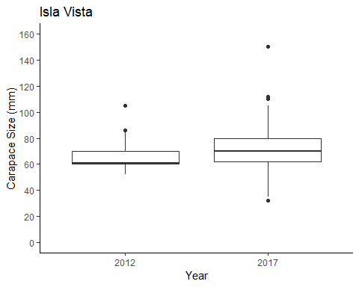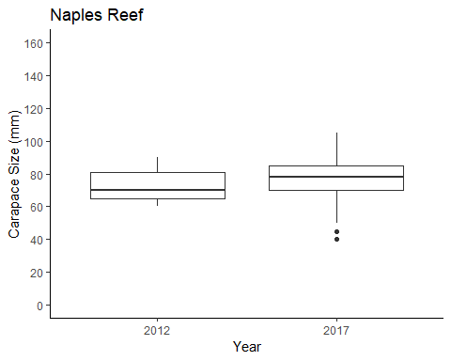

**Figures 6-8: Lobster Carapace Sizes at sites outside of Marine Protected Areas in 2012 and 2017** Lobster carapace (mm) data collected at three Long-Term Ecological Research sites outside of Marine Protected Areas in the Santa Barbara Channel: Arroyo Quemado, (n = 38 in 2012, n = 68 in 2017), Carpinteria (n = 78 in 2012, n = 705 in 2017), and Mohawk Reef (n = 83 in 2012, n = 178 in 2017). Mean lobster size only differed significantly between 2012 and 2017 at Mohawk Reef; pairwise comparison at all other sites yielded no significant difference (IN LINE REFERENCING). ADD CORRESPONDING NUMBERS TO EACH GRAPH TITLE.

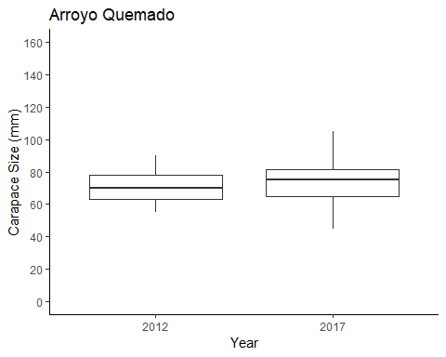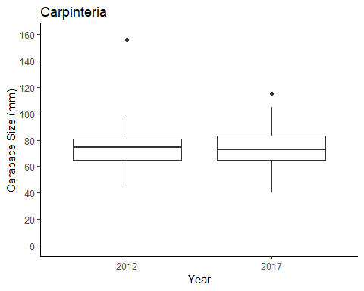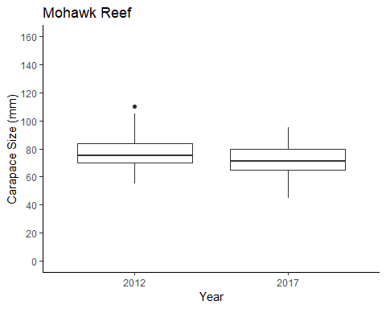

# Part 4

## Warning: Setting row names on a tibble is deprecated.