Situation and Setting
Simulation Situation
It is a morning practice at the university practice field. This is for the women’s soccer team, but practicing men’s players may assist or play with the team. Your patient could be male or female. In your pair, the head HCP is the person in your group whose letter of the last name is the latest in the alphabet. This head AT is the person who can help make decisions as needed. However, you are both certified ATs. You just witnessed two players collide. The image shown here is very similar to what you observed.
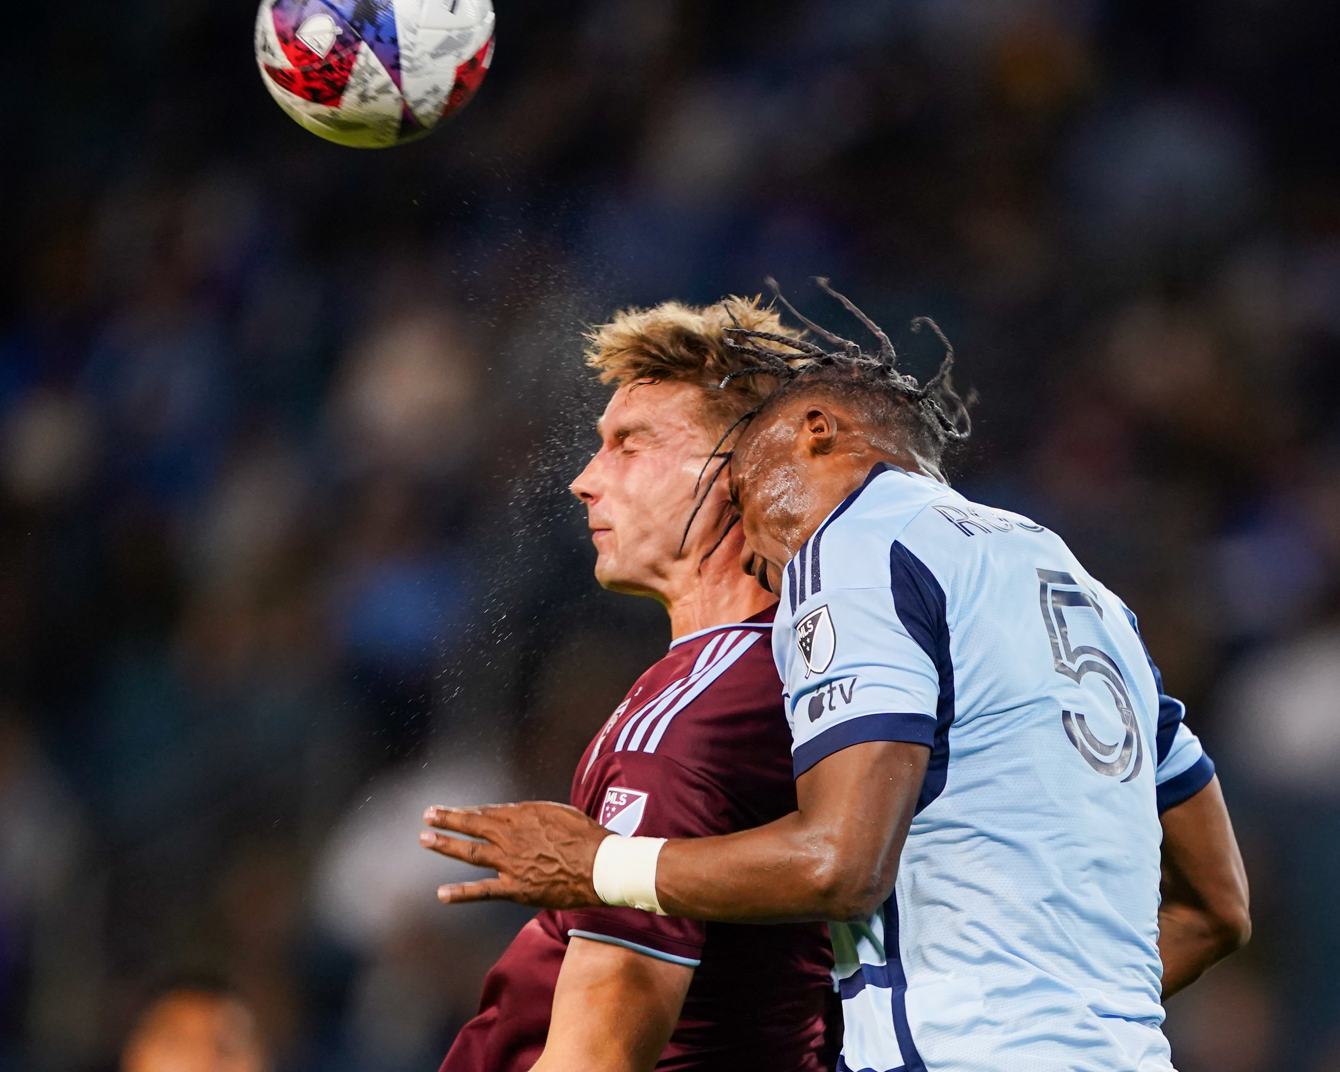
Two soccer players collide making a header.
Kyle Rivas/Getty Images
Setting
Soccer practice, outside, on the field, current temperature and conditions

