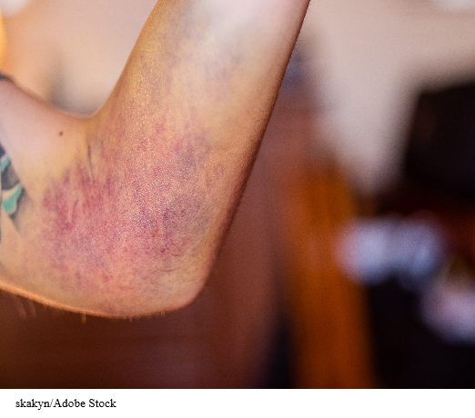

FIGURE 7.1 Day 8, out of sling. This is Emily’s injury today.

