Situation and Setting
Simulation Situation
Emily Johnson is an 18-year-old high school senior training at West Coast Gymnastics Academy for the last two years. She was on the uneven bars when she slipped off and hit the ground with a FOOSH (fall onto outstretched hands) and dislocated her left elbow. The elbow dislocation resulted in posterior displacement of the ulna with no nerve damage and minimal vascular damage. It was repaired nonsurgically. There was a pinched nerve but no fracture. Emily still has some pain today (6/10) and does not yet have full range of motion after an eight-day splint. It is the day after having the splint removed (day 9). She has come to the gym to do some light activity and discuss progression. She is concerned about her ability to compete in the Olympic Trials in eight weeks. She is currently next door chatting with teammates and hanging out. She is scheduled to go to the athletic training clinic (AT clinic) in about 30 minutes to meet with you. Prior to your meeting with Emily, her coach has asked to meet with you. Emily has had numerous other injuries, but none are currently affecting her performance. You can see in Emily’s file that she sees both a sport psychologist and a clinical psychologist, but you are not provided any information on the reason, because this is not accessible to ATs in the electronic medical record and is on a need-to-know basis.
Setting
AT clinic at a youth gymnastics center
Standardized Patient (SP) Information
You can bring this information to the simulation.
Name: Emily
Age: 18 years old
Sport and position: Gymnast, floor and bars specialty
Actual diagnosis: Elbow dislocation with a pinched nerve
Setting (place and time): Club Gym—West Star Gymnastics Academy (has had numerous qualifiers for Nationals)
Actual diagnosis: Elbow dislocation with a pinched nerve
Following are notes from imaging in the emergency department (ED) that can be found in the patient’s electronic medical record.
- 18 y/o female fell from uneven bars and experienced a closed elbow dislocation. Complained of 8/10 elbow pain and no ROM without severe pain. Posterior elbow dislocation with posterior displacement of ulna, no neurologic deficit, and unremarkable vascular injury.
- Elbow injected with lidocaine. Reduced with traction and anterior stabilization, nonsurgical.
- Postreduction, elbow stable to ROM from 30 to 130 degrees. Splinted.
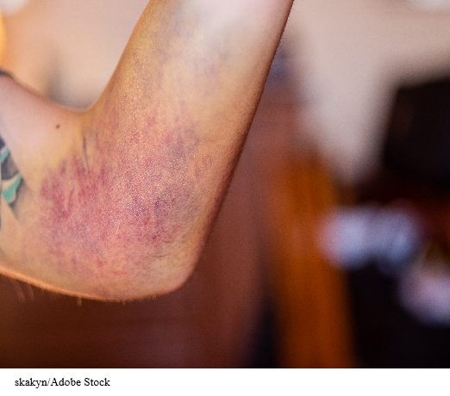
FIGURE 7.2 Day 8, out of sling. This is Emily’s injury today.
skakyn/Adobe Stock

