Instructions for SP Anaphylaxis
Please memorize your story and the following information. When we meet, please be prepared with questions, problems, or concerns from this simulation. If you are provided photos of your skin reaction at various stages, be prepared to show these to the HCP. Be sure to ask the proctor or facilitator if you have questions about when to show these photos.
Entry information (provided to HCP prior to start): It is 2:00 p.m. during women’s volleyball practice. Angel, the starting outside hitter, approaches you about itching and bumps. It is about 20 minutes into practice.
Background
Name: Angel
Sport and position: Women’s volleyball, starting outside hitter
Age and grade: 21, college junior
Relevant social and team role: Key offensive player; others look to you for consistency and energy
Setting (place and time): Volleyball practice, indoor gym, 2:00 p.m.; ~20 minutes into practice
Event description: You started practice normally about 20 minutes ago, and everything else seemed normal. You noticed an uncomfortable, itchy-sweaty feeling about five minutes into practice but just thought it was that weird feeling you get when you start to sweat sometimes. After about 15 minutes, you notice your breathing does not recover when you rest, and you see some bumps on your arms. By 20 minutes, your mouth feels funny, you are unable to catch your breath, and you notice bumps on more than just your arms.
Actual diagnosis: Anaphylaxis secondary to allergic reaction to implanted birth control. The implanted birth control device was placed ~ six weeks ago. The symptoms suddenly intensified today. You are unaware of this and don’t even think your birth control could be causing a reaction, if asked about it.
Presentation
Opening statement: “Oh my gosh. I am itching all over and getting bumps. My mouth feels weird too. Something is not right.”
Opening actions: Lightly scratching arms (you don’t want to scratch through your skin) with visible hives. You are breathing fast and feel restless or uncomfortable. Basically, something is happening to you that is uncomfortable, especially because you are having trouble breathing.
Internal
Emotion: Increasing fear; escalating panic; feel like your body is “freaking out.” Very nervous as breathing worsens. Escalating to panic (as physically able with symptoms).
Cognition: You wonder, “Why am I getting worse? Why am I not in control of this? Why am I swelling and itching? What is happening?”
Self-concept and identity: High-performing starter; serious about performance and being reliable to the team.
Medical Presentation (May Worsen or Improve Based on Provider Actions)
Signs and symptoms: Itching, hives (progresses from arms to chest to throat to face), angioedema, wheezing (later), cool or diaphoretic skin, tachycardia, hypotension (later), shallow respirations.
General appearance: Starts pink and warm; hives visible on arms, later spreading to neck, throat, face. Eventually cool, diaphoretic, distressed.
Breathing and voice: Moderately fast RR initially; becomes quick, shallow, and labored. Audible stridor occurs as the throat begins to close later in the simulation and if no medicine is given.
Movement and limitations: Increasing restlessness due to itching and increasing panic. Symptoms progress unless epinephrine is provided by HCP.
Posture: Initially upright; progresses to forward-leaning, trying to ease breathing as symptoms worsen.
Pain: Increased visible discomfort; effortful breathing; agitation from itching and airway swelling.

FIGURE 6.1
Nuttawan Jayawan/iStock / Getty Images
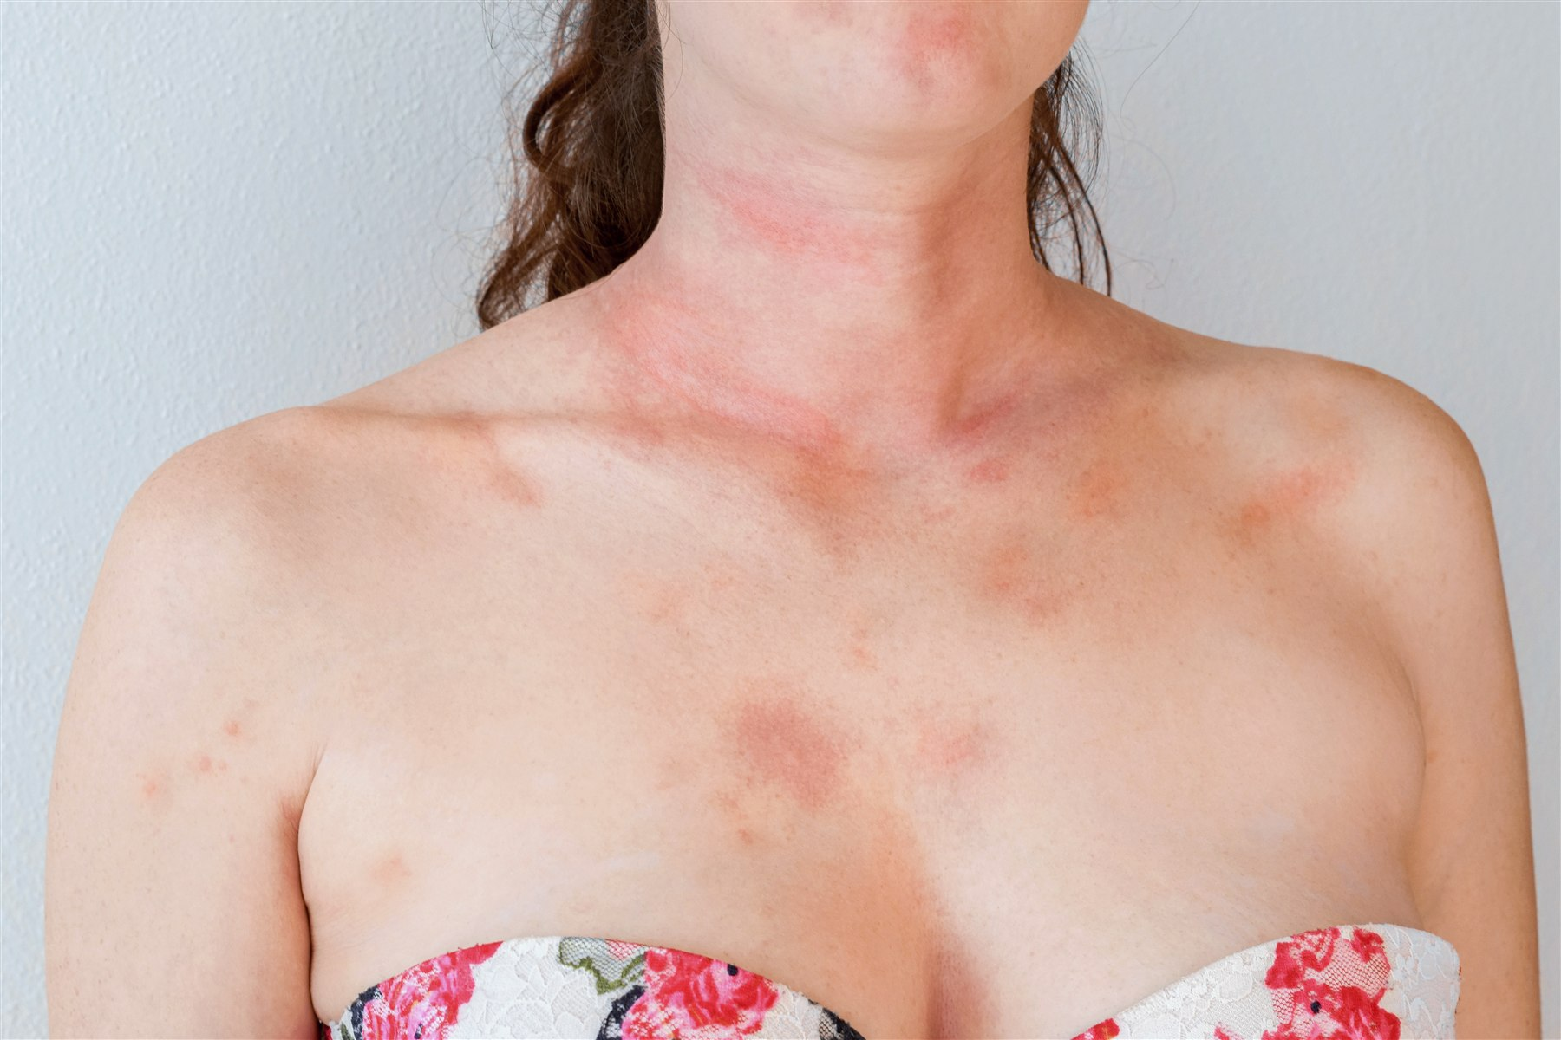
Figure 6.2
Tunatura/iStock / Getty Images
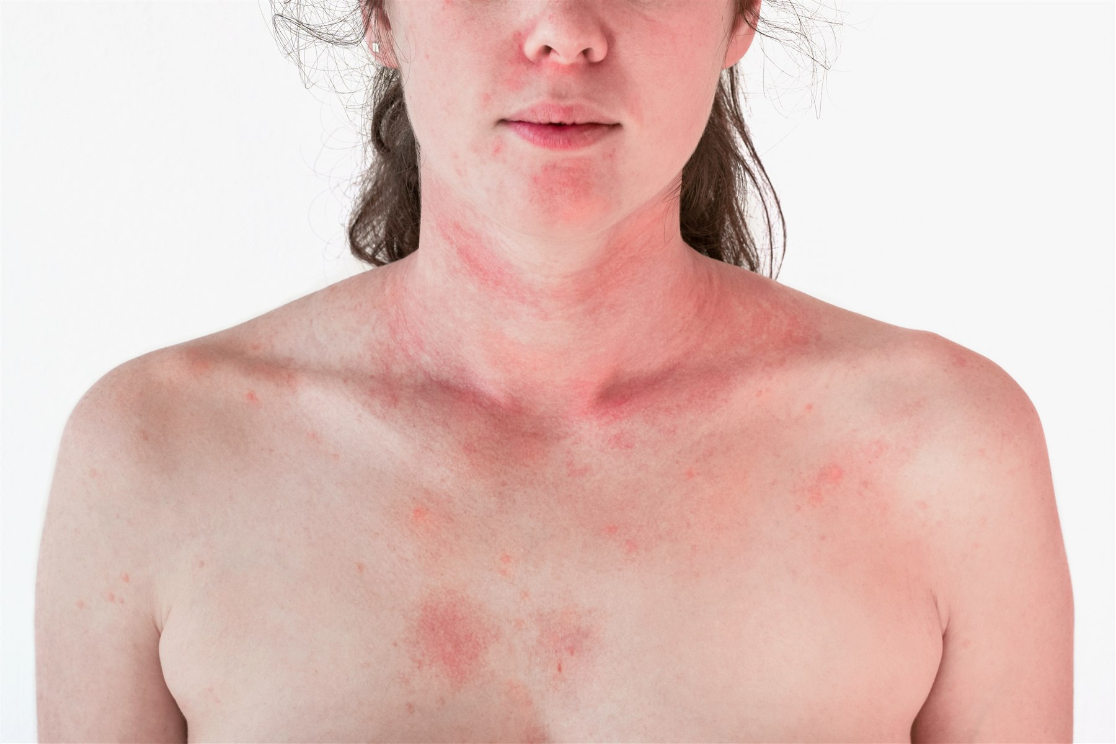
FIGURE 6.3
Tunatura/iStock / Getty Images
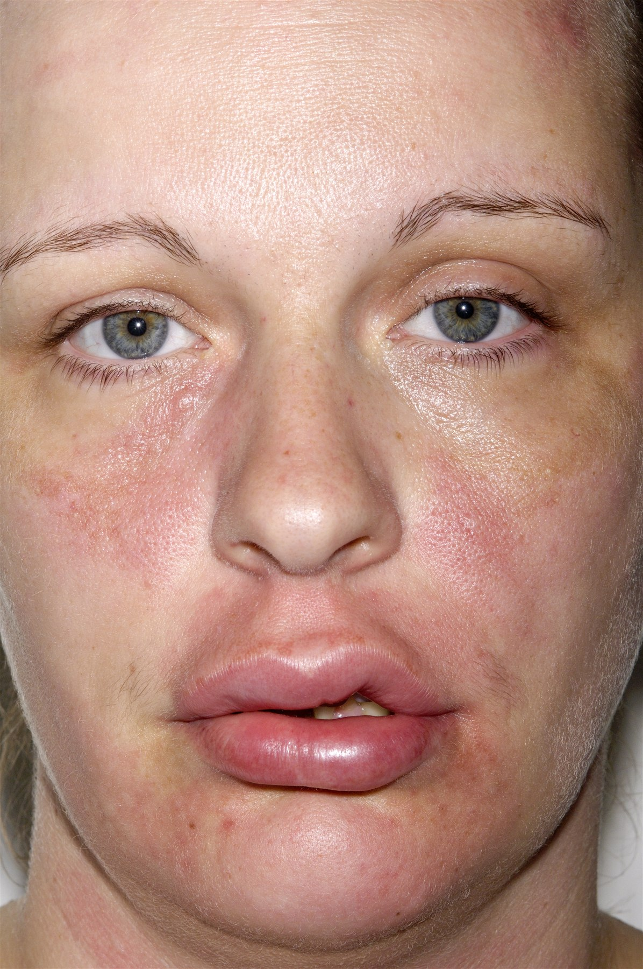
FIGURE 6.4
Dr P. Marazzi / Science Source
Relevant Medical History
No history of allergies. Nothing like this. You had hives when you had strep throat.
Onset: Started suddenly during practice.
Quality: Feels like “on fire,” itchy, throat and tongue swelling, shallow fast breaths.
Radiation: No radiating pain; hives spread over body.
Severity: 9/10 sensation of distress or shortness of breath.
Last oral intake: You recently ate a snack bar meal about an hour before practice (bagel with cream cheese, fruit cup, cheese stick).
Allergies: None
Medications: Rescue inhaler; a daily medication “It starts with Flo. I can’t remember the name.” You have been told not to take aspirin or ibuprofen because of the asthma, but you have not followed the advice.
Tests and Measures
Peak flow: You are unable to perform peak flow (blowing forcibly into HCP device) due to tongue and throat swelling.
Vital signs: (these will be provided to HCP by proctor or provided to you on an index card)
MINUTES | HR | BP | RR | SPO₂ | CTC | AUSCULTATION
0-3 | 90 | 124/74 | 22 | 98% | Pink and warm | Clear
4-7 | 100 | 136/80 | 26 | 97% | Hives spreading | Clear
8+ | 120 | 100/74 | 32—labored | 93% | Angioedema, cool, diaphoretic | Slight stridor rales
If epinephrine is provided, symptoms subside. Use column two for vitals, but skin is pink and warm. This will last for 8 min, unless time is sped up. If EMS does not arrive within 8 min or a second dose of epinephrine is not provided, symptoms continue to worsen, starting at 8+ min.
Notes on Intervention Effects
- Oral diphenhydramine: No meaningful improvement.
- Ice packs: Only temporary surface itch relief.
- Patient has no epinephrine auto-injector, but if epinephrine is administered (ampule and intramuscular injection), temporary improvement (~ eight minutes), then worsening.
Progression
Hives spread during the encounter to the chest, throat, and face. From no itching to itching and being uncomfortable constantly. Speech becomes more broken, shallow, and minimal as the condition worsens. Use scratch marks, gestures to the throat, and visible distress to cue progression. Your throat is beginning to feel tight. Eventually, you have a swollen tongue and can barely breathe because of this, plus a lot of fluid (saliva) builds in the mouth, and your throat is closing off—you are dying and panicked.
Objectives
Primary goal: To express escalating distress and symptoms consistent with anaphylaxis progressing rapidly.
Secondary goal: To give realistic emotional cues of fear and worsening breathing difficulty.
Interpersonal stance toward clinician: Anxious, increasingly desperate; seeking help and reassurance.
Safety
The phrase “Time-out; time-out” is used to immediately stop a simulation. As the standardized patient, you can say this at any time. It is particularly designed to ensure your safety and help you feel safe. All participants are taught this phrase. It means the same for everyone. If it is said, the simulation will immediately stop.

