Personnel, Equipment, and Moulage
Hotel Room, Food Poisoning That Develops Into Shock
- One SP, one proctor.
- Consider items to make a person look pale, sweaty, and ill. Could also have vomit (soup) in a waste can or vomit bag.
- Situation information to be read to the student.
Pool Deck, Tachyarrhythmia
- One SP, One Proctor
- Swimwear, towels, and so on. No special moulage or equipment
- Situation information to be read to the student
Athletic Training Clinic Dance Department, College, Skin Condition: Impetigo
- One SP, one Proctor
- Either show the picture of impetigo, or recreate the picture with makeup, moulage, a sticker, a mark, and so on, or a combination
- Situation information to be read to the student
FIGURE 10.1 Representation of impetigo.
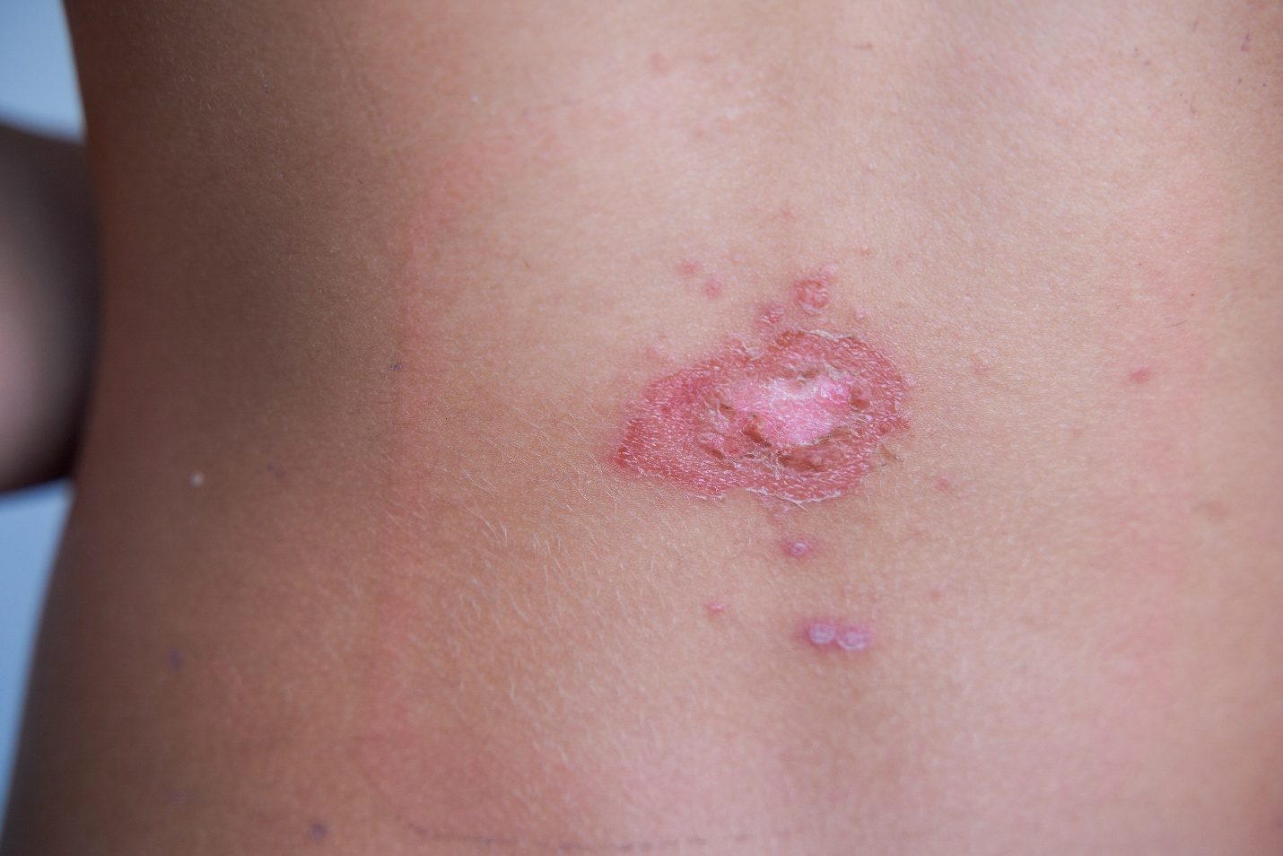
Siro Rodenas Cortes/Moment/Getty Images
Athletic Training Clinic, High School, Head Injury
- One SP, one Proctor
- No moulage or other equipment
- Situation information to be read to the student
Track, Sideline, Plantar Fasciitis
- One SP, one Proctor
- Running attire, no moulage or other equipment
- Situation information to be read to the student

