Personnel, Equipment, and Moulage
Equipment
So that the situation or circumstances are not obvious, the same materials are provided for each situation. If you have prepared the response bags as indicated in the introduction, these can be supplied and contain all necessary materials.
- Gauze
- Coban
- Rolled gauze (bleeding control items)
- Tourniquet
- Sling/triangle bandage
- Gloves
- Splint (SAM)
- Equipment or materials for shock (blanket, oxygen or nonrebreather (NRB), nasal cannula [NC])
- SpO₂
- Stethoscope
- Sphygmomanometer
- Penlight
- Peak flow meter and spacer for metered-dose inhaler (MDI)
Personnel and Moulage
Hockey Rink
Personnel: One SP or can also be a proctor
Moulage: One premade laceration, spirit gum or other glue, fake blood, spirit gum remover, one long sleeve shirt cut open. The moulage shown here was created in 10 minutes and was used for seven health care provider (HCP) situations without any problems or touch-ups (except adding additional blood).
Additional equipment: If you are able to find one, show a video of a hockey player getting their forearm run over. Alternatively, you could show a video of a leg or other appendage being lacerated by another player’s skate.
FIGURE 15.1 Example of moulage for the hockey simulation.
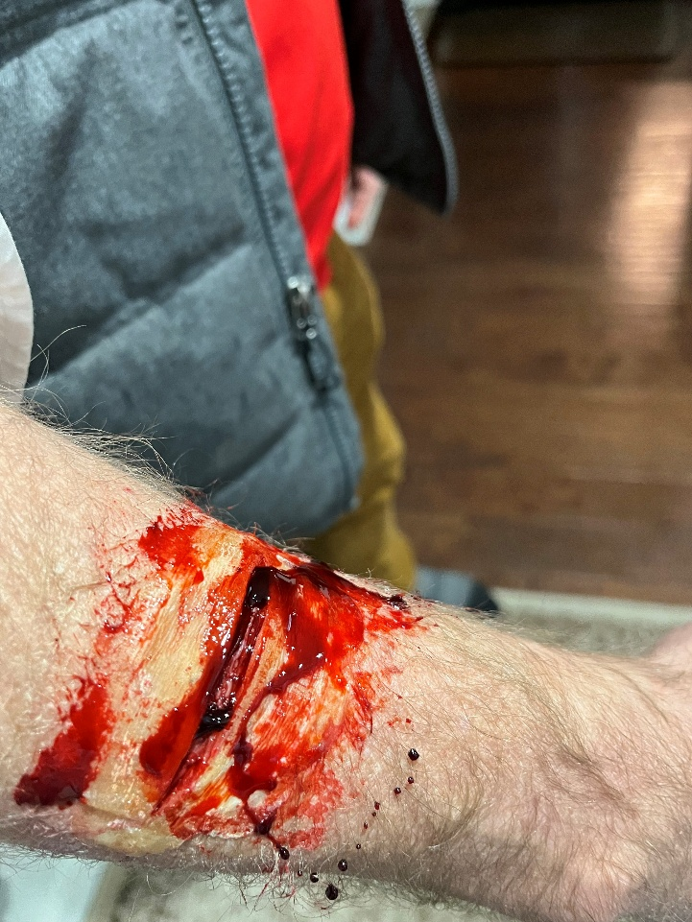

Basketball
Personnel
One proctor, one SP to be unconscious—could consider some type of full body manikin but not preferred
Moulage
Can consider bruising under the eye, but otherwise no moulage needed. Dress for basketball practice or a game

Mountain Biking
Personnel
One SP, one proctor
Moulage
Bike helmet and bike clothing. For some scrapes on the shin and chain marks, you can choose ripped bike shorts or something else. The additional scrapes and cuts along the legs should be minimal but something to draw the provider’s attention that there was likely a bike accident. The HCPs should also quickly realize that these other injuries are not a serious problem.
FIGURE 15.2 Example of moulage for the mountain biking simulation.
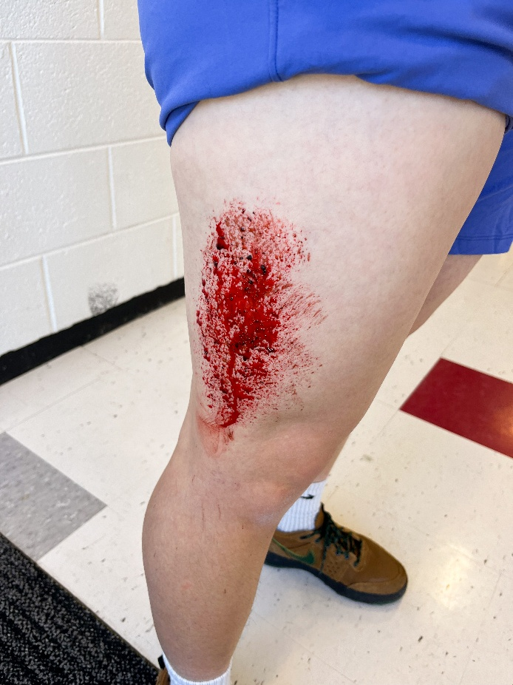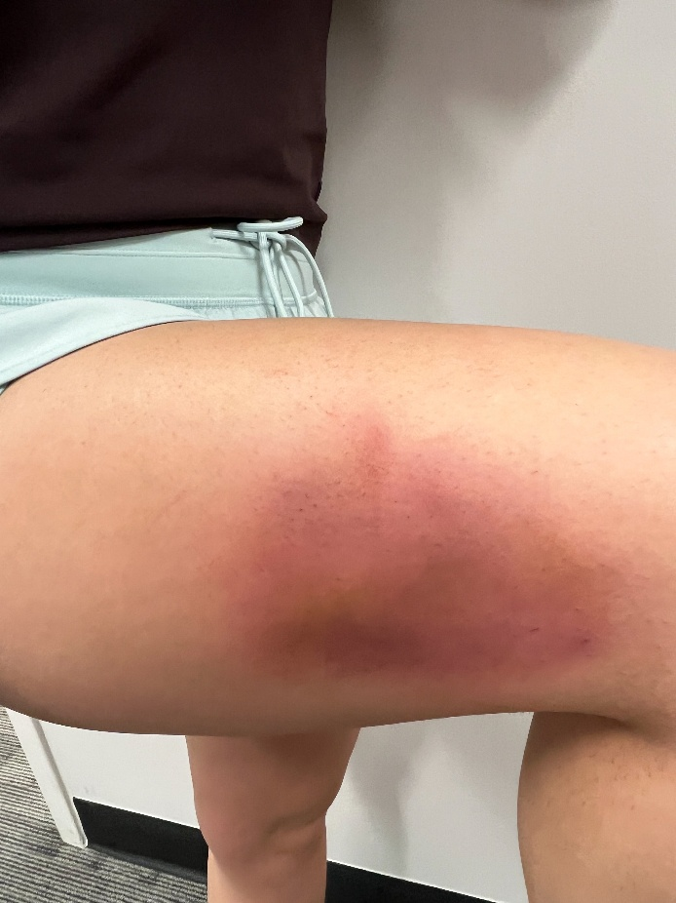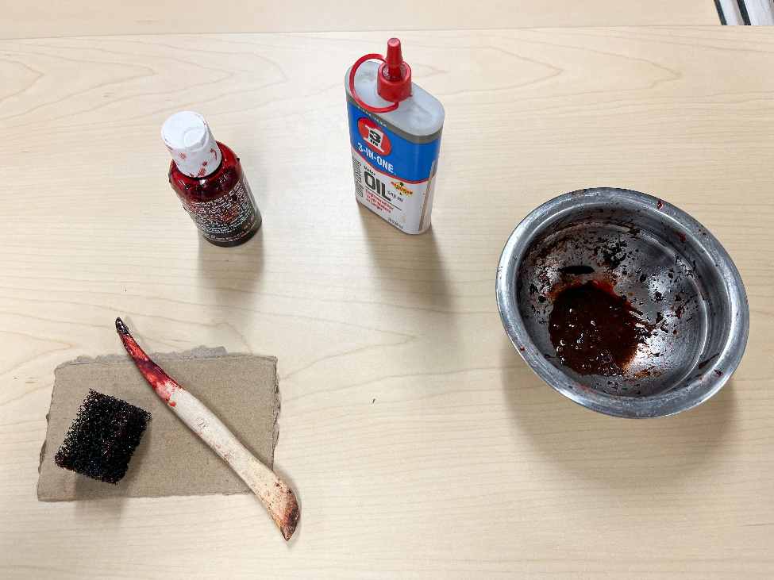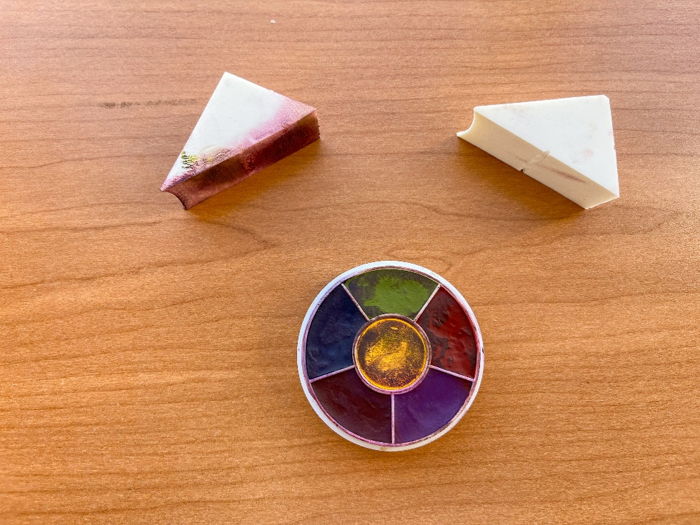
Football or Other
Personnel
One SP, one proctor
Moulage
One premade open arm fracture with blood or one red arm band stating open fracture. Football helmet, pads, and jersey. Easy to change to other sport like lacrosse or even soccer for a less equipment-intensive situation.
FIGURE 15.3 Example of moulage for open arm fracture.
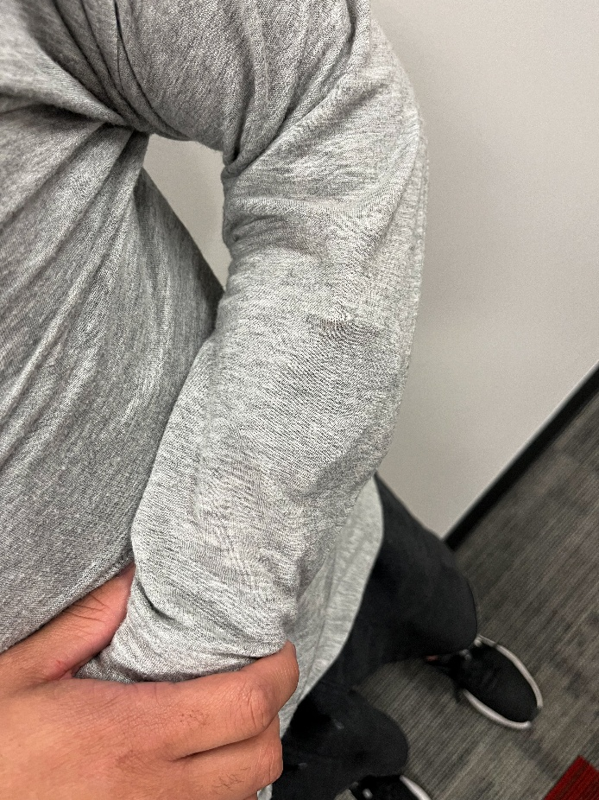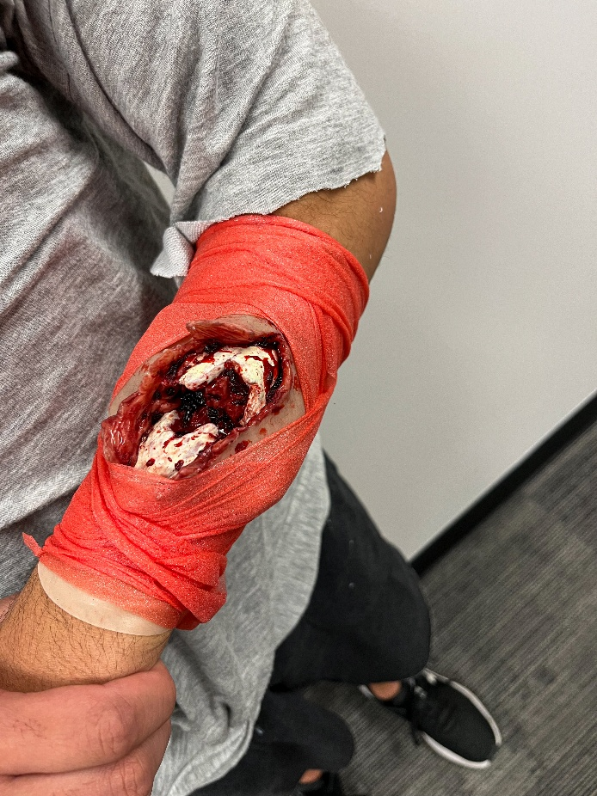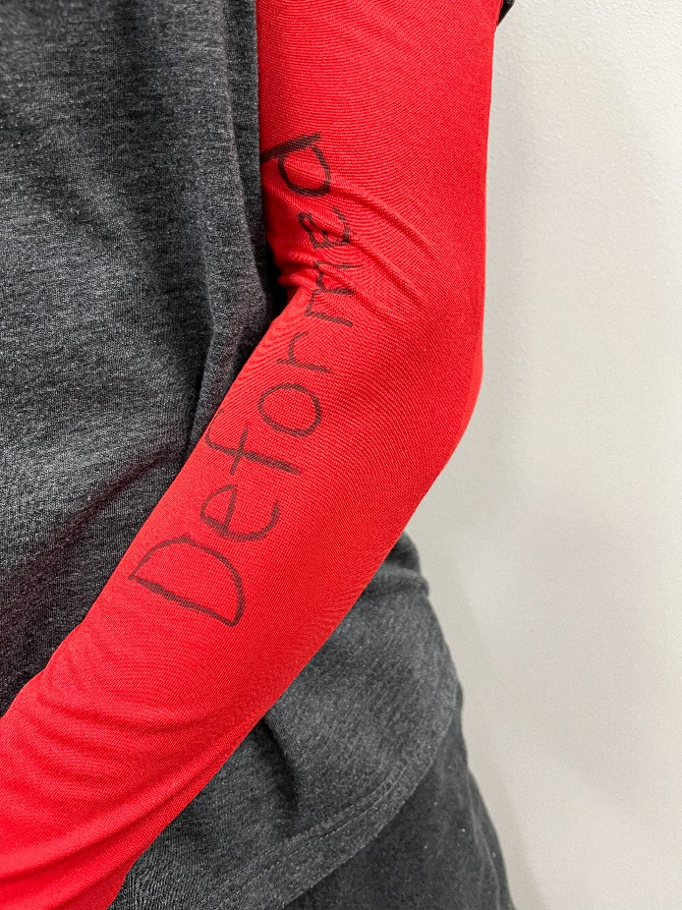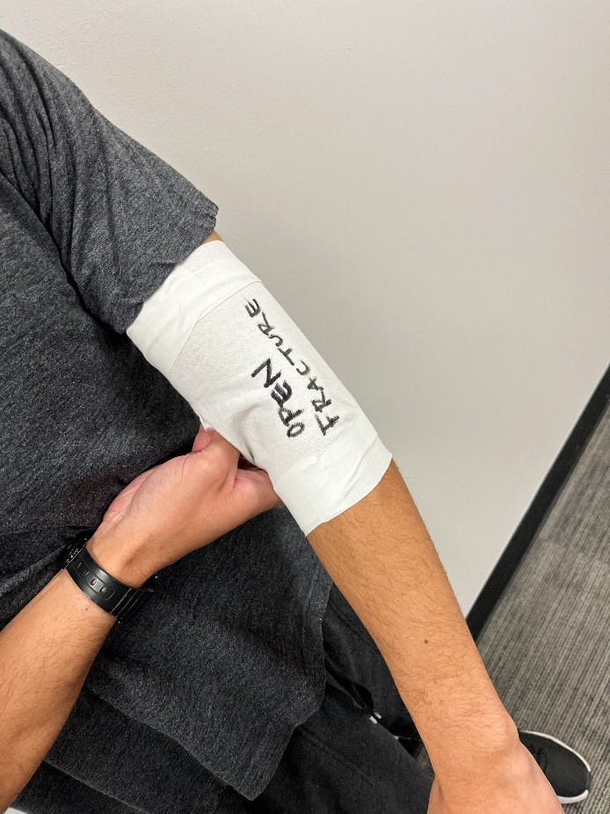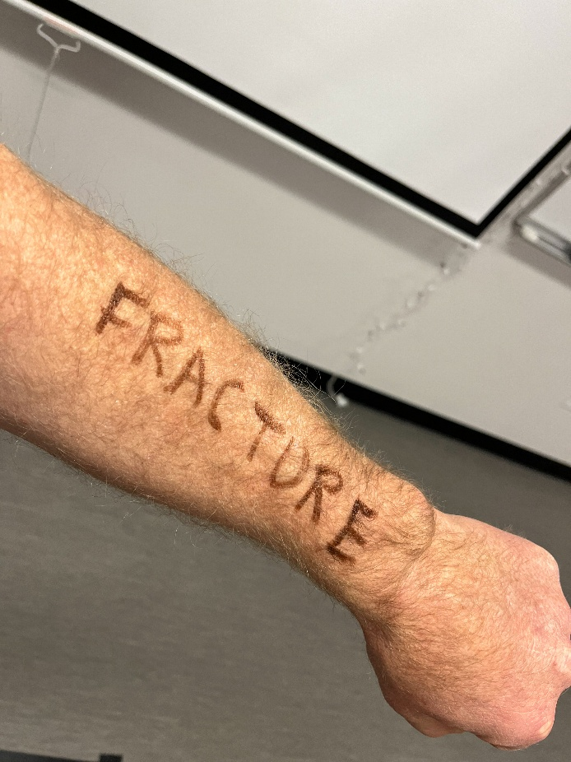
Additional equipment: Player needs to have a gym bag on the sideline with an MDI (with placebo medication, if possible).

