Personnel, Equipment, and Moulage
Personnel
For this simulation, you will want one SP per pair of students. In the earlier example, there are four SPs to portray athletes. You will want one EP to portray a physician. You may consider recruiting a faculty member or AT for this role, or you, the instructor, may portray this role.
Equipment
The following equipment should be supplied at each station
- Otoscope
- Blood pressure cuff
- Stethoscope
- Evaluation tables
Moulage
- Moulage for molluscum contagiosum (optional)
  - Simulation facilitators may wish to apply moulage to the SP’s arms (elbow creases, armpits, and wrists) to look like the bumps shown in the photo.
FIGURE 27.1 Molluscum contagiosum.
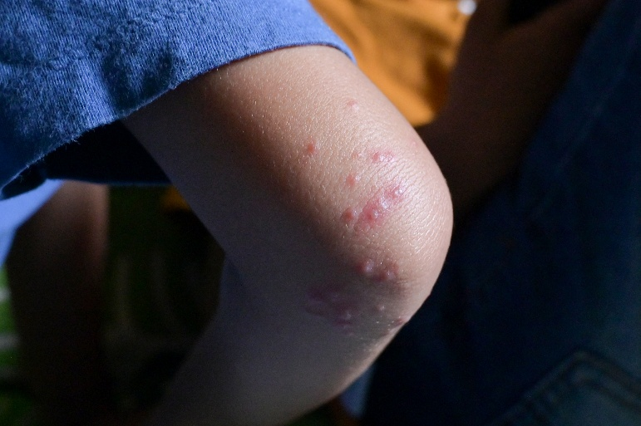
Riza Azhari/iStock / Getty Images

