Suggested Answers for Select Activities
Presimulation Activity 2: Anatomy Labeling
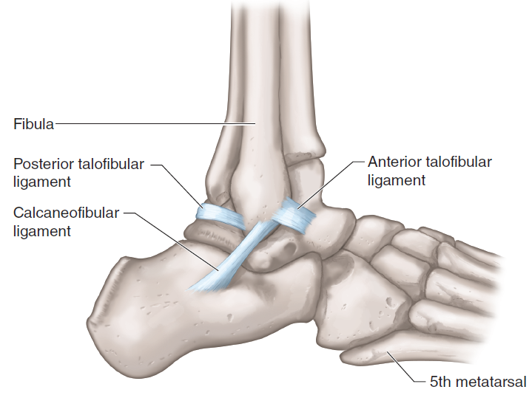
FIGURE 1.1 Ankle bones and ligaments.
Adapted by permission from K.T. Ebersole and D.T. Beine, "Clients With Orthopedic, Injury, and Rehabilitation Concerns," in NSCA's Essentials of Personal Training, 2nd ed., edited for the National Strength and Conditioning Association by J.W. Coburn and M.H. Malek (Human Kinetics, 2012). Reprinted by permission from J.A. Watkins, Structure and Function of the Musculoskeletal System, 2nd ed. (Human Kinetics, 2010).
Presimulation Activity 3: Wrestling Information
- A typical injury time-out is 90 seconds.
- An athlete is limited to two time-outs.
- An AT may extend the injury time-out to a maximum of four minutes.
- Taping is not permitted if it does not allow normal movement of the joint or if it prevents an opponent from applying normal holds. All bracing must be padded.

