Instructions for SP 4: Athletic Training Clinic, High School
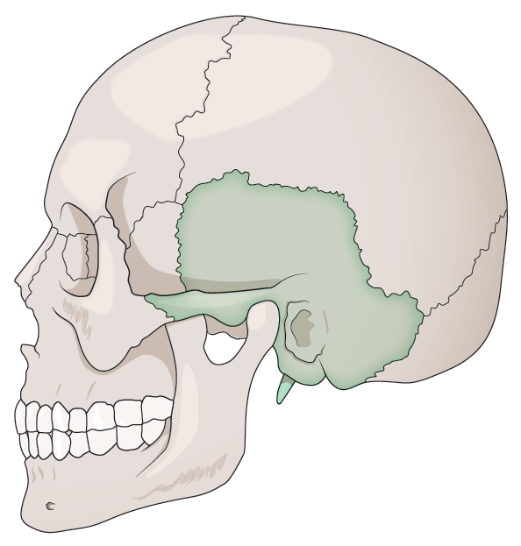
FIGURE 10.2 Representation of bone injured by patient.
You hit your head around the bone as pictured.
You are an 18-year-old high school senior.
Opening statement: “I hit my head about 30 minutes ago, and the pain is getting worse. I also have a headache now.”
You were goofing off in the hallway, competing to touch an exit sign. It was near a place where the ceiling changes height and protrudes outward. You noticed the ledge after jumping and turned your head to avoid it, but you hit the edge hard in the area pictured.
You are a volleyball athlete. Your position is outside. You left school for lunch but did not feel hungry and now feel even worse. It happened about 30 minutes ago.
Immediate: You initially felt fine and were able to get up without difficulty. You immediately had a headache, sensitivity to light and noise, dizziness, feeling slowed down, difficulty concentrating, but you were able to talk and walk normally. You felt stupid for hitting your head and assumed you hit it extra hard and went to lunch, assuming it would go away.
You feel like you could vomit. You are pale, a little clammy, and sweaty. All your symptoms have only gotten worse.
You feel sick and dizzy. You have not vomited. You have a headache. Moving your head around hurts.
You are shielding your eyes, holding your head, and trying not to raise your blood pressure or stimulate yourself too much.
If your pupils are checked, they are slow to react and may be slightly different in size.
Medical history: You had a wart removed. You participated in the PPE. If female, you take birth control. If they ask, you took ibuprofen for your headache just before coming in and forgot to mention it earlier.
Exam: There is no noticeable swelling or damage. However, it hurts for you to touch the spot where you hit your head.
Diagnosis: Some type of hematoma with a small skull fracture—no movement, swelling, or deformity—fracture is in line and does not produce movement, swelling, or deformity.
Safety
The phrase “Time-out; time-out” is used to immediately stop a simulation. As the standardized patient, you can say this at any time. It is particularly designed to ensure your safety and help you feel safe. All participants are taught this phrase. It means the same for everyone. If it is said, the simulation will immediately stop.

