Suggested Answers for Select Activities
Presimulation Activity 2: Describing the Phases of Healing
The student should describe the following phases of healing: hemostasis, inflammatory (sometimes the first two phases are referred to as just the inflammatory phase), proliferation, maturation or remodeling.
Presimulation Activity 3: Communication
Students should identify at least three things that are important for them when working as a team.
Presimulation Activity 4: Anatomy
2.
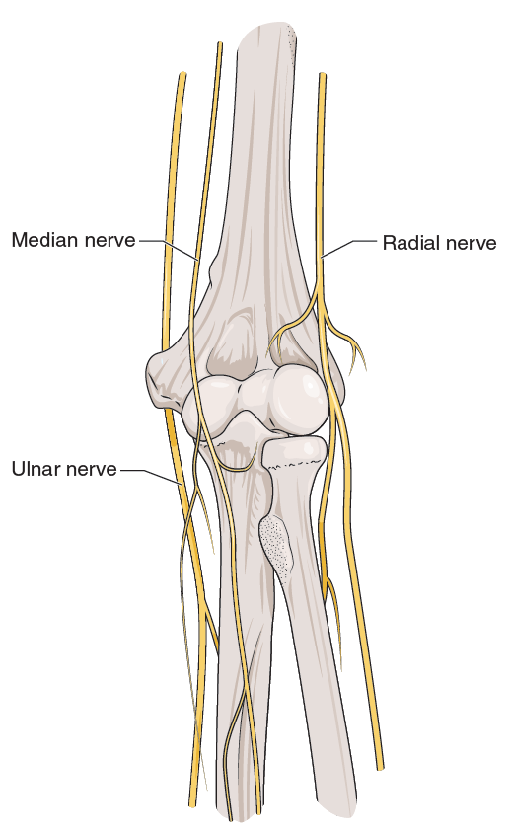
Figure 7.3 Nerves that cross the elbow joint.
3.
- Brachial artery with branches radial and ulnar
- Subclavian vein with branches ulnar, radial, and median
4.
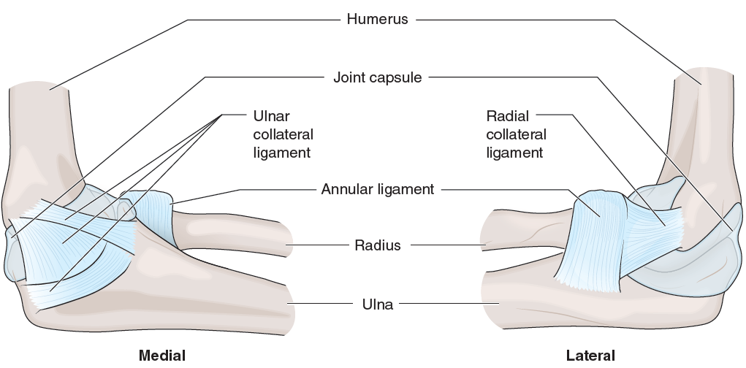
FIGURE 7.4 Anatomy of the elbow.
5. Students may list any four of these muscles: biceps brachii, brachialis, brachioradialis, triceps brachii, anconeus, supinator, pronator teres, flexor carpi radialis, flexor carpi ulnaris, palmaris longus, flexor digitorum superficialis, extensor carpi radialis longus, extensor carpi radialis brevis, extensor digitorum
6.
- Posterolateral
- Splint and then either operative care or stabilized in a splint until proliferation phase
- When there is vascular or neurological damage, or an open dislocation
- Hinge joint with flexion and extension

