Suggested Answers for Select Activities
Presimulation Activity 2: Clinical Observations and Assessments
Following are some of the signs, symptoms, or tests and measures students could list.
Liver
- RUQ abdominal pain or pain with percussion or palpation
- Radiating or referred pain to the right shoulder
- Rigid abdomen or guarding
- Nausea or vomiting
- Rebound tenderness
- Pain unrelieved by position or does not increase with muscular effort (helps rule out musculoskeletal injury)
- Rib compression test (to consider rib pain as a cause)
- Murphy’s sign (inspiratory arrest with RUQ palpation)
- Signs of shock: hypotension, pale, cool clammy, tachycardia
- RUQ ecchymosis
- Increased respiratory rate that does not return to “normal” with rest
- RUQ pain after trauma
Spleen
- Left upper quadrant abdominal pain
- Current or recent illness, fever, excessive fatigue (high index of suspicion for splenomegaly)
- Pain radiating or referred to the left shoulder—Kehr’s sign
- Rib compression test (to consider rib pain as a cause) or tenderness over left ribs
- Nausea or vomiting
- Pain unrelieved by position or does not increase with muscular effort (helps rule out musculoskeletal injury)
- Lightheaded
- Left upper quadrant trauma with signs of shock (hypotension, pale, cool clammy, tachycardia)
Appendix
- Pain over McBurney’s point or with other appendix tests
- Rebound tenderness and guarding
- Low-grade fever
- Nausea or vomiting
- Pain with coughing or movement
- Rovsing’s sign
- Psoas sign
- Obturator sign
- Periumbilical that migrates to right lower quadrant (RLQ)
- Signs of shock (e.g., tachycardia, hypotension, narrowing pulse pressure)
Kidney
- Pain around the flank or pain with palpation
- Radiating pain to abdomen, groin, or low back
- Nausea or vomiting
- Abdominal tenderness or guarding
- Pain with urination
- Hematuria
- Urinalysis
- Costovertebral angle tenderness
- Signs of shock (e.g., tachycardia, hypotension, narrowing pulse pressure)
Presimulation Activity 3: Anatomy Labeling
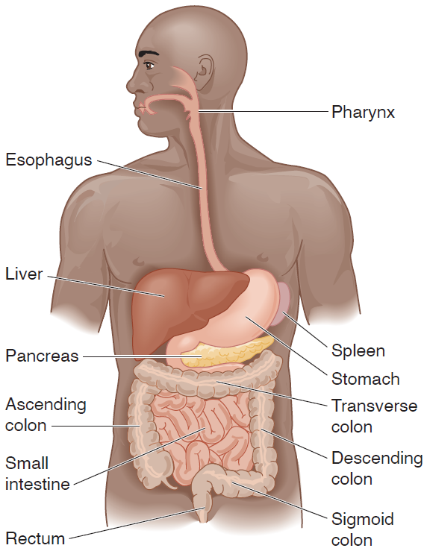
Figure 8.1 Abdominal cavity.
Adapted by permission from M.J. Flegel, Sport First Aid, 3rd ed. (Human Kinetics, 2004).

