Personnel, Equipment, and Moulage
Personnel
One facilitator minimum
Equipment
- Tape, preferably both white and rainbow athletic tape, which will be requested by the patient
  - Note cards for evaluations (these are provided as downloadable documents)
  - One set for first eval (half the number of students)
  - One set for second eval (half the number of students)
- Instructor PPT slides (provided), with photos of skin conditions and a power wheel
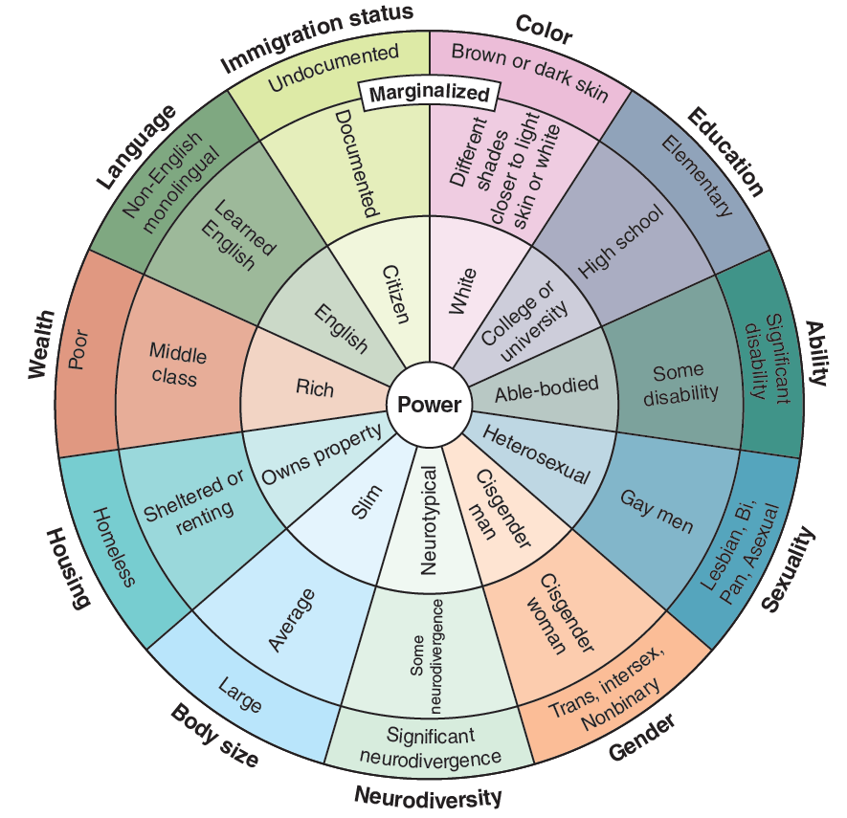
FIGURE 16.1 A sample of a wheel of power.
Adapted from ccrweb.ca, © Slyvia Duckworth. Distributed under the terms of the Creative Commons Attribution 4.0 International License (http://creativecommons.org/licenses/by/4.0/).
- Evaluation equipment you prefer for ankle injury.
- General medical evaluation equipment.
  - Thermometer, pulse oximeter, sphygmomanometer, stethoscope, and so on. You can also have the responder kits mentioned in the introduction available, and this will have all necessary supplies. (Consider having it available but not obvious to the students because this may cue them that it is not an ankle injury.)

