Instructions for Standardized Patient
Please memorize your story and the following information. When we meet, please be prepared with questions, problems, or concerns from this simulation.
Name: Brooklyn Bartson
History
You are a sophomore soccer player at a local high school. You are a starter on the team, and your coach expects you to be one of the top scoring players this season. You may be asked other questions, which you answer as you see fit. Be consistent with your answers. You are 16 years old (a minor). Your parents have always supported any necessary actions to keep you healthy and fit. Their goal is for you to play professional soccer one day.
Chief Complaint
Sharp pain on the arch of your right foot, which intensifies during weight bearing. You are able to plantar flex your foot with weight, but it is painful. You are able to walk without a limp but with pain.
Actual Diagnosis (Do Not Disclose to the HCP)
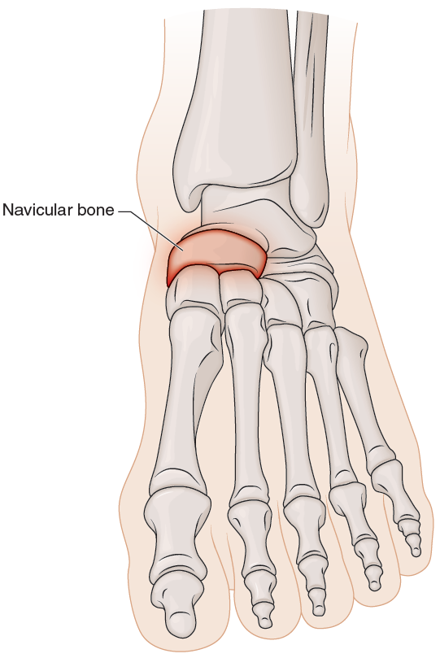
FIGURE 25.1 Stress fracture of the navicular.
Adapted by permission from J.K. Loudon, M.P. Reinman, and R.C. Manske, Clinical Mechanics and Kinesiology (Human Kinetics, 2013).
Situation
You were competing in your first match of the season and just finished beating last year’s second place state runner-up three to one. You made one of the goals. The team is elated and celebrating as this was an unexpected win so early in the season. About 15 minutes after the game, as the excitement wore off and you were getting dressed to leave, you noticed the arch of your foot hurting. You did not want to miss the celebration, so you blew it off, assuming it would get better. At the end of the celebration and a shower, you walk the ½ mile (804 m) to the bus, take the bus ride, then walk about ½ mile (804 m) home. The pain persisted but was less intense. Mostly getting worse with the walking. At home, you lay on the couch and played video games for about 80 minutes. When you got up, there was immediate, sharp pain, 8 or 9/10. You decide to call the school HCP (athletic trainer [AT]). You have met the HCP previously, but you’ve never been injured before, so you have never spoken with them directly or had much interaction. You are nervous that something is wrong; you just started on the varsity team and don’t want this to be serious. If the HCP implies or confirms that this is likely a season-ending injury, you are very upset and verbally display this emotion. You try to get this information from the HCP because you performed so well in this game, and it is your first varsity game.
Setting
You are calling from your apartment. You take the bus to school. It is about ½ mile (804 m) walk, 20 to 30 minute bus ride depending on the time of day, and then another ½ mile (804 m) walk. You are attending a private school on scholarship.
Other Info
If asked, you can’t send a photo of your foot or do FaceTime or any of that. Your parents are very strict about that, and you can’t do it with anyone who is not immediate family without explicit permission from your parent.
Opening Statement
“Hey, this is Brooklyn. I am a sophomore and was in the game today. I scored one of the goals; anyway, I just got up off the couch, and my foot really hurts, I’m not sure what I did.”
Other Directions
Ask these questions unless the HCP has already provided you with the answers:
- “What do you think is wrong with my foot?”
- “I am supposed to go on a family trip tomorrow with all my cousins and everything. We are going to hike, camp, play volleyball, roast marshmallows, all that stuff this weekend. Can I do all that if I wrap it really well or ice it or something?”
- “What should I do about it?”
- “Can I just take some ibuprofen and ice it? Will that do it?”
- “Am I going to have to stop playing?! I can’t do that. This is my year. I just made varsity. I’ll lose my starting position!”
You are anxious about the possibility of a long-term injury and what it could mean for the rest of your career. You don’t know what you would do if you couldn’t play soccer anymore. You feel like you will cry if the HCP says you can’t play the rest of this season.
Injury History Information
You don’t remember doing anything, and it didn’t hurt while playing. No pop or other noise was heard. While the pain has diminished at different times, it has been present since it started. Starting around a 4 or 5 out of 10 at a minimum, and it gets to an 8 or 9/10 with walking or lots of movement—gets worse with activity.
Weight bearing significantly increases your pain, and non-weight bearing significantly decreases it. The pain is sharp, does not radiate, and is focused on one point (see images online of the location of your navicular bone). No visual deformities. You have not done anything for it yet, only rest on the couch. You do not know any anatomical terms except the Achilles tendon.
Footwear
You have been trying some new shoes. You wear your old shoes sometimes but mostly the new shoes for about three weeks now. The new shoes were recommended for the players. You wore the new shoes during the game. As a new varsity player and because of your excitement, you have also increased your training quite a bit. You have been doing weights, running in the hills, and doing all kinds of plyometrics to get better.
Safety
The phrase “Time-out; time-out” is used to immediately stop a simulation. As the standardized patient, you can say this at any time. It is particularly designed to ensure your safety and help you feel safe. All participants are taught this phrase. It means the same for everyone. If it is said, the simulation will immediately stop.
Ending the Simulation
If 15 minutes have passed, simply say to the HCP, “I have to go.” It can be for any reason, such as “My friends are here. My mom is calling. I ordered food and need to eat. I have to clean my room before my mom gets home.”

