Presimulation Activity 4: Power Wheel
Using the privilege and power wheel, consider the privilege and power you may have as it is reflected in this wheel. Also consider areas where that privilege or power is lacking. How might power present itself in your current life and interactions? List 10 to 12 words to describe your power (whether present or lacking) according to the wheel, and write at least one sentence describing how that power is present or lacking. You will not share this with anyone but the instructor. Also consider how these assumed privileges and power may not hold true in every situation, or for every person, or for you. Please include any insights in your reflection.

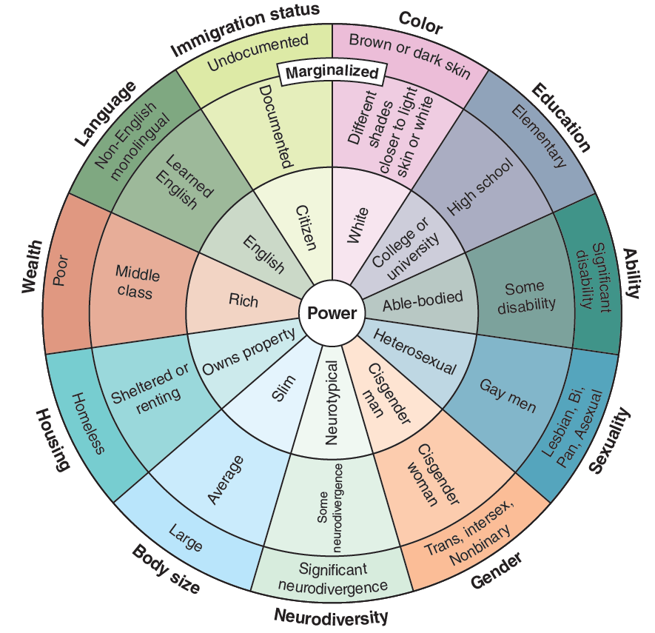
FIGURE 16.1 A sample of a wheel of power.
Adapted from ccrweb.ca, © Slyvia Duckworth. Distributed under the terms of the Creative Commons Attribution 4.0 International License (http://creativecommons.org/licenses/by/4.0/).

