Presimulation Activity 2: Anatomy Labeling

In the figure shown here, label the following bones and ligaments:
- Fibula
- Fifth metatarsal
- Anterior talofibular ligament
- Calcaneofibular ligament
- Posterior talofibular ligament
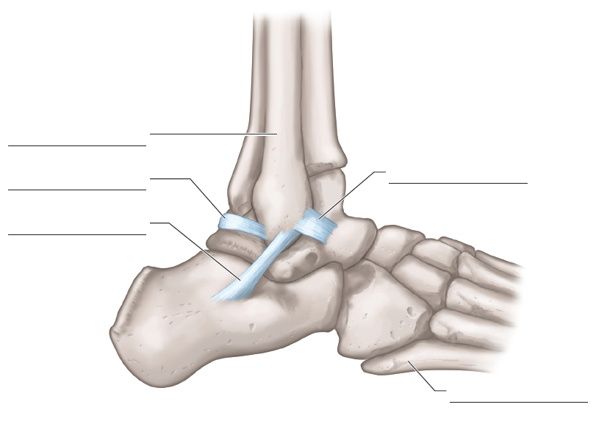
FIGURE 1.1 Ankle bones and ligaments.
Adapted by permission from K.T. Ebersole and D.T. Beine, "Clients With Orthopedic, Injury, and Rehabilitation Concerns," in NSCA's Essentials of Personal Training, 2nd ed., edited for the National Strength and Conditioning Association by J.W. Coburn and M.H. Malek (Human Kinetics, 2012). Reprinted by permission from J.A. Watkins, Structure and Function of the Musculoskeletal System, 2nd ed. (Human Kinetics, 2010).

