Presimulation Activity 4: Anatomy
- Review and find all of the following bony landmarks:
- Olecranon process | - Head of the ulna
- Medial humeral epicondyle | - Styloid process of the ulna
- Lateral humeral epicondyle | - Head of the radius
- Supracondylar ridges of the humerus | - Shaft of the radius
- Olecranon fossa | - Styloid process of the radius
- Shaft of the ulna | - Lister’s tubercle
- Many nerve branches cross the elbow joint. Locate and label the following nerves in the figure.
- Radial nerve
- Median nerve
- Ulnar nerve
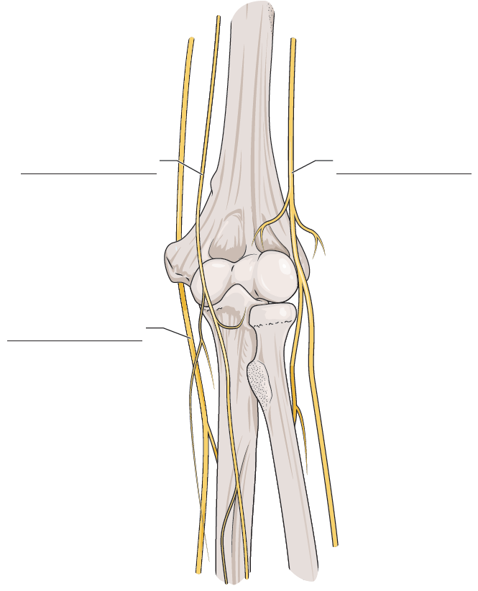
FIGURE 7.1 Nerves that cross the elbow joint.
- List the vasculature that crosses the elbow joint.
- One major artery and its branches across the elbow:
- The major vein starting in the neck and its branches that cross the elbow:
- Label the anatomy of the elbow shown in the figure.
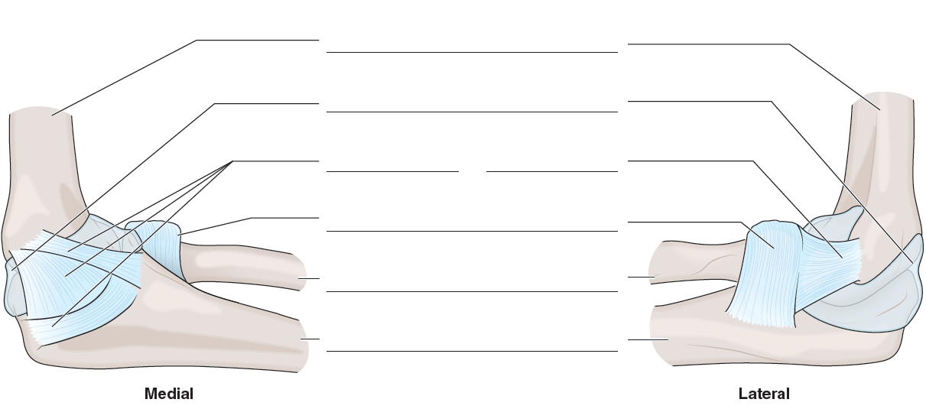
FIGURE 7.2 Anatomy of the elbow.
- List four of the major muscles that cross the elbow.
- Answer the following additional questions:
- How does an elbow typically dislocate (what moves in what direction)?
- How do you treat an elbow dislocation?
- When is an elbow dislocation emergent and under what conditions?
- Describe the osteokinematics at the elbow.

