Presimulation Activity 3: Anatomy Labeling
Label each item.
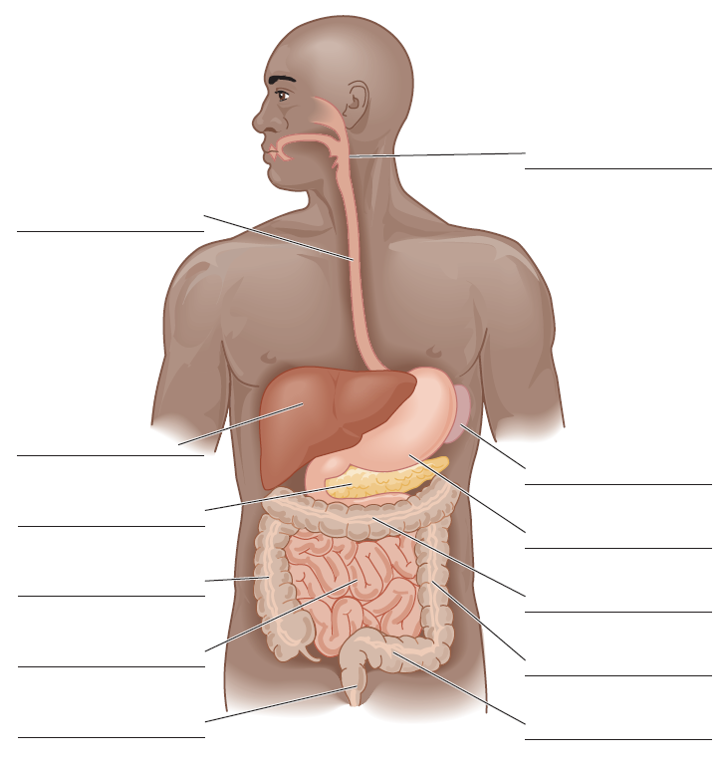
Figure 8.1 Abdominal cavity.
Adapted by permission from M.J. Flegel, Sport First Aid, 3rd ed. (Human Kinetics, 2004).

