Postsimulation Activity 1: Pulse and Heart Rate
Working with a partner, take each other’s vital signs, record your partner’s heart rate (HR) at various assessment locations noted in the table, and then respond to the following questions:
- What are some reasons the HR might slow? How might this affect the body?
- What are some reasons the HR would speed up? How might this affect the body?
- Why might the heart beat irregularly? How might this affect the body?
LOCATION | RATE | QUALITY
Carotid | bpm
Radial | bpm
Femoral | bpm
Popliteal | bpm
Posterior tibial | bpm
Dorsalis pedis | bpm
bpm = beats per minute.
HR from pulse oximeter = |  | bpm
HR from pulse oximeter = |  | bpm

- How does the pulse oximeter bpm relate to your palpated pulse?
- When discussing the heart working to pump blood throughout the body, describe at least one problem associated with a small or large afterload.

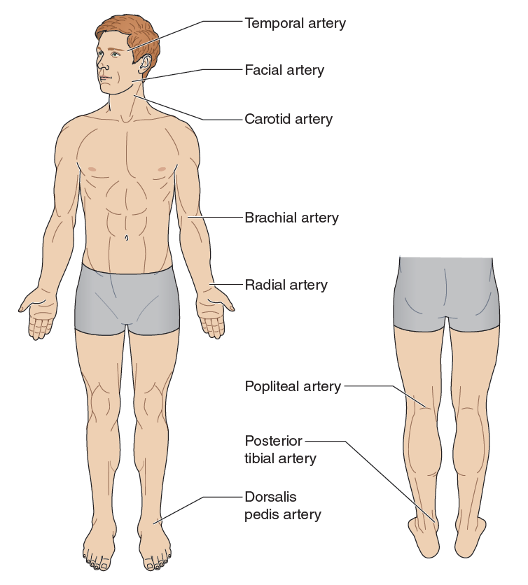
FIGURE 15.1 Locations of heart rate assessment.
Adapted by permission from K. Walsh Flanagan and M. Cuppett, Medical Conditions in the Athlete, 3rd ed. (Human Kinetics, 2017).

