**Reliable Power Conversion for Space Applications**

Student Researcher: Claire Hopfensperger

Advisor: Dr. Mark Scott

Miami University

Electrical and Computer Engineering Department/Computer Engineering & Electrical Engineering

**Abstract**

Power electronics are essential to space innovations, supporting critical functions such as power conversion, conditioning, and management. Due to the complex and dynamic behavior of power electronics, reliable tools and methods for simulation, health monitoring, and failure prediction are not currently widely available. By determining when power electronics will fail, we can balance the expensive costs of frequent component replacement against the risks of unexpected failures. One health monitoring method being explored in the current research space is using a digital twin, or simulated version of a system, for failure detection and prediction. This research aims to design and fabricate a compact, accessible, and scalable printed circuit board (PCB) that consolidates a previously developed digital twin-based multi-part system for power electronics health monitoring and failure prediction. The condensed PCB was designed with Altium Designer to fit and interact with a Raspberry Pi 3, enabling adjustable and scalable operation.

**Project Objectives**

The objective of my research is to condense a previously developed digital twin-based health monitoring system to one PCB, which interacts with a Raspberry Pi 3 as a Raspberry Pi HAT (“Hardware Attached on Top”), to reduce the size of the system while increasing the scalability and ease of use. My research is the next step in prototyping a health monitoring and failure prediction system.

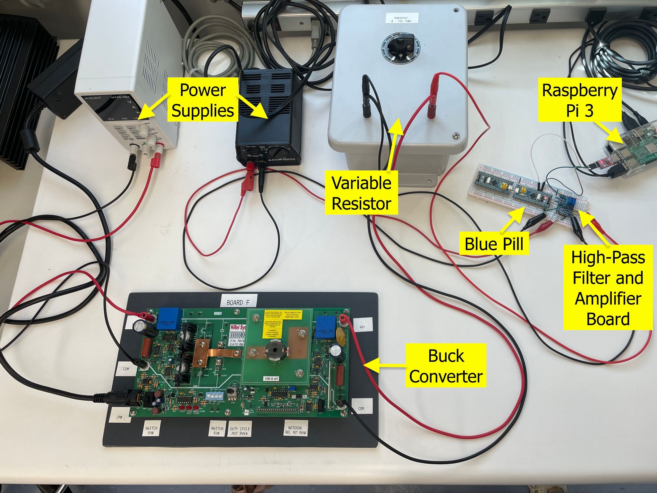

Fig. 1: Original System Setup

A Miami University 2023-2024 senior capstone group developed this previous system (Fig. 1) that monitors the health of a capacitor within a Buck converter, a commonly used power converter.

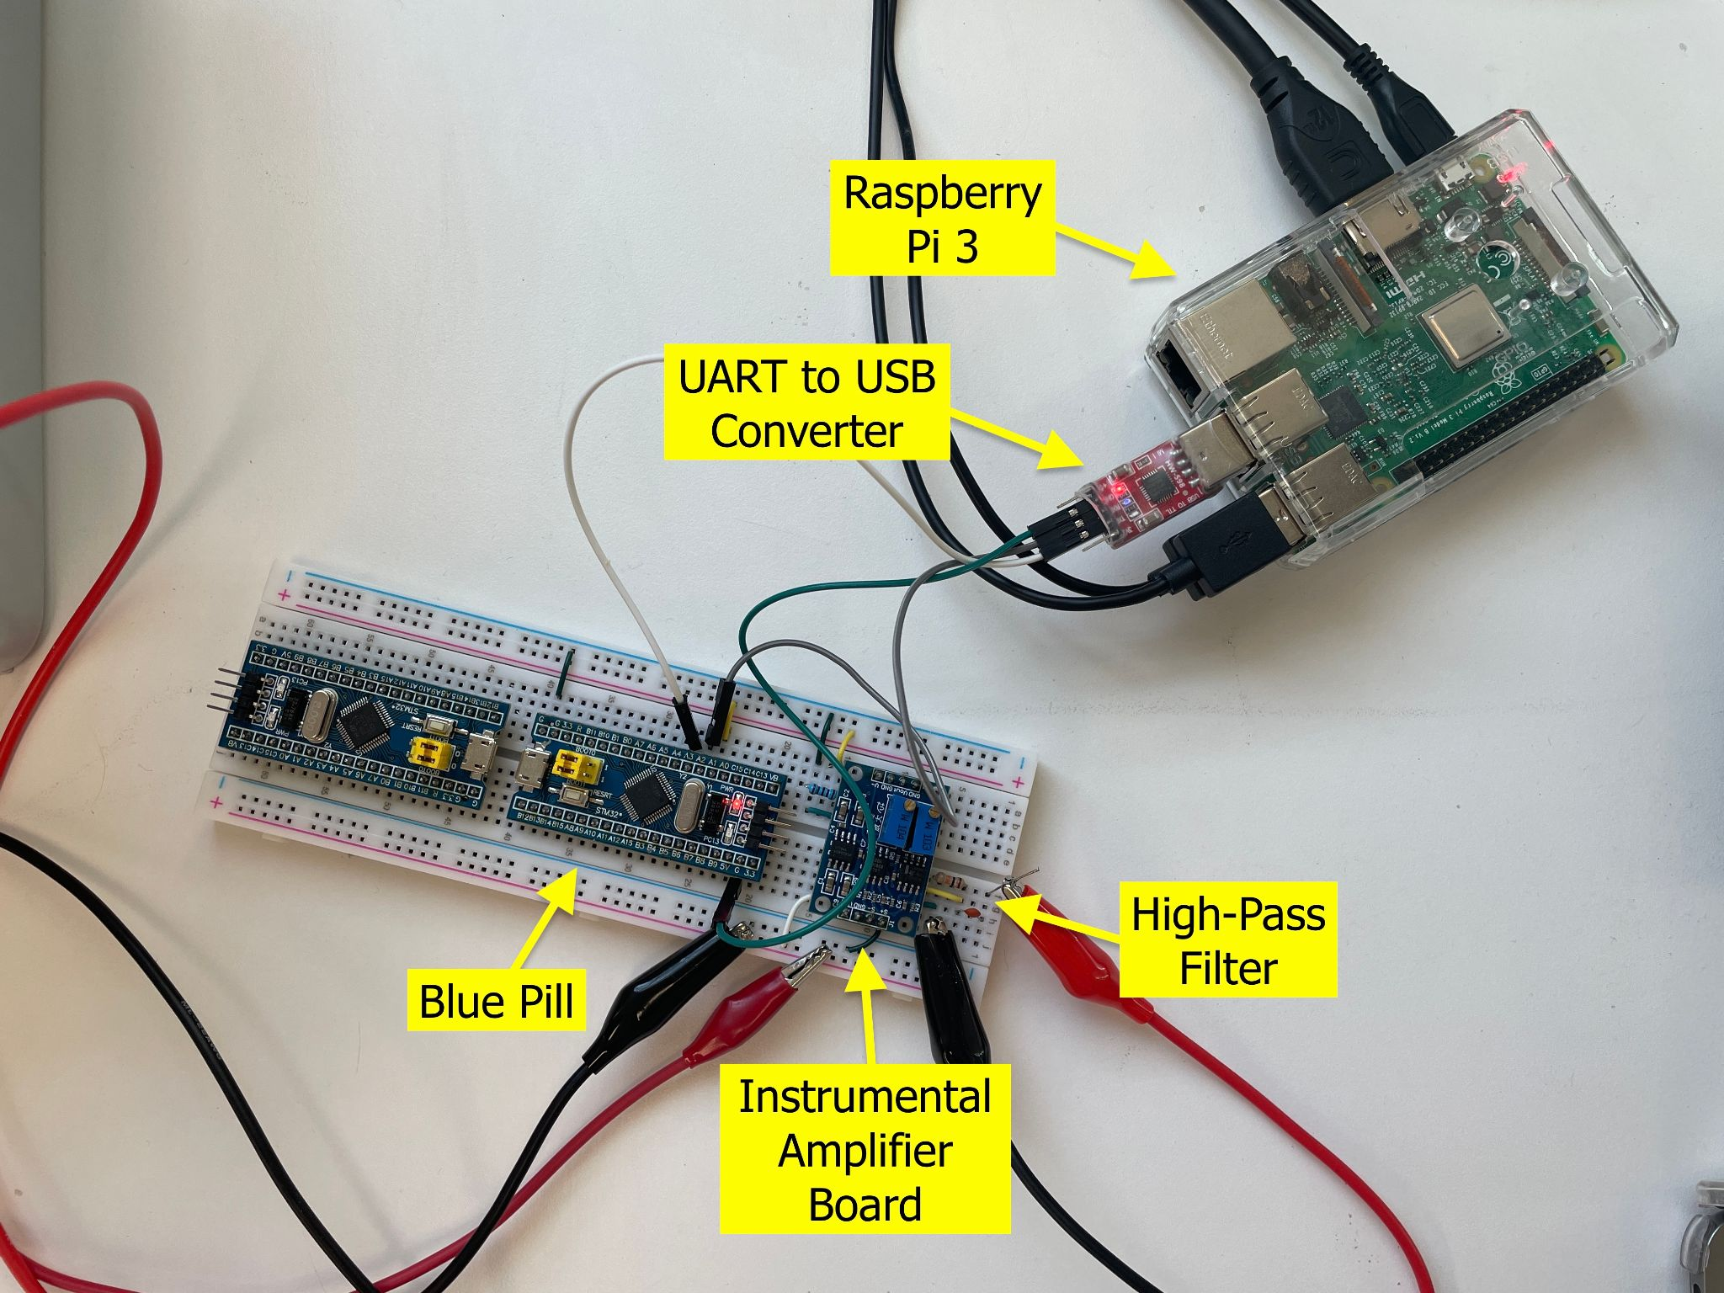

Fig. 2: Original system setup sub-section including high-pass filter, instrumental amplifier board, Blue Pill, UART to USB converter, and Raspberry Pi 3.

The previous system consists of a high-pass filter, an instrumental amplifier board [1], and an STM32 microcontroller (called a “Blue Pill”) [2]. These three components are connected on a breadboard and then connected to a Raspberry Pi 3 via a UART to USB converter (Fig. 2). The high-pass filter removes the DC offset from the Buck converter capacitor ripple voltage signal so that the amplifier can read it, the amplifier board amplifies the signal so it can be sampled, and the Blue Pill samples the signal with its analog-to-digital converter (ADC) and then transfers it to the Raspberry Pi via UART communication for analysis.

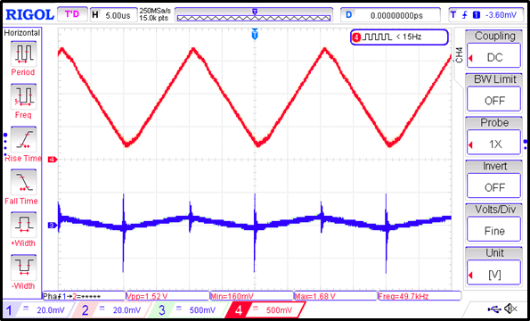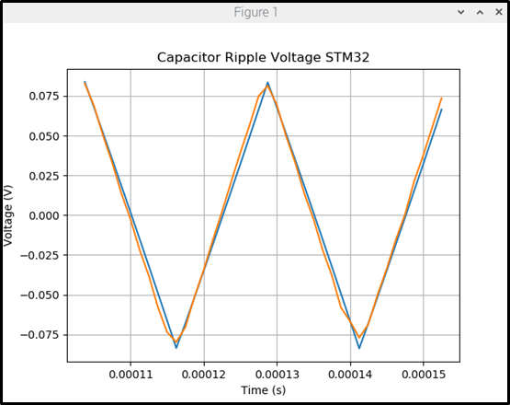

Fig. 3: Left: Oscilloscope capture of capacitor voltage with no DC offset (blue) and amplified capacitor voltage (red). Right: Raspberry Pi plot of measured capacitor voltage (orange) and simulated capacitor voltage (blue).

On the Raspberry Pi, via a Python script, the sampled signal is plotted against the ideal capacitor ripple voltage model (the “digital dwin”) (Fig. 3), which was also developed by the 2023-2024 senior capstone group, so visual comparison can be used to determine if the capacitor is in good health or failing. The health of the capacitor is determined based on the shape difference of the ripple voltage signals; if the sampled ripple voltage is much larger or offset from the simulated ripple voltage, then the capacitor’s equivalent series resistance has increased or its capacitance has decreased, meaning the capacitor has aged.

**Methods**

First, to determine how the system could be condensed to a single PCB, I needed to understand how the previous system worked and what the expected outcome should look like. Upon breaking the system down and learning each part’s purpose and functionality, I made several small adjustments to the original system to ensure the Raspberry Pi HAT PCB system would be achievable. Before, the amplifier board and Blue Pill were externally powered, but I determined that they could be powered with the 5 V and 3.3 V sources, respectively, from the Raspberry Pi. I also discovered that by reconfguring the Raspberry Pi to enable UART communication, I could eliminate the need for the UART to USB converter and connect the Blue Pill directly to the Raspberry Pi’s UART transmit/receive general purpose input/output (GPIO) pins.

Then, I started designing my Raspberry Pi HAT PCB. I used Altium Designer for the circuit design and PCB layout process. The PCB circuit would include the high-pass filter, the amplifier board components, GPIO header pins to attach the Blue Pill to the top of the PCB, and GPIO header pins to attach the PCB to the Raspberry Pi.

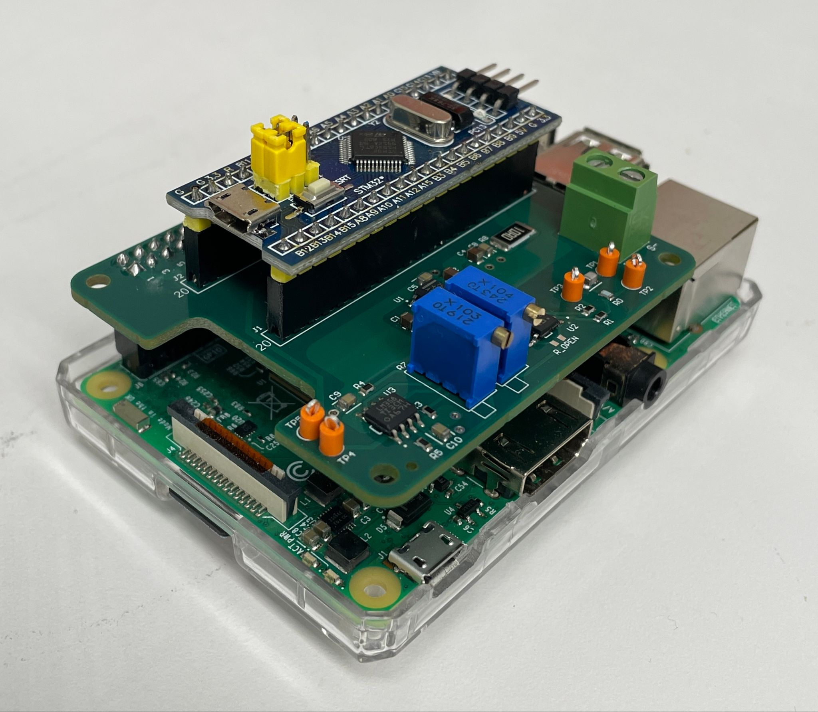

Fig. 4: Raspberry Pi HAT plugged into Raspberry Pi with Blue Pill attached on top.

Next, I ordered the PCB for fabrication and assembly through JLCPCB.com. Throughout the layout process, I ensured that the majority of my components were available through JLCPCB so that I could receive the PCB mostly assembled. Some components were not available through JPCPCB, though, so I hand-soldered those remaining components onto the PCB once it arrived and then integrated the Raspberry Pi HAT with the Blue Pill and Raspberry Pi (Fig. 4).

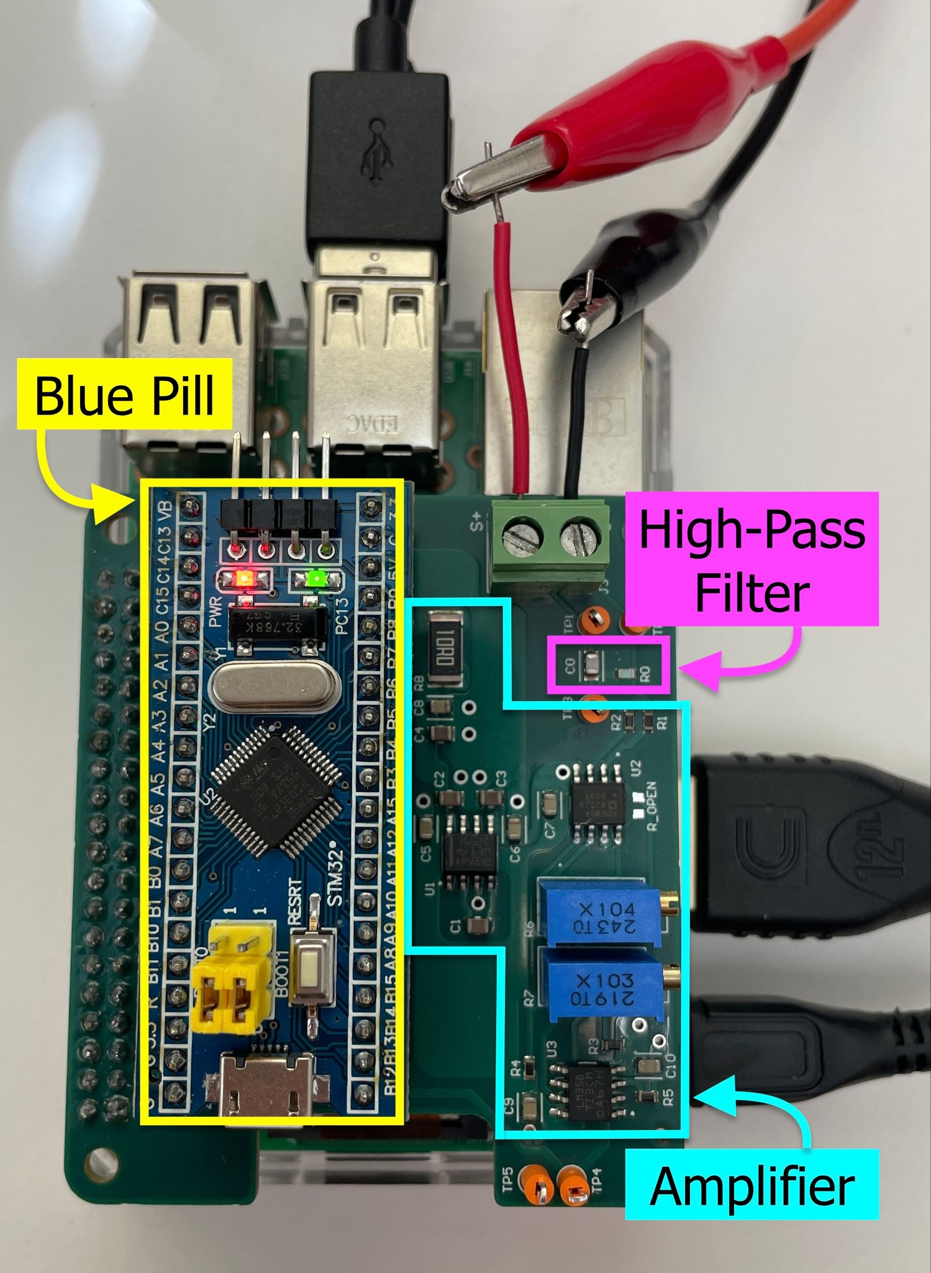

Fig. 5: New system setup sub-section showing the high-pass filter, amplifier, and Blue Pill on the Raspberry Pi HAT utop the Raspberry Pi.

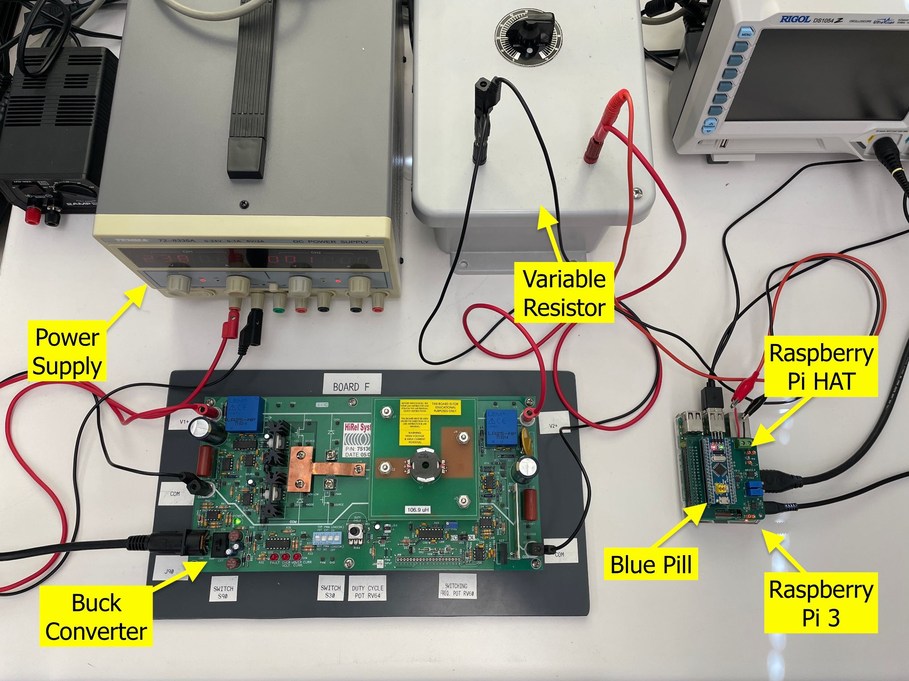

Fig. 6: New system setup.

Finally, I set up the new system (Fig. 5, 6) and tested the Raspberry Pi HAT to ensure proper functionality.

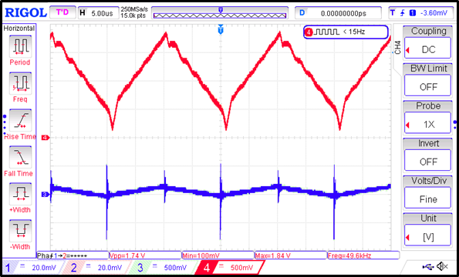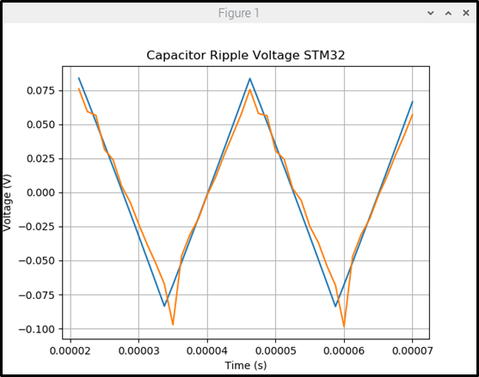

Fig. 7: Left: Oscilloscope capture of capacitor voltage with no DC offset (blue) and amplified capacitor voltage (red). Right: Raspberry Pi plot of measured capacitor voltage (orange) and simulated capacitor voltage (blue).

Luckily, the HAT worked as intended on the first try (Fig. 7)! Because the testing process was shorter than anticipated, I also implemented pseudo-live sampling. I adjusted the Raspberry Pi Python script to repeatedly trigger the Blue Pill to sample the capacitor voltage and send the data to the Raspberry Pi for data plotting. The sampling does not update instantaneously, but the repeated sampling offers a better idea of how the capacitor voltage acts over a short time period rather than a singular snapshot of its behavior.

**Results and Discussion**

The Raspberry Pi HAT system was successful in recreating the expected outcome of the original system (Fig. 3), with slightly more noise than the original system (seen in the peaks and dips of the measured signal) (Fig. 7). After investigating this difference with my advisor, we decided that the PCB system is more reliably sampling the capacitor voltage due to its secure connections in the PCB versus the breadboard setup, and the imperfect test setup introduces noise into the system, as seen in the measurements. Or, the additional noise is due to some artifact that came with the new system that we have not yet discovered in our investigation.

The PCB’s adjustability and scalability come from the two potentiometers included in the circuitry (Fig. 5). The 100 kΩ potentiometer (labeled “104”) adjusts the amplifier gain of the signal, and the 10 kΩ potentiometer (labeled “103”) adjusts the amplifier offset of the signal. By adjusting these two potentiometers, the user can line up the measured capacitor voltage with the simulated capacitor voltage for easier visual comparison. It is with these adjustable aspects of the Raspberry Pi HAT along with the programmability of the Blue Pill and Raspberry Pi that we hope to be able to extend the use of this health monitoring system to more than just a capacitor in a Buck converter.

This research has a lot of room for future work and advancements. First, the pseudo-live sampling could be improved to get the sampling as close to live as possible. Achieving live sampling would allow for a more accurate representation of the signal in real time. Second, doubling the Blue Pill sample rate would allow for more detailed sampling of the capacitor voltage, which, in turn, draws a more detailed graph of the voltage on the Raspberry Pi. The more detailed graphs would enable a more accurate and reliable visual comparison between the sampled voltage and the simulated voltage for health monitoring. Third, testing the entire health monitoring system with different power systems and components that require health monitoring would expand the known ability of the health monitoring system. To test different power systems, though, more digital twin models of these power systems would need to be developed, which in and of itself is an important research topic.

NASA had developed a similar health monitoring system called the Inductive Monitoring System (IMS) [1]. IMS is a data-driven anomaly detection system. It extracts “models of normal system operation from archived data,” which it gathers during its learning process by taking measurements of the system during normal operation [1]. Then, during IMS’s monitoring process, the system “reads and normalizes real-time or archived data values” and attempts to fit it to the model [1]. If any of the data parameters are outside of the expected values decided by the model, IMS reports that behavior, and as the parameters stray further from the expected values, the system alerts the user to a potential anomaly [1]. This anomaly detection system is similar to my research’s health monitoring system as it compares a model of the system under test to the measured values of the system under test. My research strives to remove the need for the hardware that is used to measure the normally operating system by replacing it with the digital twin version of the system. Since sensors and other hardware can have failure rates of their own, removing the need for them could result in more reliable health monitoring and, eventually, failure prediction.

For more detailed information on my research process and test results, please visit my GitHub repository at [2].

**Acknowledgments**

I would like to thank the Ohio Space Grant Consortium (OSGC) for enabling me to conduct this research and present my findings at the OSGC Student Research Symposium at the Ohio Aerospace Institute in Cleveland, Ohio. I also thank the 2023-2024 Miami University senior capstone group, Alecea Grosjean, Ethan Barnes, and Jimmy Roach, who developed the digital twin model and health monitoring system upon which I based my research. Lastly, I would like to express my gratitude to my research advisor, Dr. Mark Scott, for the guidance, support, and expertise he offered me throughout this entire research process.

**References**

[1] D. L. Iverson, R. Martin, M, Schwabacher, L. Spirkovska, W. Taylor, R. Mackey, J. P. Castle, and V. Baskaran. “General Purpose Data-Driven System Monitoring for Space Operations.” in *Journal of Aerospace Computing, Information, and Communication*, Volume 9, No. 2, Oct. 2012. [Online]. Available: https://c3.ndc.nasa.gov/dashlink/static/media/publication/IMS_JACIC.pdf

[2] clairehopfensperger. “OSGC_Research_Virtual_Twinning.” GitHub. [Online]. Available: https://github.com/clairehopfensperger/OSGC_Research_Virtual_Twinning